**Power BI Monthly updates** [**https://www.youtube.com/c/MSPowerBI/featured**](https://www.youtube.com/c/MSPowerBI/featured)

1. Can we create slicer in power bi service
2. Charticulator
3. Create Slicer on service
4. Data volt - data modelling
5. CTE, Temp, table variable
6. Paginated report – report builder
7. Subscribe report with RLS
8. Explain one model you have developed.
9. **Global cockpit reporting**

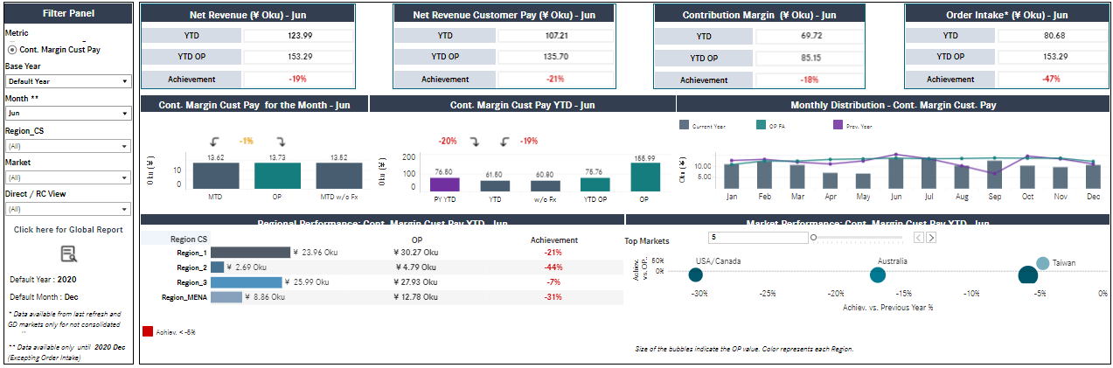

1. **Club connect**

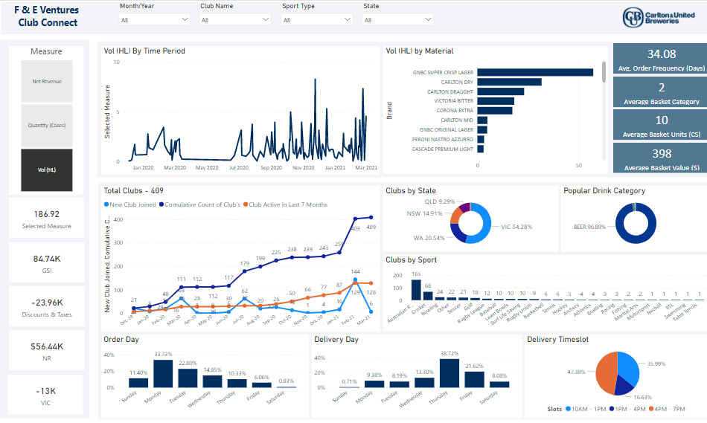

1. **Challenges**
2. **Challenge: Dynamically change visuals based on KPI selection.**

-Create “Enter data” table with one column Named (Toggle) with 3 values “CY”, “PY”, “BS”.

-Create Slicer with (Toggle Column).

-Create 3 measure.

CY Sales = if (CONTAINS (MT, MT[Matrix],"CY"), [CY Sales])

PY Sales = if (CONTAINS (MT, MT[Matrix],"PY"), [PY Sales])

BY Sales = if (CONTAINS (MT, MT[Matrix],"BS"), [BS Sales])

-Then Create visual 1 dimension with 3 measures.

1. **Multiple visual show / hide based on user selection**
2. **Append Files** **Dynamically when you add files into folder automatically row will add.**

* Select folder path (where all .CSV files located).
* click on Combined & Transform >> Click OK
* Once new file added into folder. Just have to refresh dataset that's all.

1. **Append different data sources in Power Query**

[**https://www.youtube.com/watch?v=ev76W-drqmc&list=PL6Omre3duO-OGTAMuFuDOS8wMuuxmyaiX&index=107**](https://www.youtube.com/watch?v=ev76W-drqmc&list=PL6Omre3duO-OGTAMuFuDOS8wMuuxmyaiX&index=107)

It can be SQL server, Excel, CSV, Hive, Oracle – after all it’s a table/query.

* Import **1st query** **from HiveQL** and Import **2nd query** from SQL Server, 2 Query will be created at Power Query.
* Before appending Please note both are same structure of columns.
* Now append 1st with 2nd Query, It will generate final query.

1. **Huge (5GB) data in database table which we don’t want to load, refresh in Power BI Desktop.**

* Developed report pointing to Development database server with limited data.
* Create parameter with server name and database name.
* Change server name and database name to production in dataset in power bi service.
* Manually Refresh dataset.

**Explain project uses case you have developed with business and technical?**

**<https://www.youtube.com/watch?v=X7DsnK5bD-0>**

1. 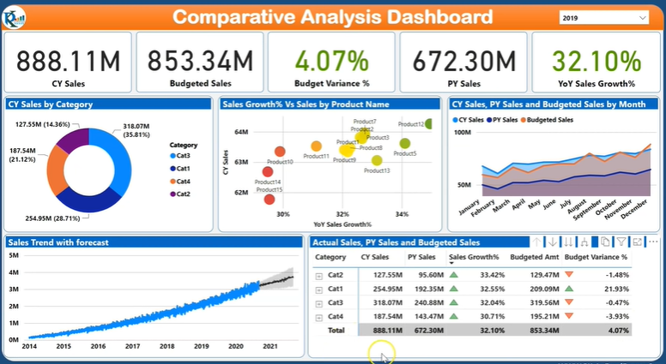

**Comparative Analysis to do analysis CY sales with PY Sales and Budgeted sales.**

|  |  |
| --- | --- |
|  |  |
| Donut chat shows, CY Sales by each Product Category. If I mouse over on Product category then it will show Product level details  (CY Sales, PY Sales, Budgeted Sales) Pop window | Scatter chat will show CY sales and Growth % for each product. If wants to see Budgeted varience each months of current year then just mouse over on product that will show separate chat with bugeted varience. |
|  |  |
| Area chat showup each month wise CY, PY, Budgeted sales. | Forecasting the Sales each day wise but in forecast chat display forecast sales in year wise. We do forcast 2021 sales |
|  | |
| In Matrix chat Product category, Product wise CY Sales, PY Sales, Sales Growth green & red arrow (up/down). Category and Product can go drill up/down. It can explore by Plus / Minus. | |

**CY Sales** =

var CY = MAX(Orders [Order Date].[Year])

return

CALCULATE(SUM(Orders[Sales]), Orders [Order Date].[Year]=CY)

**CY Budget Sales** =

var CY = MAX(Orders [Order Date].[Year])

return

CALCULATE(SUM(Orders[**Budget Amount**]), Orders [Order Date].[Year]=CY)

**PY Sales** =

var PY = MAX(Orders [Order Date].[Year])-1

return

CALCULATE(SUM(Orders [Sales]),Orders [Order Date].[Year]=PY)

**YoY Sales** =

DIVIDE([CY Sales]-[PY Sales],[PY Sales],BLANK())

1. **Project architecture**

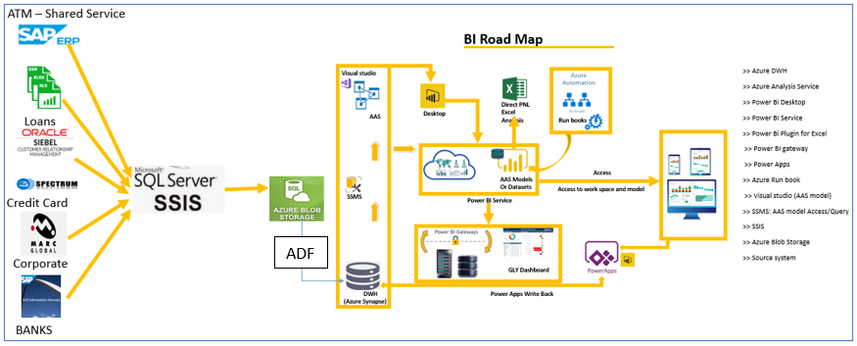

1. **How on-prem data will dump/load to Cloud?**

***Azure Feature Pack for Integration Services (SSIS)***

**SSIS Feature Pack** for Azure is an extension that provides the components listed on this page for SSIS to connect to Azure services, transfer data between Azure and on-premises data sources, and process data stored in Azure.

1. **Polybase**

* Polybase is a technology that accesses external data stored in Azure **Blob, Data Lake, HDFS** using the Transact-SQL.
* This is the most scalable and fastest way of loading data into an Azure Synapse SQL Pool.
* Polybase helps in the bidirectional transfer of data between Synapse SQL Pool and the external load performance.
* Synapse (formerly Azure SQL Data Warehouse) from Azure Storage using Polybase. Polybase require data being in Azure Storage to transfer to synapse.
* Access external data from Azure Synapse Analytics using Polybase
* Azure Data Factory allows using Polybase even if your data is on-premises.
* Azure Data Factory can be used to schedule the data movement using Polybase.

1. Can I create a report connecting 2 tabular model. If yes, what all things will not work

You can add more than one SSAS Tabular model in a Power BI Report, but you cannot create New relationships because it is a direct connect to source.

1. 10 users have access to a workspace, 5 uses have access to all reports whereas other 5

has access to restricted reports. How can I share with them?

Just remove 5 unwanted users access and share them reports.

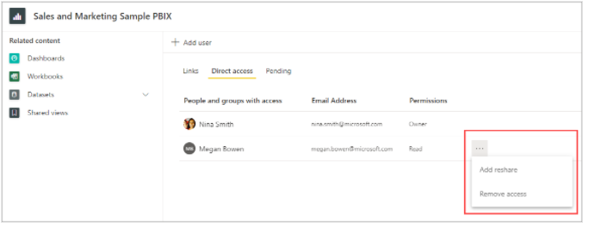

1. Show same reports in different languages (English, Deutsch)
   * In Power BI Desktop, go to **File** > **Options and settings** > **Options**.
   * Under **Global**, select **Regional Settings**.
   * In the **Model language** box, select a different language.
2. Shown latest refresh date in report
   * 1. Create table with Blank query
     2. Write M code = DateTime.LocalNow()
     3. Add new column Date, Date and Time & Time.

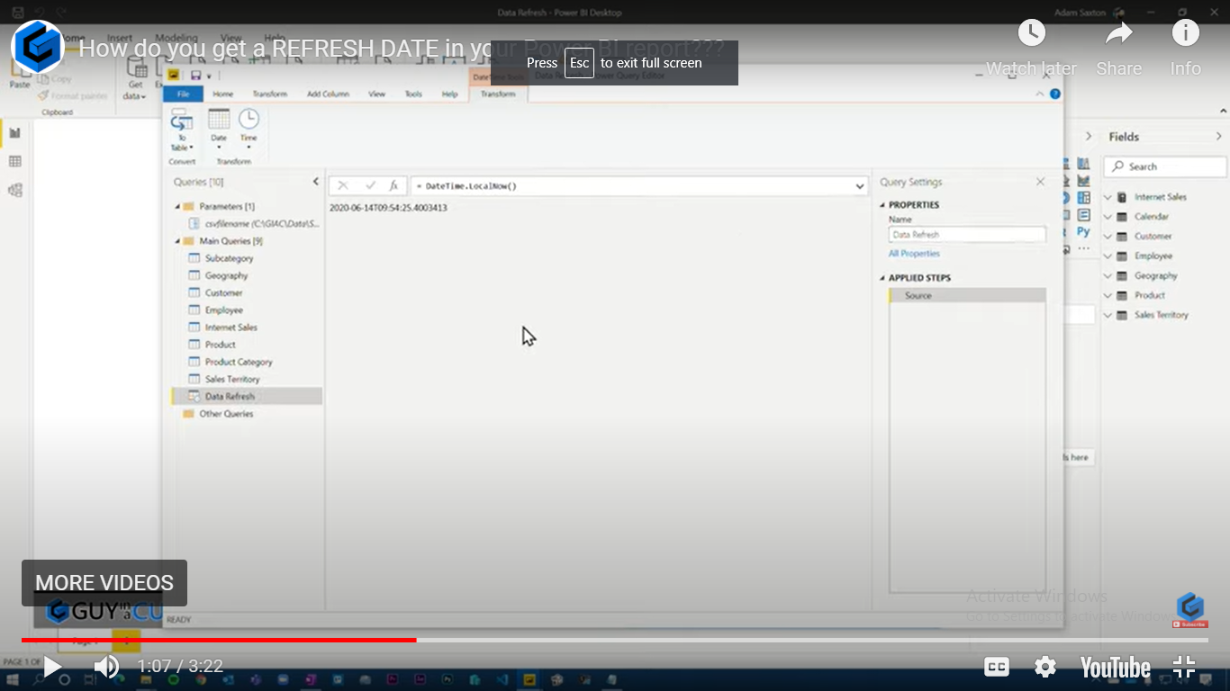

1. How can we achieve Top N, Bottom N

Top 2 sales = CALCULATE([Total Sales], TOPN(2,orders,[Total Sales],DESC))

1. Challenges faced in AAS

* Some visual in my report not showing data where as others are showing data. When I do refresh multiple time it shows me data it this issue occurs multiple times.

For solution: Use import mode to import model into power bi desktop.

* File Path:

Adding new table from Data lake storage with completely new folder.

When add path of data lake file location to M query in Tabular editor.

* Added all the columns and data type into Partition M query script all the columns but columns was not showing in model output. again added column into table to show up into model output.
* **Missing** values appearing in in Planned, Un-Planned, Blank and **Missing.**
* Compactable mode change from 1200 to 1500 in Visual studio.

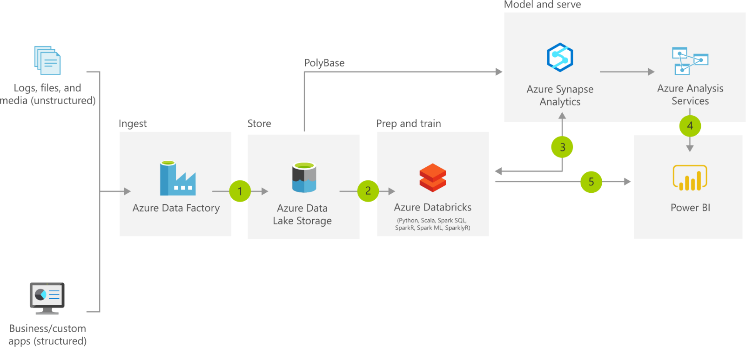

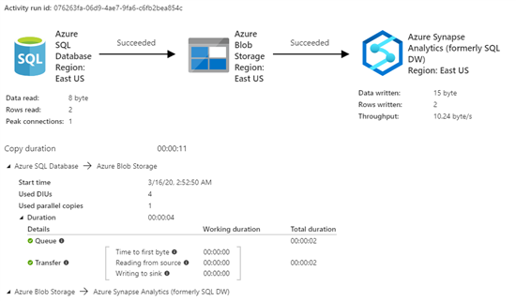

1. **SUM AND SUMX**

|  |  |
| --- | --- |
| SUM | SUMX |
| SUM() is an aggregate function **Single value** or **Scalar value** | SUMX() is an iterator function. |
| It adds up all the values in a single column. | It works through a table, row by row. |
| SUM() has no knowledge of the existence of rows (it can’t do row by row evaluation) | SUMX() has awareness of rows in a table, row by row evaluation.  1a = SUMX(Orders, Orders[Quantity] + Orders[Sales]) |
| SUM operate everything in the **single column**. | SUMX can operate over both a single column & multiple columns. |
| Performance - Sum & Sumx | **SE - Storage Engine & FE - Formula Engine.** |
| * The SE is faster, multi-threaded and cached whereas The FE is slower, single threaded and not cached. * SUM () always uses SE for its calculations - No performance issue. * SUMX() always uses SE for (Simple) calculations = No performance issue. * SUMX() Sometime for Complex calculation needs to use the FE to improve performance. | |

1. **Calculate and Calculate Table**

|  |  |
| --- | --- |
| CALCULATE | CALCULATETABLE |
| Input as Table with filter expression | Input Table with filter expression |
| Output scalar values / column / measure | Output as table Virtual (Measure) , Physical (column) |
| =CALCULATE (Sum (Sales),  FILTER (East_Sales, East_Sales[Product]=”Coke”)) | CALCULATETABLE (East_Sales, FILTER (East_Sales, East_Sales[Product]=”Coke”) |
| Doesn’t required other function to return scalar value | Required SUMX function to return scalar value |

1. **Import and Direct Query**

|  |  |  |  |
| --- | --- | --- | --- |
|  | **Capability** | **Import** | **Direct Query** |
| 1 | Dataset Size | 1 GB / 10GB per dataset (Pro/Premium) | No limitation |
| 2 | Performance | High | Slow |
| 3 | Data Modelling | Strong | Limited – NO autodetect relation |
| 4 | Data Transformations | Supports all transformations | Limited transformations |
| 5 | Built-in Date Hierarchy | Available | Not available |
| 6 | DAX expressions | Supports all DAX functions | Limited - DAX Time Intelligence functions. |
| 7 | Bi-directional filtering | available | not support |
| 8 | Schedule Refresh | Maximum 8 / 48 schedules per day | Auto refresh –  Schedule often as every 1 sec, default 30 mins |
| 9 | Data Refresh & Change | Manual & Schedule Refresh | (near) Real-time |
| 10 | Incremental refresh | Not allowed | Allowed |
| 11 | Security (dataset / DB) | Create row-level security on the PBI dataset (import only) | Re-use on-prem database row-level security for (Tabular and Direct Query) |
| 12 | Large datasets | Small and Medium Datasets | Large Datasets (Greater than 1 GB) |
| 13 | Q&A | Available | Not available |
| 14 | Verities of data sources | Many | Limited |
| 15 | Pre-Built models | Pre-built and customize | Only pre-built with less customize |
| 16 | Composite model | Support | limited Support |

1. **Workspace security level**

|  |  |  |  |  |
| --- | --- | --- | --- | --- |
| Capabilities | Admin | Member | Contributor | Viewer |
| Update & Delete workspace, Apps | Y |  |  |  |
| Add / Remove people | Y |  |  |  |
| **Report content: Create, delete, edit, publish content in workspace** | **Y** | **Y** |  |  |
| * **App content: Publish, update & share.** * **Add other users as (viewer or contributor).** | **Y** | **Y** |  |  |
| **Report content: Create, delete, edit, publish content in workspace** | **Y** | **Y** | **Y** |  |
| Create report based on dataset in workspace | Y | Y | Y | Y |
| Copy report, view contents | Y | Y | Y | Y |

1. **Cluster and Non-Cluster Index**

|  |  |  |
| --- | --- | --- |
|  | Clustered Index | Non-Clustered Index |
| Where they stored | Cluster index created same table both context and data same place | -Non-Clustered Index is similar to the index of a book. The index of a book consists of a chapter name and page number. |
| Automatically Sorting | Whenever you apply clustered indexing in a table, it will perform sorting in that table only. | Data and index sorting separate places. |
| Automatically Index created | **Unique Index**: You can create only one clustered index in a table like: **primary key**. | No concept on unique index |
| Single / Multiple index | Single | multiple |
| Performance | Clustered index is faster. | Non-clustered index is slower. |
| Memory consume | Clustered index requires less memory for operations. | Non-Clustered index requires more memory for operations. |
| Index on main data | In clustered index, index work on the main data. | In Non-Clustered index, index work on the copy of data. |
| Data on the disk | Clustered index has inherent ability of storing data on the disk. | Non-Clustered index does not have inherent ability of storing data on the disk. |
| Store pointers of data. | Clustered index store pointers of data. | Non-Clustered index store both pointer and data. |
| Physically reordered data | A Clustered index is a type of index in which table records are physically reordered to match the index. | A Non-Clustered index is a type of index in which logical order of index does not match physical stored order of the rows on disk |

1. **Cognos is superior than power BI**

|  |  |  |
| --- | --- | --- |
|  | **Cognos** | **Power BI** |
| Table **relationships** flow | Winner | Loser |
| **Native SQL** query generation | Winner | Loser |
| **Data volume** | Winner | Loser |
| **Ad-hoc reporting** | Winner | Loser |
| **Auditing** In-build feature | Winner | Loser |
| **Multiple components** like Cube, dynamic cube, workspace dashboarding, RS, AS, QS, FM | Winner | Loser |
| **Live connect** with DWH | Winner | Loser |
| **Role playing Dimension** | Winner | Loser |
| Multiple **active relationship** between table | Winner | Loser |
| Admin view download reports | Winner | Loser |
| **Admin run**, start, stop reports | Winner | Loser |
| Key Performance Indicators | Winner | Loser |
| **Data source & Dataset** | Winner | Loser |
| **Size limitation** | Winner | Loser |
| Excellent **technical support** | Winner | Loser |
| **Folder hierarchy** / Workspace, report organize hierarchical. | Winner | Loser |

1. **How to share report / dashboard to user**
   1. Schedule dataset and send email
   2. Subscribe report/dashboards
   3. Using Content pack
   4. workspace and provide access
   5. Publish into app
   6. PBIX file share (email or share drive)
   7. Export into PDF, Excel, Power Point
   8. Embed into Organization website
   9. Share or embed into share point
   10. Web URL (Public data)
2. **Tableau and Power BI**

|  |  |  |
| --- | --- | --- |
|  | **Power BI** | **Tableau** |
| Connectivity to Data | Power BI native data connectivity excel, Azure products, MSBI tools, Office 365 login. | Has a wider variety and can connect to numerous data sources. |
| Small Business | Small businesses with limited financial and human resources should start out with Power BI. | However, medium and enterprise companies that prioritize data analytics and have the human capital to support them will be better off with Tableau. |
| Native support | Especially if they already invest in Microsoft products. |  |
| Easy to Use | Power BI wins for ease of use | Tableau wins in speed and capabilities. |
| User Interface | Simple - Power BI in built for the common stakeholder, not necessarily a data analyst. | Complex - Tableau is similarly powerful, but the interface isn’t quite as intuitive, which makes it a more difficult to use and learn. |
| Subscription | It Provides Account based subscription. | It Provides Key based subscription. |
| Embedding | Embedding a report is fairly simple. | Embedding report is a real-time challenge in tableau. |
| Large Dataset | Can handle large data sets using Premium. | Can handle large data sets. |
| Language | DAX | MDX |
| Huge data volume | Limited volume | Huge Volume |
| customer support | Limited | excellent |
| Pricing | $10 | $70 (Cloud)  $12 (On-prem) |
| Big data | Good | Best |

1. **Cube & Tabular model**

|  |  |  |
| --- | --- | --- |
|  | **Tabular Model** | **Multidimensional Model** |
| In-Memory | The Tabular model (In-Memory Cube). Tabular models are in-memory databases in Analysis Services. Using state-of-the-art compression algorithms and multi-threaded query processing, | The Multidimensional model (traditional Cube on Disk). This model is the OLAP cube that already exists for more than ten years. |
| Performance | 10 times, More performance than OLAP | Mature Technology. |
| Data volume | Limited to RAM available (= midsized project). | handle very large volume of data. |
| Future technology. | Technology for the future. | OLD technology. |
| Advance modelling | Poor modelling | Able to cope with advanced modeling/ computations requirements. |
| Power Pivot | Integration with Power Pivot. | Cannot be used with Power View. |
| Easy | Easier to develop than Multidimensional model. | Higher complexity than Tabular. |
| Calculated Column | Calculated Column allowed | Calculated Column not allowed |
| Stored in | stored in memory | Stored on disk |
| Language | DAX (Data Analysis Expression) | MDX (Multidimensional Expression) |
| Parent-Child hierarchy | You cannot define a Parent-Child hierarchy | You can easily define a Parent-Child hierarchy |
| Direct Query mode | Supported | Not Supported |
| Translations | Not available | available |

1. **Power BI Best practice / Performance of Report & Dashboard**
2. Query folding - Query tuning.
3. Query Diagnostics of Power Query.
4. Performance Analyzer.
5. Vertipaq Analyzer.
6. Query Folding: you can optimize SQL statement that will fire to database in single statement.
7. Limit visuals, in dashboards and reports.
8. Limit tiles, no more than 10 Tiles in dashboard.
9. Limit complex measures, columns in data models.
10. Limit dataset Import only necessary fields and tables instead of entire datasets.
11. Limit interactions between visuals.
12. Avoid use hierarchical filters.
13. Avoid scrolls within the visual and on page.
14. Avoid Bi-direction relationship.
15. Use Row-Level Security (RLS).
16. Use certified custom visuals.
17. Use the On-premises data gateway.
18. Use thousands or millions - Shorten numbers.
19. Use drill through buttons to generate an intuitive user experience.
20. Use the Power BI report and data source are in the same region.
21. Use same dataset multiple reports.
22. Use Create calculated measures instead of calculated columns.
23. Use calculated columns and measures from the source database not PBI desktop model.
24. Categorize the data for Power BI reports (HBI, MBI, LBI). High Business Impact (HBI) data.
25. **Query Tuning / Optimization**
    1. use key column in Joins
    2. use Index, Cluster Index, Materialize view, Summery Table.
    3. use Optimal Data Types, number, Integer etc.
    4. use temp table when doing join and calculation
    5. use EXISTS & BETWEEN instead of IN
    6. use UNION ALL instead of UNION
    7. use TRUNCATE instead of DELTE statement
    8. use WHERE instead of HAVING to define filters
    9. Avoid Correlated Sub-queries
    10. Avoid Null Values.
    11. Avoid “SELECT DISTINCT”
    12. Avoid Too unwanted Columns
    13. Avoid to-run during peak hours
    14. Query Execution plan: which steps is taking % of cost

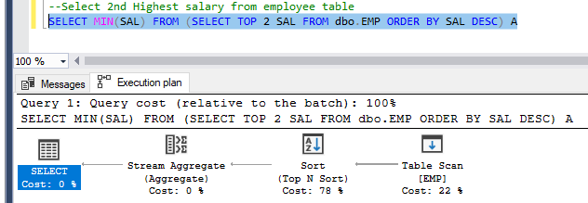

1. **Power BI License**

|  |  |  |  |
| --- | --- | --- | --- |
|  | **Pro-license: $9.9 per user** | **Premium license: $4995 bulk** | **PPU** |
| Single license | Individual license provision | Bulk license provisions |  |
| Small organization | Small organization less no of users | Large organization, more no of user |  |
| On-premises reporting | On-premises reporting not allowed | On-premises reporting in Power BI (Report Server) |  |
| Shared processing | Shared processing environment. | Both Dedicated and Shared processing environment |  |
| Embed | Not Allowed, to embed Power BI visuals into apps (PowerApps, SharePoint, Teams, etc) | Yes allowed, to embed Power BI visuals into apps (PowerApps, SharePoint, Teams, etc) |  |
| Subscribe attached report to email | Not Allowed | Yes allowed. |  |
| Deployment Pipeline | Not Allowed | Yes allowed. |  |
| Data flow | Not Allowed | Yes allowed. |  |
| Data Lake Analysis | Not Allowed | Yes allowed. |  |
| Workspace size | Workspace 10 GB | 100TB |  |
| User allowed limit | User allowed 10 GB | No Limit |  |
| Dataset size | Dataset allowed 1 GB | Dataset allowed 10 GB space |  |
| Daily refresh limit | Daily refresh limit = 8 | Daily refresh limit = 48 | No Limit |
| Rows limit | Rows limit 1 Million | Rows limit 2 Billion |  |

1. **Data flow and Dataset**

|  |  |  |
| --- | --- | --- |
|  | Data flow | Data set |
| ETL / Reporting | Dataflow is the ETL Layer | Dataset is the reporting Layer |
| Self service | Dataflow is used organize & persist for self-service meta data. | Dataset is used to organize & persist data & meta data. |
| Storage ADLS | Dataflow used “ADLS” for storage of the data and meta data. | Dataset is a pointer to your data source. |
| Data Transformation | Data can be cleaned and transformed as part of the dataflow. | Dataset calculate, add, modified and published into service. |
| Dataflow map to CDM,  Dataset map to reports. | Data mapped into a standard extensible schema called (CDM). | Once published, datasets can be shared between workspaces and reports. |
| Power query / DAX & relationship | Dataflow is Replacement of your Power Query. | Dataset is Replacement of DAX and Relationships. |
| Data sources | Dataflow will extract data from data sources, transform the data, and load it into the CDM. | Dataset is the layer of all the calculations and modeling. It will get data from the dataflow or from other sources. |
| Feeds to visual | Dataflow Feeds Data to the Dataset. | Dataset Feeds Data into Visualizations. |
| Dataflow used | Dataflow used the Data Source Directly. | Dataset used the Data Source Directly & by Dataflow.  Best practice to use dataset through dataflow. |
| Power query / DAX and Modelling | Dataflow Developer Needs Power Query Skills. | Dataset Developer Needs DAX and Modeling Skills. |
| Data modeler / report visualizer | Dataflow are used by Data Modelers. | Dataset are used by Report Visualizers/users. |

1. **Calculated column and measure**

|  |  |  |
| --- | --- | --- |
| Differ points | Calculated columns | Measures |
| When Evaluated | Calculate when column created | Calculated on the fly when visualize it. |
| Consume CPU | YES | YES |
| Consume Memory | YES | NO |
| Auto Update | No | Yes |
| Performance | Low | High |
| Used in relationship | YES | NO |
| Intermediate calculation is stored in RAM | YES | NO |
| Category, Date, Text, Range age (10-20) | YES | NO |
| Aggregation- Sum (), Min (), Max () | NO | YES |
| Margin profit / Ratios / Running total / weighted averages | NO | YES |
| Expensive | YES | NO |
| FE - Formula Engine | Less used | More Used |
| SE – Store Engine | More Used | Less Used (When complex calculation) |

1. CDM & CDS

CDM is a data model that includes many existing standard definition for tables (entities), such as Account, Product, etc. The reason that this data model exists is to help to unify databases and applications into a standard form of data or let’s say into a Common Data Model.

CDS is a data storage system, which also comes with a lot of services around it for security, integration, and etc. **CDS is something like a database, which is primarily used for Power Apps** and some other Power Platform services.

To understand the difference, you need to understand that CDM is not a data storage system, is not a database. You cannot say data is stored in CDM as storage. There should be always a data storage technology behind it. CDM just provides the metadata structure for entities. For example, the Power BI dataflows stores data into Azure Data Lake Storage, but that data can get stored in the format of CDM, into the structure of CDM.

CDS on the other hand side, is a database system. you can store data in it. CDS fortunately leverages the structure of CDM. that means you can use the entity templates that are defined in CDM as your entities and fill data into it, But you can also define your custom entities.

1. **Data verse**.

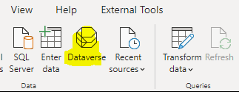

Microsoft Dataverse Power BI Connect with Power Apps.

Easily connect Microsoft Power BI with live Microsoft Dataverse (CDS) data for up-to-date visual analysis and reporting.

• Real-Time Data Access (DirectQuery)

• Full Metadata Discovery

• Robust SQL-92 Support

• Enable real-time analytics through unmatched data processing.

• Request data as quickly as possible using server-side paging and bulk capabilities.

1. **Subscription - Report subscription in power bi service.**

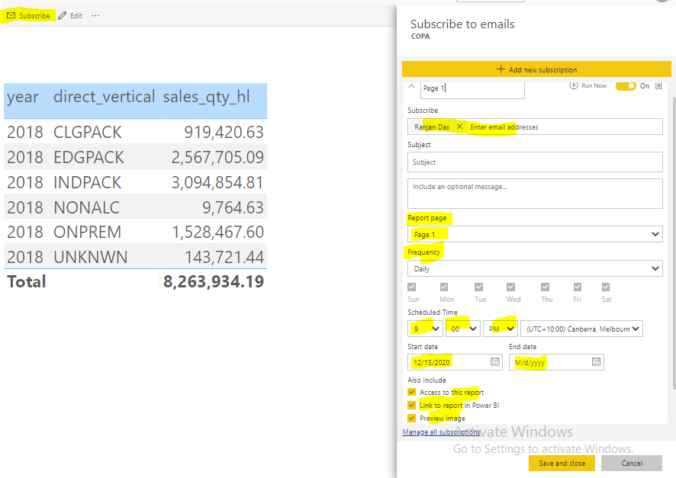

1. **In Active relationship / role playing dimension**

Normally inactive relationship will not do any filtering role only active relationship will do so.

But there are situation Fact table connect to Dimension table with more than one relation that means Dimension table is here roleplaying dimension example **Date table** (**Order Date & Ship Date**) and **Product Table**.

Let’s assume fact table has active relationship with Date table (Order Date) and Inactive relation with (Ship Date), In this scenario if we need inactive relation (**Ship Date**) to work then we need write

A dimension that plays the role of multiple dimensions called role-playing dimension in the data warehousing terminologies. In the above example, Date dimension is going to play the role of Order Date in some scenarios, and the role of Ship Date in other scenarios, and also sometimes role of Due Date in other times.

DAX-

**Sales by ship Date = CALCULATE(SUM (‘Sales Order’ [Order Total]), USERRELATIONSHIP(‘Sale Orders’ [ship Date], Date[Date] ))**

The type of relationship you have seen above is called an active relationship. There is another type of relationship called Inactive. Let’s see how an inactive relationship will be created. In the previous example, we sliced and diced data by the Order Date Key field, because that was the field connected through the relationship to the Dim Date table. Now, let’s say we want to slice and dice data by the Ship Date Key. The very simple approach is to create another relationship between the Dim Date table and Fact Internet Sales but this time to the Ship Date Key.

If we need set 2 active relationship between Date Dimension and Product Dimension then we need to create Ship Date Dimension and Order Date Dimension and setup 2 active relationship Product table like below.

|  |  |
| --- | --- |
|  |  |

1. **Oracle database** connection.

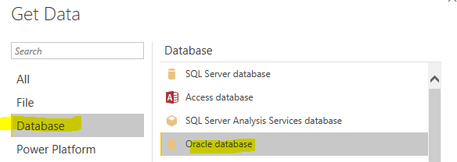

* **Give Server** and click **OK**
* **ServerName/SID**

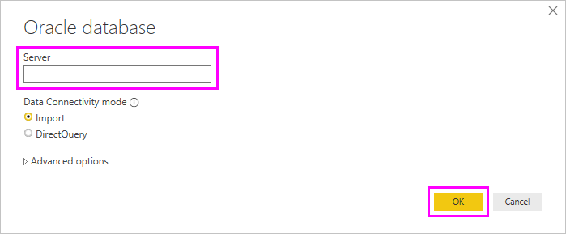

1. **Power Query - RECORDS**

First records, Last records, Range of records, Duplicate records, Alternate records, Error records, Append queries, Merge queries

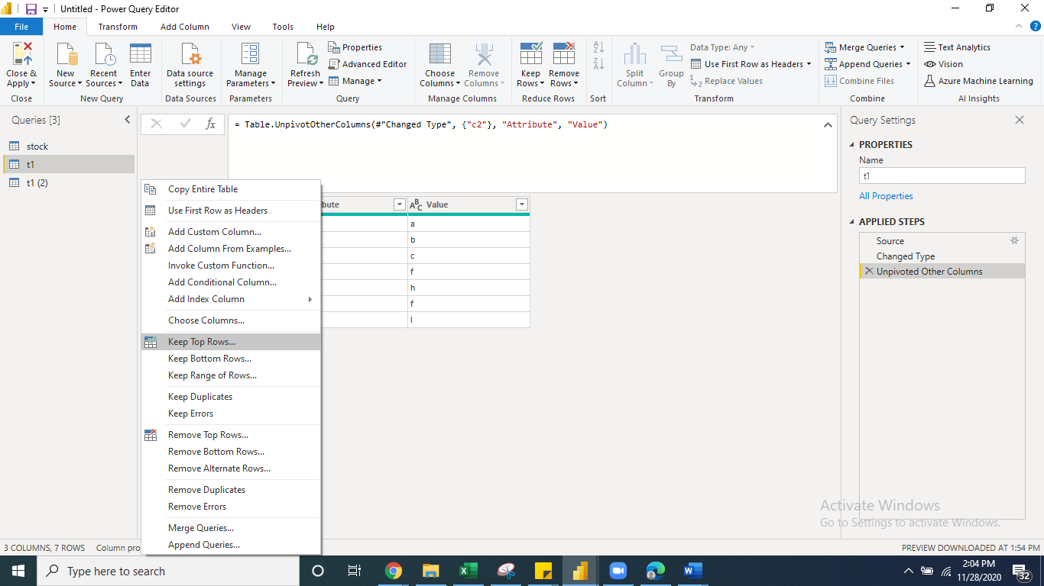

1. Rank and Dense Rank

|  |  |
| --- | --- |
| Player | Score |
| A | 400 |
| B | 400 |
| C | 300 |
| D | 200 |

|  |
| --- |
| Rank |
| 1 |
| 1 |
| 3 |
| 4 |

|  |
| --- |
| Dense Rank |
| 1 |
| 1 |
| 2 |
| 3 |

1. **Mode swiping Live <> Direct <> Import**

Open PBIX > Power Query > Right click on tables delete > Apply & Save > (your visuals will be cracked) > Get Data

> select mode (which you like to move)

1. **Copy report workspace to another workspace**

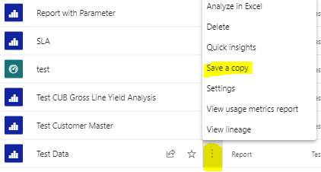

1. **Filters in Power B**

## **Manual filters**

Manual filters are the filters that report creators drag and drop anywhere in the new filter pane.

**Report level, Page level, Visual level.**

## **Automatic** **filters**

Automatic filters are the filters that get automatically added to the visual level of the filter pane when you build a visual.

* + **Cascade filter:**

One after depends on another filter

* + **Tooltip filter:**

When create report page as tooltip then used in visual. Once you mouse over on visual tooltip report will filter accordingly.

* + **Data source filter:** Applied on source Power Query or Data tab

## **Include and exclude filters**

Include and exclude filters get automatically added to the filter pane when you use the include or exclude functionality.

## **Drill-up & Drill-down filters**

Drill-down filters get automatically added to the filter pane when you use the drill-down functionality for a visual.

## **Drill-through filters**

Cross-drill filters are automatically added to the new pane when a drill through to other page, filter is passed to another visual on another report page via the cross-filter.

* + **Cross-filter (Bi-Directional filter)**

When doing join between table with bidirectional filter

## **URL filters**

URL filters get added to the new pane by adding a URL query parameter.

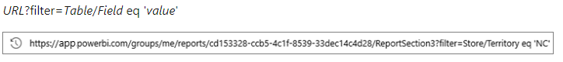

## **Q&A / Pass-through filters in power bi service**

Pass-through filters are visual-level filters created through Q&A in power bi service.

* + **Persistent filters**

As soon as you interact with the report (e.g. applying a filter or slicer), the button will light up and you will see the reset icon turn yellow. This is an indicator that the report is not in the default state and you have made changes.



Once you have modified the report to the view that you like, simply navigate away to another dashboard or report that you have access to. Soon after, go back to the report that you just modified. You should now see a tutorial dialog pop up (only on the first run for each report) that gives you a heads up that all the changes you made last time has been saved.



1. **Difference between data source filter and report filter?**

**Data Source:** applied on source or table itself and applied in data tab which will impact complete data set or entire report. Which help performance improve of report and limiting data set.

**Report level filter:** There are 9 to 10 filter for report level filters.

Common filter, Automatic filter, include exclude, drill up and drill down filter, Drill through filter, URL filter, Drill cross filter, Pass through filter (Q&A), Bi-direction cross filter.

1. **Report migration one org to another?**

if the new Power BI Service account is in another tenant then you would need to download the PBIX file and upload them into the new Power BI tenant with the new Power BI Service account.

Create content pack in Power BI service under your old account, which contains the dashboards/reports/datasets you want to transfer. Publish the content pack, then, log into Power BI service with new account, install and make a copy of that content pack.

1. **What is Power BI Report Server?**

Power BI Report Server is an on-premises server product that ships with Power BI Premium. Report Server allows users to take advantage of Power BI on-premise. For some businesses, uploading their data to the cloud isn’t an option. This could be because there are data regulation laws applying to their particular industry, or maybe they don’t have the necessary infrastructure or connectivity where they are to be able to reliably access SaaS platforms.

Power BI Report Server can be deployed behind a firewall and is compatible with Power BI in the cloud so that businesses have the freedom to move a cloud-based version of Power BI when they’re ready.

Report Server packs has similar functionality to Power BI Service, though it’s largely focused on report generation, and there are a number of key features that are exclusive to its cloud-based sibling. Report Server users must use the Power BI Desktop app and cannot work in a web browser. They also don’t get access to dashboards, real-time streaming, content packs, app workspaces, natural language queries, the ability to analyze data in Excel, email subscriptions, or data alerts.

It also has a sparser update cycle, with new features and fixes rolled out to Report Server every four months, rather than once a month.

1. **User level custom sorting**

Enter data >> Create **sort table** with 2 cols >> (Country, sort) >> Enter sort 1, 2, 3 etc. in order >> create relationship county col with existing country col >> then do sort by col sort col.

1. **How to create group & Bin in Power BI?**

Right click column from Fields pane >> create **group** >> select values give the name of the group > like this multiple group can be created. And same like **BIN** can be created from measure with given range.

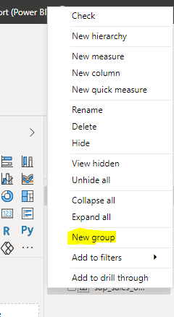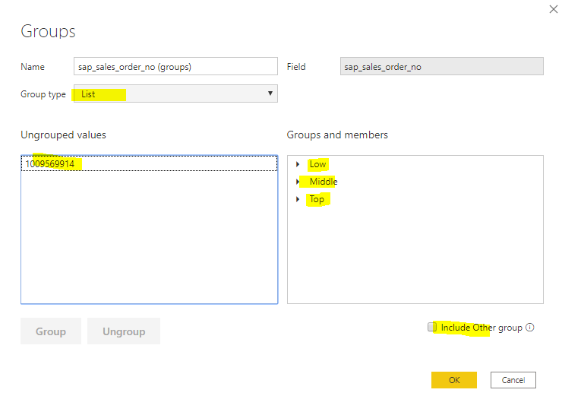

Bin

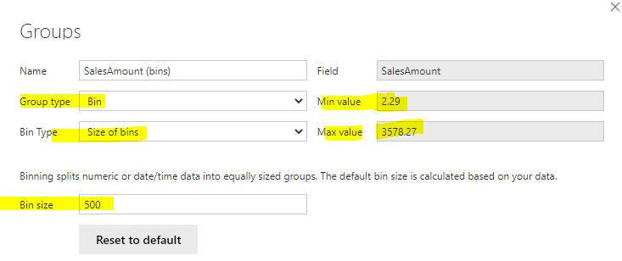 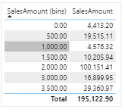

1. **Bi-Direction Cross filtering or (Many to many solve)**

-With bidirectional cross-filtering have more control over how can apply filters when working with related tables. --Bidirectional cross-filtering enables them to apply filters on *both* sides of a table relationship.

-You can apply the filters by propagating the filter context to a second related table on the other side of a table.

-In a unidirectional relationship the filter context is propagated from the one-side to the many-side

-With a single direction of cross filter, if you filter a product you also filter the sales of that product, but you do not filter the customer who bought those products.

-This can help you solve the **many to many** problems without writing complicated DAX formulas.

-The relationship between **Product and customer is a many-to-many relationship**. A single Product can be associated with many customers and each customer can be associated with many transactions.

-**USERELATIONSHIP:** A **disabled relationship can be activated using DAX (**In this caserelationship will be active for that specific measure only)

***- CROSSFILTER:*** *CALCULATE ([Count of Customers], CROSSFILTER (‘Fact Sales’ [Customer Key], ‘Dim Customer’ [Customer Key], Both))*

-When no relationship exists between 2 tables, the ‘LookupValue’ function can be used to act like an excel vlookup function, returning a field in a table using a lookup value. Ex. Customer and Product.

**CROSSFILTER:**

**USERELATIONSHIP:**

1. **Without relation between table**

[RELATED](https://dax.guide/related/) : One to One / May to One

Used in Fact table and bring data from Dim table.

RELATED can only draw values from One-Side(dimension) to the Many (Fact).

[RELATED](https://dax.guide/related/) : One to One / May to One

CASE 1 = SUMX (Sales, Sales [Qty] * RELATED (products [Sales Price]))

**CASE 2** = Sales = ‘Orders'[Quality] * [**RELATED**](https://dax.guide/related/)**(‘Price List' [Cost] )**

**CASE 3** = [CALCULATE](https://dax.guide/calculate/)([SUM](https://dax.guide/values/)(‘Price List'[AMOUNT] ), [FILTER](https://dax.guide/filter/)( ‘Price List’, ‘Price List'[Country] = ‘Orders'[Country] ))

[RELATEDTABLE](https://dax.guide/relatedtable/) : One to Many

Used in Dim table and bring data from Fact table. For RELATEDTABLE it can look up values from the Many-Side and bringing it into the One-Side. Returns the related tables filtered so that it only includes the related rows.

[RELATEDTABLE](https://dax.guide/relatedtable/) One to Many

CASE 1 = SUMX (RELATEDTABLE (Sales, Sales [Qty]) * products [Sales Price]) //This should be written in Products table.

**CASE 2** = SUMX(**RELATEDTABLE(Sales)**, Sales [Qty]* products [Sales Price])

**CASE 3** = CALCULATE (SUM (Fact B[Qty]), RELATEDTABLE (Fact B))

**CASE 4 =** SUMX (**RELATEDTABLE(Sales)**, Sales [Sales Amount]) // Sales wants to bring into product Dim

1. **Size & Limit of Power BI**

|  |  |  |
| --- | --- | --- |
| **Limit** | **Pro** | **Premium** |
| Dataset | **1GB** | **10GB > 12GB** |
| Workspace | **10GB** | **100TB** |
| User | **10GB** | **1TB** |
| Rows | **1 Million** | **2 Billion** |

* + **Dataset limit?**
    - PBIX file locally – No Limit,
    - Pro 1GB file,
    - Premium 10GB file (refreshed to up to 12 GB in size of Premium license)
    - Direct query mode: 1 million rows limit per Dataset
    - Import mode: 2 Billion rows
  + **User Storage limit?**
    - Pro 10 GB per user
    - Premium 1 TB per user
  + **Workspace Storage limit?**
    - Free 10GB
    - PRO - 10 * No. of License (5), then 10*5=50GB
    - Premium 100TB
  + **Direct query** Default timeout**?**
    - 3600 seconds (or 60 minutes).
  + **Power BI Export Limit?** 
    - CSV: 30,000
    - Excel: 150,000
  + **Column limit in a dataset?**
    - Columns limit – 16,000 columns

1. **x-Velocity engine (formerly known as VertiPaq) vertipaq analyser**

VertiPaq Analyzer is useful to analyze VertiPaq storage structures for a data model in Power BI and Analysis Services Tabular. ... You can analyze a Power BI / Tabular data model by importing it in Vertipaq analyzer.

Microsoft x-Velocity in-memory technology (formerly known as Vertipaq)

Vertipaq is a columnar database which means that **every column is physically separated** from other columns and Vertipaq also called is an **in-memory database**. As columns are separated that’s why this I/O operations are less but processing will be more. I/O operations are more costly than processing. As I/O operations less that leads to improve performance in model.

* + It maintains referential integrity, It Create petitions, It segments of data, It compress of data, It create Distinct row, It create own table, It creates hierarchy of data.

**How it works**

**When you send the query to get data for your Power BI report, here is what happens:**

**Formula Engine** (**FE**) or **DAX** Calculate Engine accepts request, process it, generates query/execution plan, & executes it.

**Storage Engine (SE)** pulls the data out of the Tabular model to satisfy the request issued within the query generated by the Formula Engine, **Vertipaq** keeps the snapshot of the **data in-memory**. This snapshot can be refreshed from time to time, from the original data source.

Data in the Tabular model is stored **in-memory** snapshot (**Vertipaq**) or **Direct Query** or **hybrid Composite model**.

Once the query been generated and executed by the Formula Engine, the *Storage Engine* comes into the scene. It physically goes through the data stored within the Tabular model (**Vertipaq**) or *Direct Query* doesn’t store any data. It just forwards the query straight to the data source for every single request.

When you send the query to get data for your Power BI report, here is what happens:

> Formula Engine (FE) accepts the request, process it, generates the query plan and finally executes it

> Storage Engine (SE) pulls the data out of the Tabular model to satisfy the request issued within the query generated by the Formula Engine

Storage Engine works in two different ways in order to retrieve requested data: VertiPaq keeps the snapshot of the data in-memory. This snapshot can be refreshed from time to time, from the original data source.

On the opposite, DirectQuery doesn’t store any data. It just forwards the query straight to the data source for every single request.

* 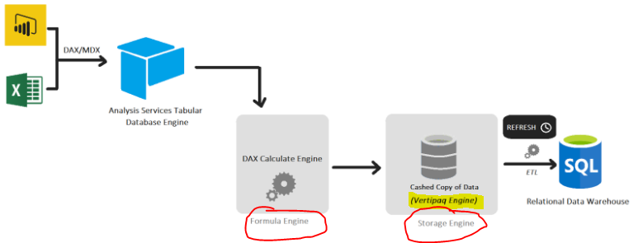

1. **Z-Order in power**

You can manage the **front-to-back order of visuals** in a report, often referred to as the z-order of elements. This feature lets you overlap visuals in any way you want, then adjust the front-to-back order.

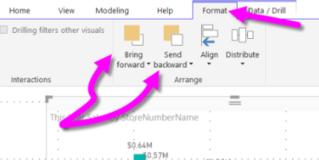

1. **Hierarchy & cascade slicer**

**Hierarchy slicer:** Hierarchy slicer will work automatically when will use hierarchical column is normal slicer. Custom Hierarchy Slicer also available in marketplace that also work same Hierarchy slicer. Keeping note columns are available in one table if its different table there should have relationship exist among all required tables.

**Cascade slicer:** Power BI support cascade slicer provision as default behavior. By selecting 1st slicer value automatically 2nd slicer values get filtered automatically. Keeping note columns are available in one table if its different table there should have relationship exist among all required tables. If no relationship, then we need to setup relationship in manage relationships.

1. **What is tiles**

A tile is a snapshot of your data, pinned to the dashboard. A tile can be created from a report, dataset, dashboard, the Q&A box, Excel, SQL Server Reporting Services (SSRS) reports, and more.

If the original visualization used to create the tile changes, the tile doesn't change. For example, if you pinned a line chart from a report and then you changed the line chart to a bar chart, the dashboard tile continues to show a line chart. The data refreshes, but the visualization type does not.

You create standalone tiles for images, text boxes, videos, streaming data, and web content directly on the dashboard by using the [Add tile](https://docs.microsoft.com/en-us/power-bi/create-reports/service-dashboard-add-widget) control.

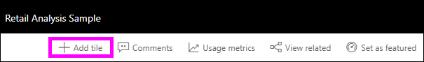

After you've added a tile to a dashboard, you can move and resize it, or change its appearance & behavior.

1. **Type of refresh in Power BI**
2. **Dataset refresh:**

-Refreshing data typically means importing data from the original data sources into a dataset, either based on a refresh schedule or on-demand.

-Power BI limits datasets on shared capacity to 8 or 48 daily refreshes based on pro or premium.

-Data refreshes must complete in less than 2 hours on shared capacity and 5 hours on premium capacity.

1. **OneDrive refresh:**

-Report created using excel, CSV files located at ONE DRIVE or Share Point then that is required One Drive refresh.

-OneDrive refresh synchronizes datasets and reports with their source files.

-By default, Power BI checks about **every hour** if a dataset connected to a file on OneDrive or SharePoint Online requires synchronization.

-When you set a OneDrive file as the data source, Power BI references the **item ID** of the file when it performs the refresh. If you **move file** one location to another power will continue to refresh if you **copy file** one location another then power bi will fail to create Item ID which will cause failure.

1. **Tile refresh**

-Power BI maintains a cache for every tile visual on your dashboards.

-Tile refresh happens when data refresh by scheduled and on-demand refresh.

- Manual refresh by selecting **More options** (...) in the upper right of a dashboard and **Refresh dashboard tiles**.

- Refresh duration increases with the number of tiles.

- Power BI maintains a single cache for every tile,

- Multiple caches: In case of RLS (multiple Roles) then Power BI create multiple caches (Tiles * Roles).

1. **Visuals:**

-In Power BI service manually Refresh button of the report to trigger a refresh of all report visuals.

-Power BI caches the last state of the report visuals so that when you view the report again, Power BI does not have to query the Analysis Services tabular model.

- When you interact with the report, such as by changing a report filter it updates the report visuals automatically.

1. **Model Refresh:** Refreshing SSAS Model both schedule and manually
2. **Gateways refresh:**

-If your dataset uses a data source that Power BI can't access over a direct network connection, you must configure a gateway connection for this dataset before you can enable a refresh schedule / on-demand data.

- Microsoft recommends using an enterprise data gateway instead of a personal gateway to connect a dataset to an on-premises data source.

- Only gateway admins can add data sources to a gateway. Also make sure your gateway admin adds your user account to the list of users with permissions to use the data source.

- A dataset can get data from multiple sources; these sources can reside on-premises. If data sources are both cloud and on-prem then it required gateways, if data source is only cloud then not required gateways.

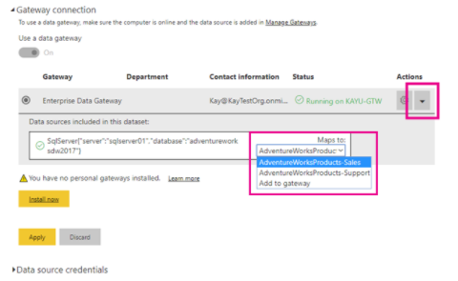

1. **Automatic page refresh: Direct Query mode**

-Automatic page refresh is only available for Direct Query data sources.

-Automatic page refresh works at a report page level

-Allows report authors to set a refresh interval for visuals in a page that is only active when page is consumed.

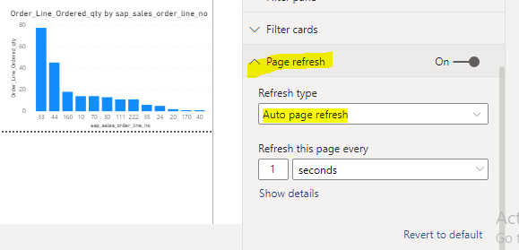

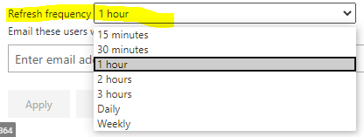

1. **Query caches refresh:**

- When you are playing with report and just for a while if go out to other report once you comeback you will same as it is you left the report, that means report query are cached.

-Query caching is only available on Power BI Premium or Power BI Embedded. It is not applicable tabular model.

- Previously cached query results are no longer valid. Power BI discards these cached results and must rebuild.

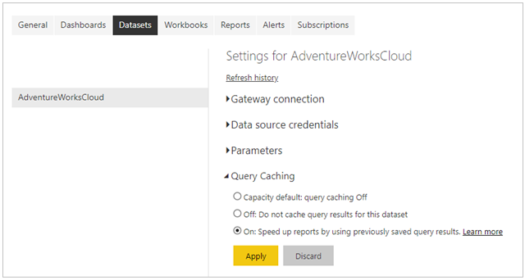

1. **Incremental refresh:**

Incremental refresh policies defined in **Power BI Desktop** and applied when published to the **Power BI service**.

* + - **What is query collapsing?**

The process of converting power query to SQL and executing it by the source database is called query **collapsing**.

* + - ***Query folding*:**

Its a process by which transformation you make in power query editor are simultaneously convert to native queries or simple select statement. Query folding will improve performance of dashboard. You find out query and write single SQL statement and you can optimize SQL statement that will fire to database in single statement to your native database.

Is the ability for a Power Query to generate a single query statement to retrieve and transform source data. The Power Query mashup engine attempts to achieve query folding whenever possible for reasons of efficiency.

Query folding is when steps defined in Power Query Editor are translated into SQL and executed by the source database rather than the client machine. It’s important for processing performance and scalability, given limited resources on the client machine. Relational data source transformations that can be query folded that can be written as a single SELECT statement. A SELECT statement can be constructed with appropriate WHERE, GROUP BY, and JOIN clauses. It can also contain column expressions (calculations) that use common built-in functions supported by SQL databases. It will support native database connection and O-data feed. If don’t get native “query folding” then we can Start **Diagnostics**.

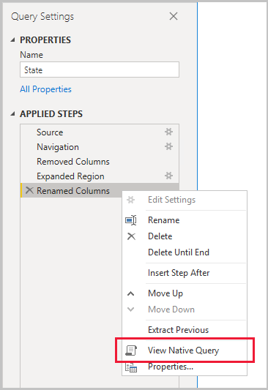

* + - **Define Power BI Desktop parameters:**

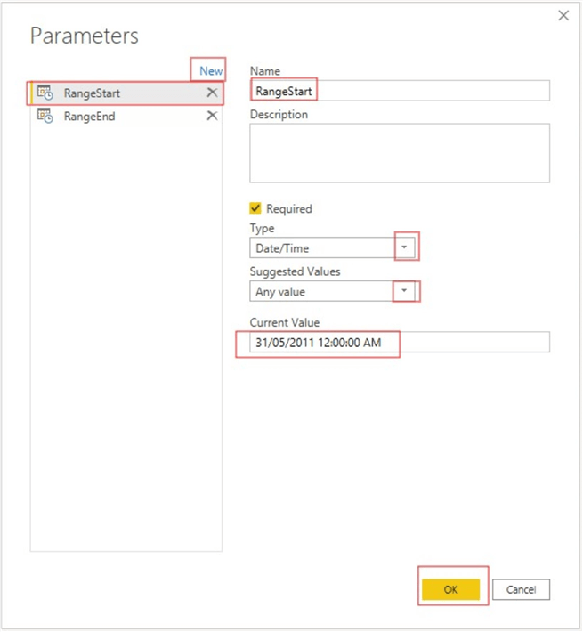

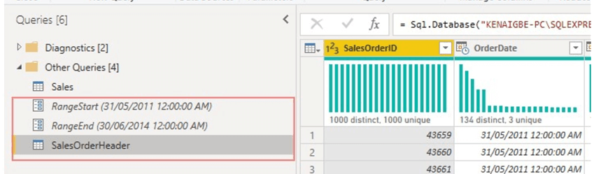

* + - **Apply parameter as filters to the dataset:**

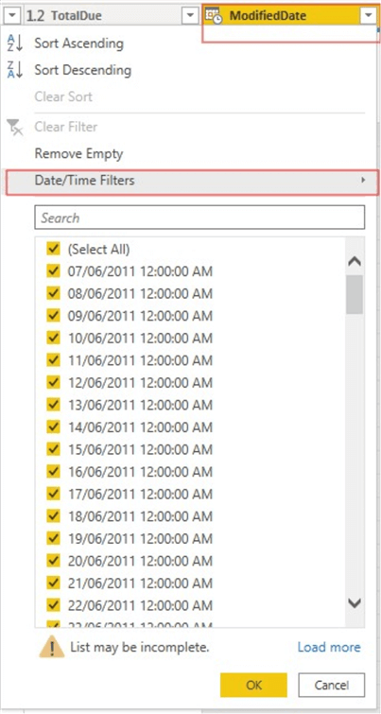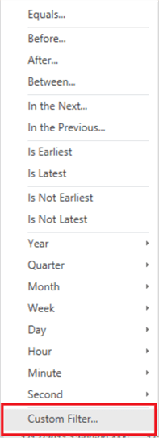

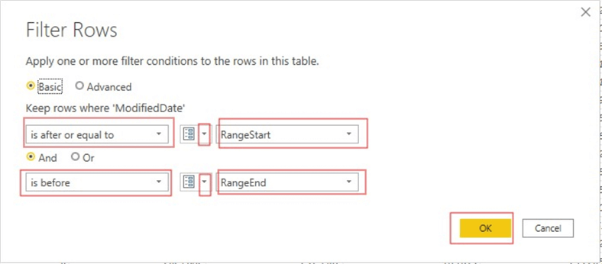

* + - **Activate the incremental refresh on the dataset**

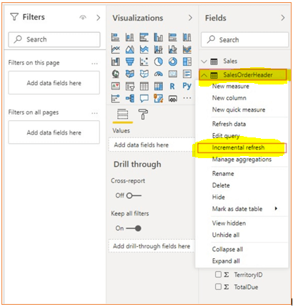

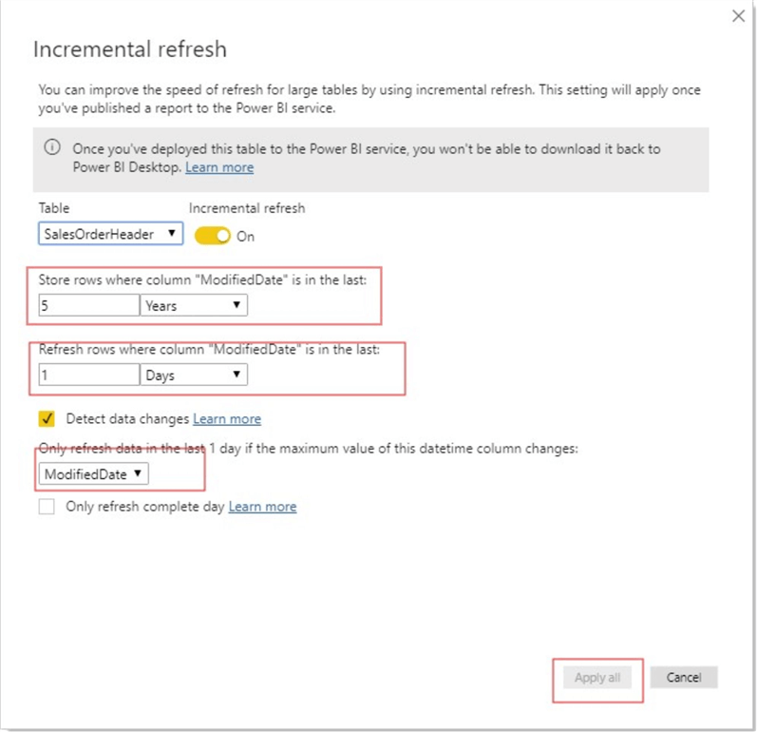

Last how many days data you wants to refresh

History, how much data you want to store

* + - **Publish to Power BI Service schedule dataset based on frequency (date interval)**

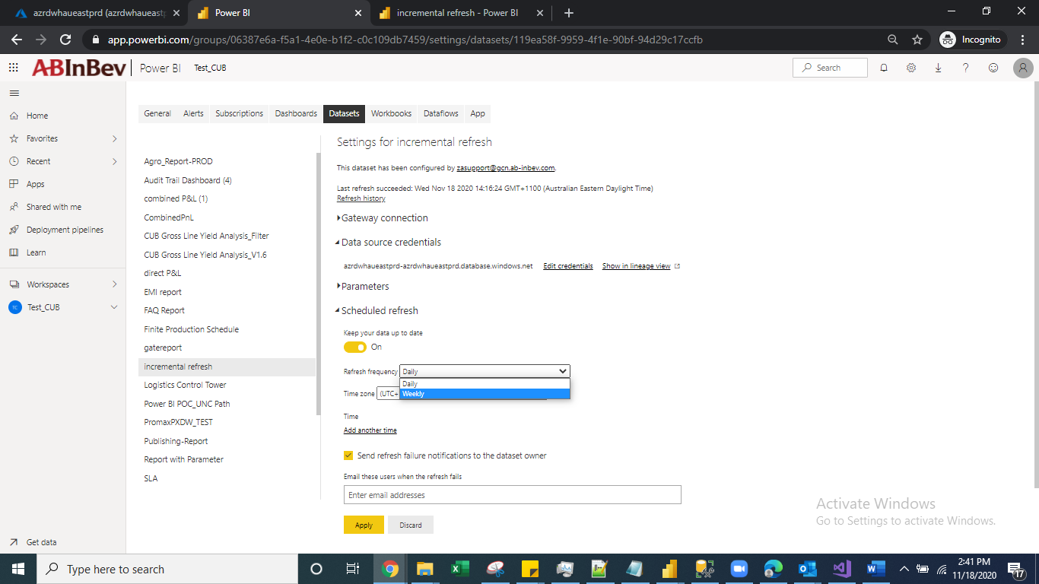

1. **Power BI Alert:**

* When business Status, volume, number, figures, margin have changed, alert will play vital to inform to users.
* Dashboards in Power BI service configured to send alerts to users when the underlying data changes to meet limit conditions set on gauge, KPI, and card visualizations.
* Each visualization can have multiple alerts.
* **Click eclipse**
* **Manage alert**

**Type of alert delivery:**

1. Power IB service we will find alert.
2. Email: “Power Automate” Template.

**Power Automate:**

Alert parameters can be send all the users of a dashboard by send emails: using “Power Automate” Template.



**Power Automate:**

Create workflows in a simple, drag-and-drop interface, included with an Office 365 subscription.

After logging into Flow, click on Templates in the toolbar and type ‘Power BI’ into the search bar.

|  |  |
| --- | --- |
| This is alert | Power Automation |

**Power Automation:**

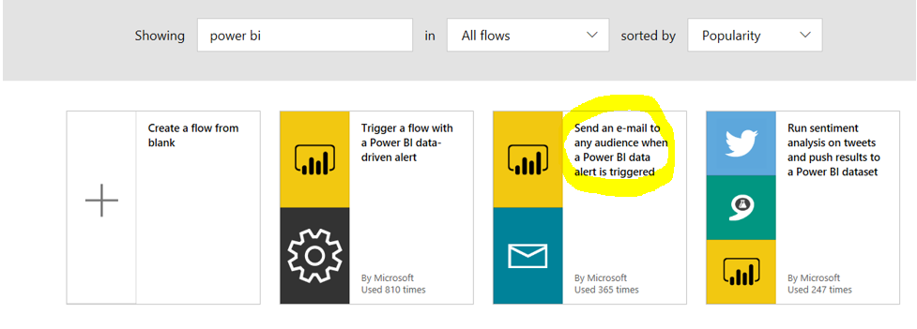

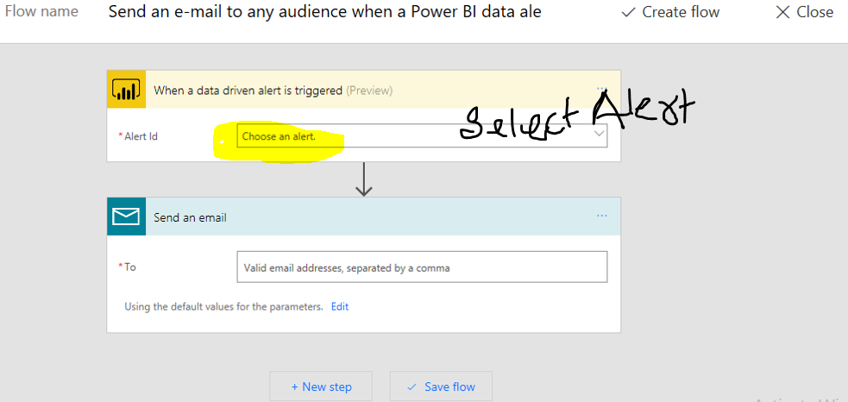

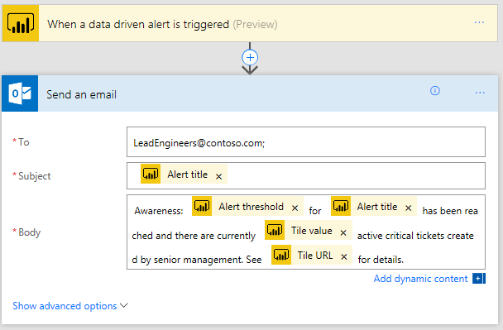

1. **Total sales till date from Jan – YTD, MTD, QTD**

* YTD Sum of Sales = TOTALYTD ([Sum of Sales],’Calendar'[Date])
* QTD Sum of Sales = TOTALQTD ([Sum of Sales],’Calendar'[Date])
* MTD Sum of Sales = TOTALMTD ([Sum of Sales],’Calendar'[Date])
* CALCULATE(SUM[AMOUNT], DATESYTD [dates]))
* CALCULATE(SUM[AMOUNT], DATESYTD [dates],’03/31’)) // financial year or calendar year

1. **Data sources used**
   * **SQL server**
   * **Azure DWH / Azure Synapse**
   * **Share point: using Power BI Web connector**

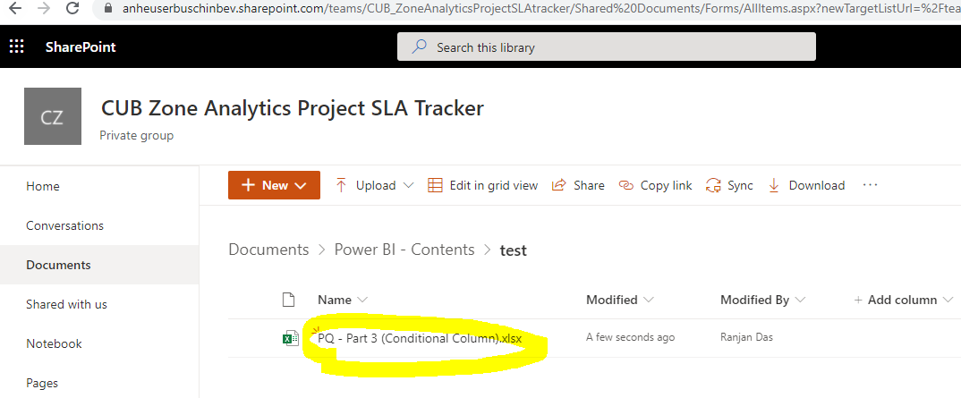

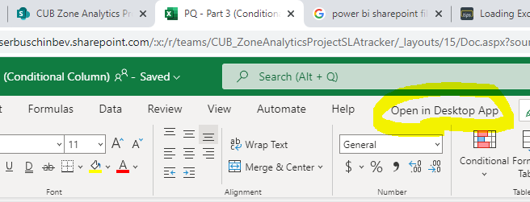

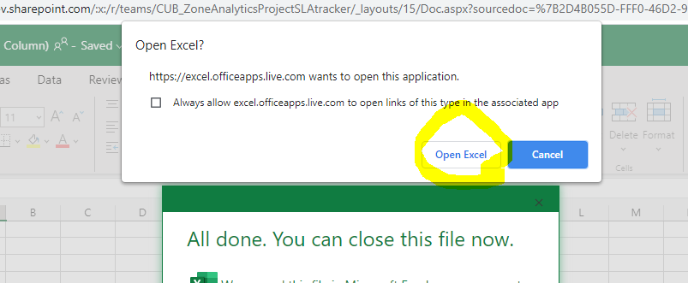

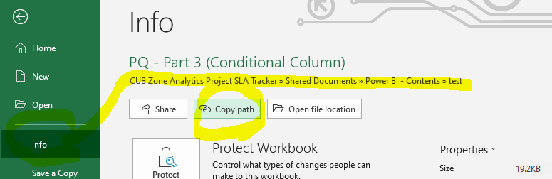

* + **O-Data (SAP cloud IBP)**

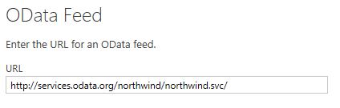

* + **Microsoft exchange**

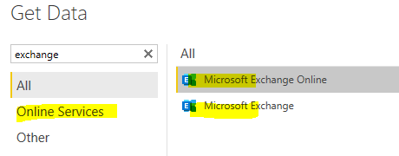

* + **Web connector**

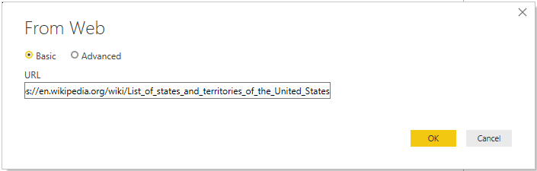

* + **Oracle database**

SERVER/DATABASE

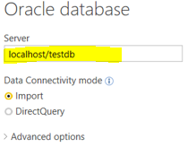

* + **Share point / One Drive**

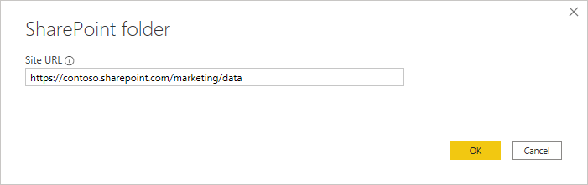

* + **Excel / CSV**
  + **Hadoop / Hive database**

> Install Cloudera “**hive connector ODBC driver”**

> create DSN server (Host, Port, Database) > Direct Query

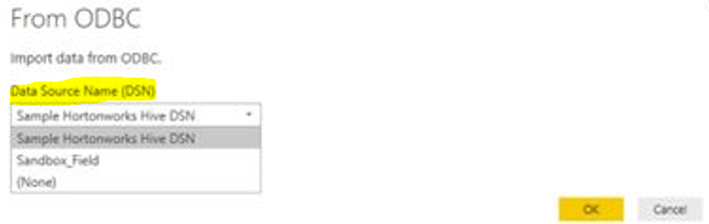

* + **AAS Tabular model**
  + **Azure Streaming Analytics data - Live**

*Push Dataset* - With a push dataset, data is pushed into the Power BI service. When the dataset is created, the Power BI service automatically creates a new database in the service to store the data. Since there is an underlying database that continues to store the data as it comes in, reports can be created with the data.

***Streaming Dataset*** - With a streaming dataset, data is also pushed into the Power BI service, with an difference: Power BI only stores the data into a temporary cache, **which quickly expires in time window of one hour**.

***PubNub Dataset* -** No data is stored by the Power BI service. Call is made from the **web client directly – with SDK.** There is no underlying database in Power BI.

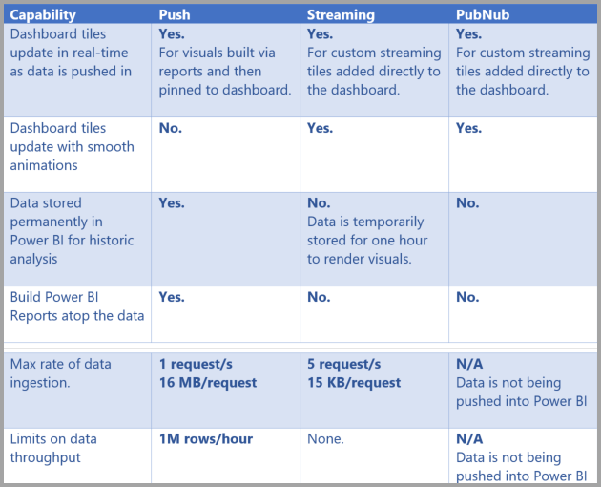 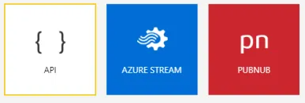

* + **Blob Storage**

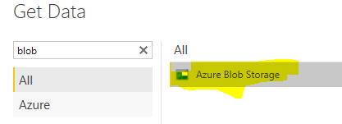

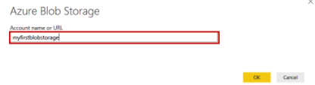

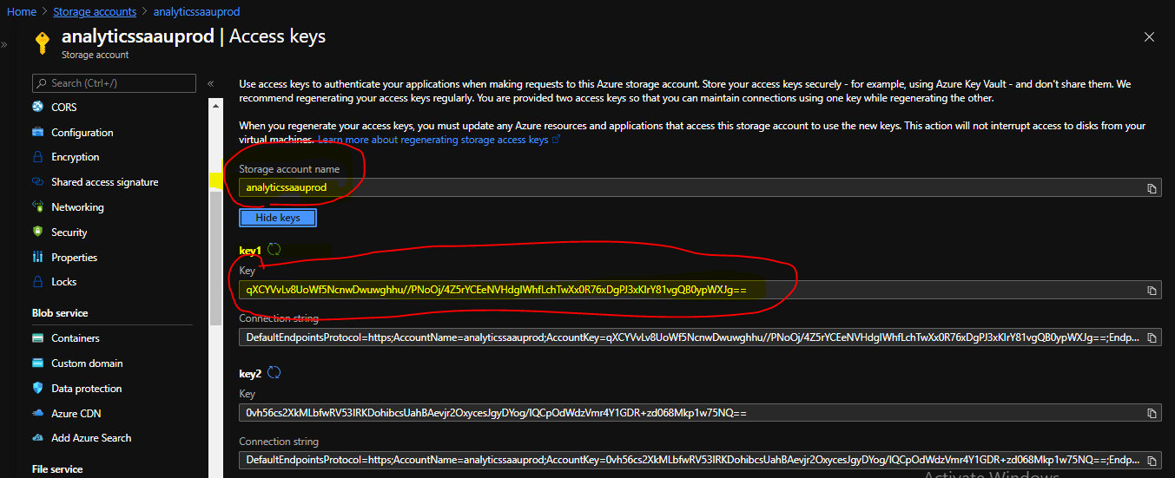

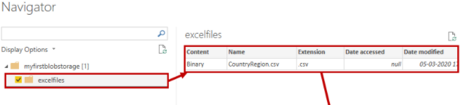

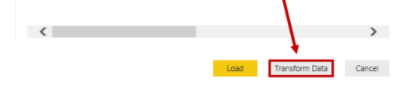

1. **M Query**
   * The **M** stands for data **Mash-up**, as power query is all about connecting to various different data sources and “Mashing” them up.
   * M code is the language behind the scenes of power query. When you create a data transformation in the power query editor UI, its writing the corresponding M code for the query. If i have apply any transformation on data so will be write code in M Query.
   * **M** is a functional language which means it is primarily written with functions that are called to evaluate and return results. **M** code comes with a very large library of predefined functions available and user define functions as well.

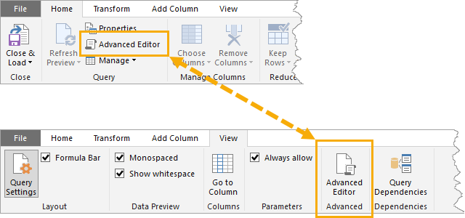

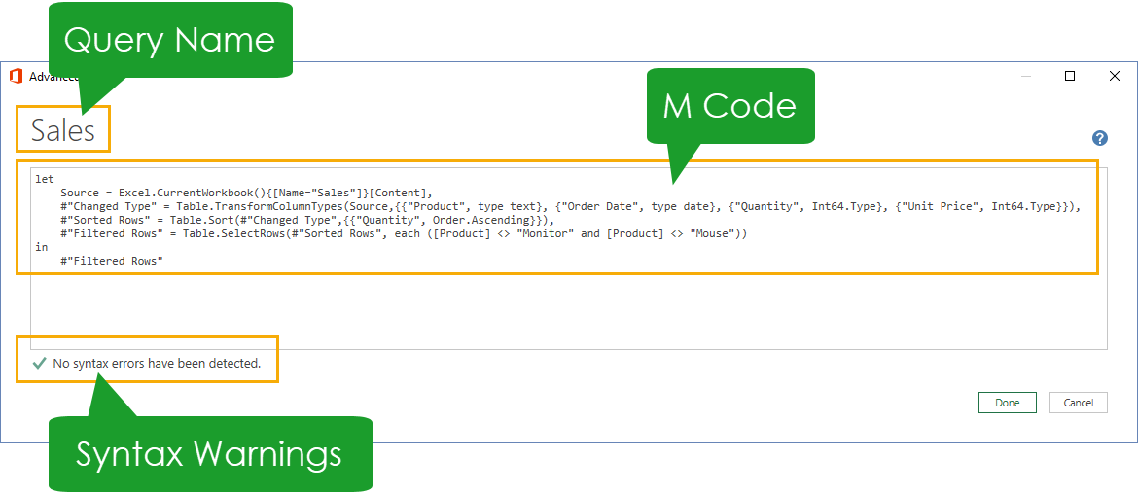

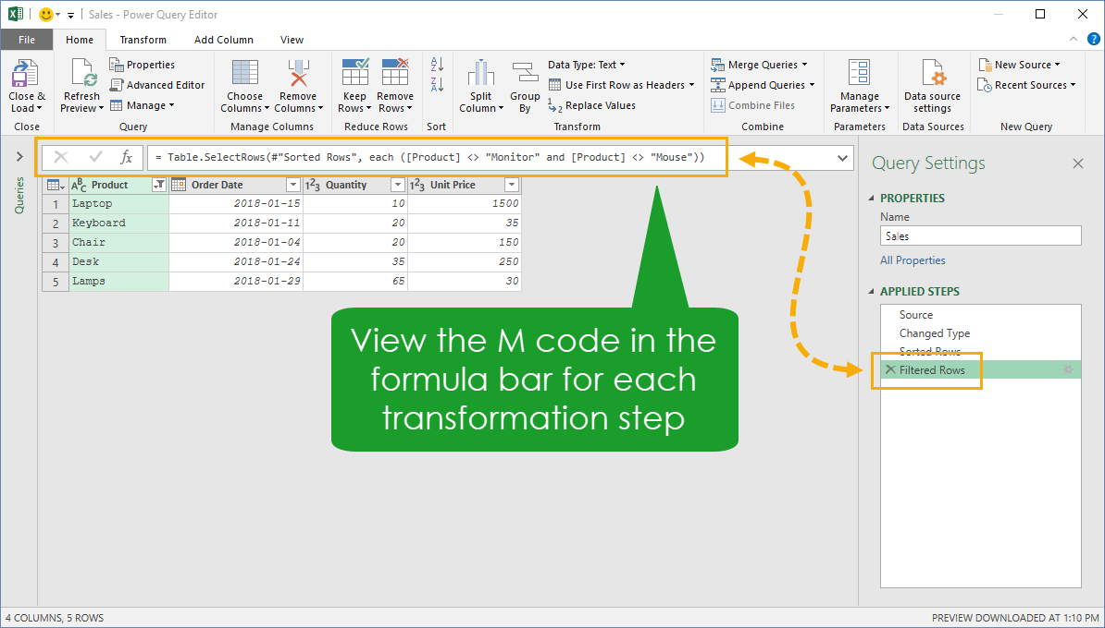

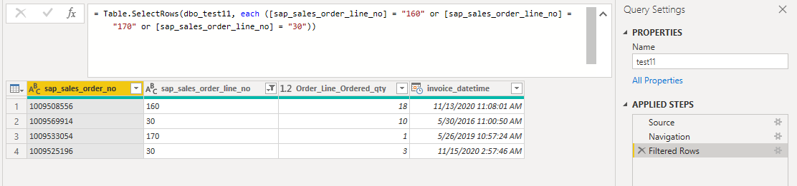

1. **Object level (Table, Column) security - Power BI.**

* Create role in Power BI desktop

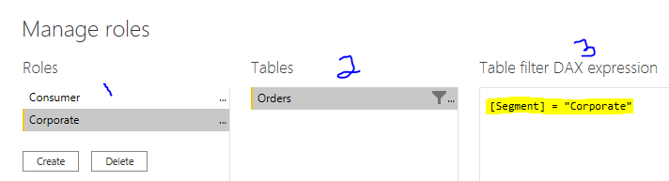

* Open Tabular Editor (Power BI Desktop model will automatically show in tabular model when both open)
  1. Select the **Role**.
  2. Open the **Table Permissions**.
  3. Change Object Level Security is available for the Role **(Default/None/Read).**
  4. Save the model and close tabular editor.

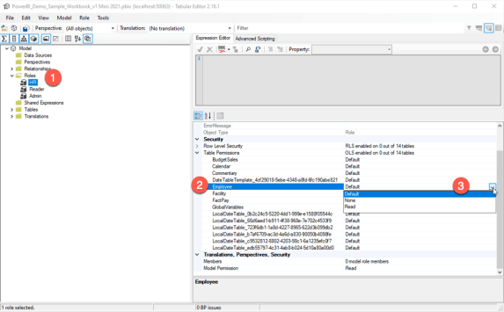

* Publish to Power BI report.
* Add users into Roles

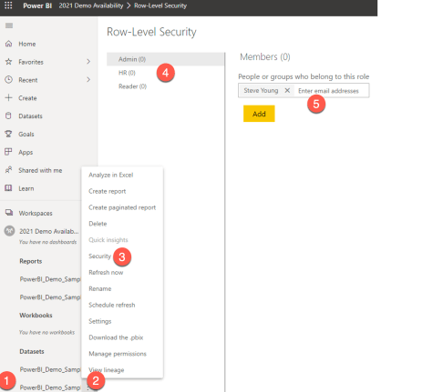

1. **RLS – Row Level Security**

**Create Role**: Create simple visual >> Modelling >> Manager Role >> Click on Create Role >> Select Tables >> Click on ... dot >> Add filter >> Customer Key >> [Customer key] = "Value", in place of Value replace with customer ID like below ex:

DAX Filter Expression ([Customer key] = "B53813" && [Customer key] = "C45450" && [Customer key] = "O49904")

**Power BI Service Configuration**: Save and publish the report into Power BI >> PBI service >> go to Dataset of report > click on Security > add email ids> save

1. Select the **Modeling** tab, and then Click on **Manage Roles**

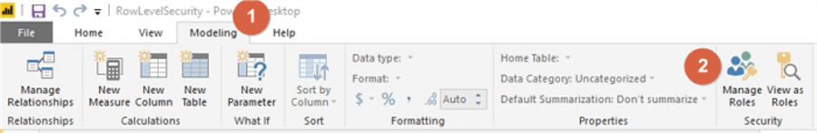

1. **Create Role and Name all the roles**

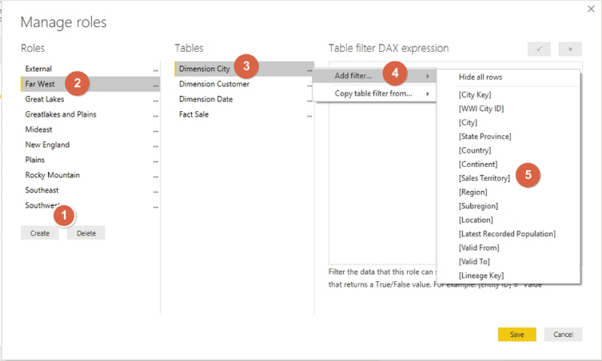

1. **Apply filter in table**

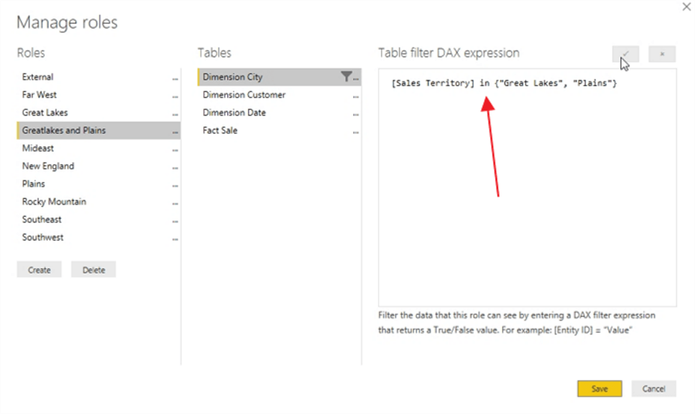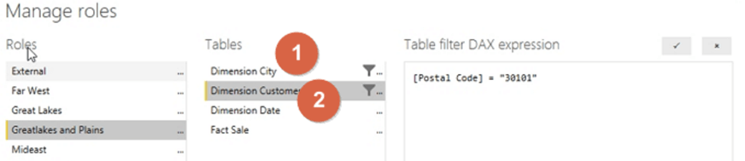

1. Clicking the **View as Roles** button opens the view as roles selection window.

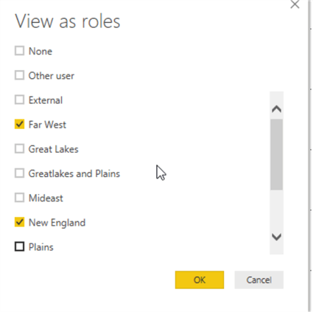

1. **Publish report and apply RLS security**

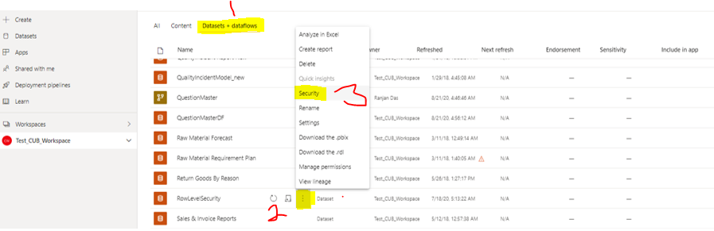

1. **Add email Ids into respective Roles**

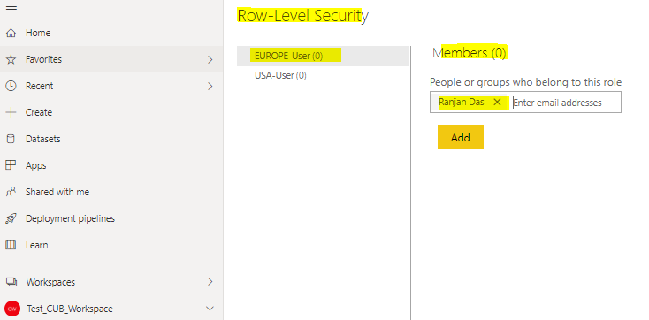

**Test roles**

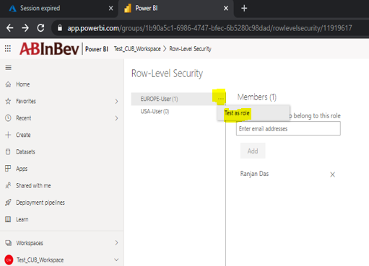

1. **Dynamic row level security (RLS) in power BI**

Dynamic RLS is possible in Power BI using DAX UserName() or **UserPrincipalName()** function.

**Why dynamic row level security?**

limitation of static row level security. Static row level security is simple to implement, however,

* If you have thousands of roles, for example, if you want to create a **payroll report**, in a company with ten thousand users.
* If you have bunch of users and **some user having access to multiple departments**, its difficulty to handle with static RLS.

**Sales Rep Table**: has information of sales representatives

**Transaction Table**: data is sales transactions

Obviously, each sales transaction handled by a sales rep.

UserName() : domain\username (gcn\rdas)

UserPrincipalName() : username@domain.com ([rdas@gcn.ab-inbev.com](mailto:rdas@gcn.ab-inbev.com))

<https://www.youtube.com/watch?v=iMfkj_xgYYc>

<https://www.youtube.com/watch?v=zDTsz5y4Nmc>

**Step1**

Create **User table** join with transaction table

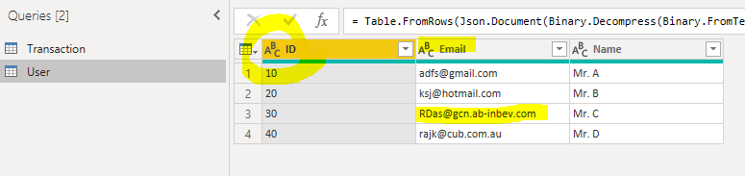

**Step2**

**Join** between tables.

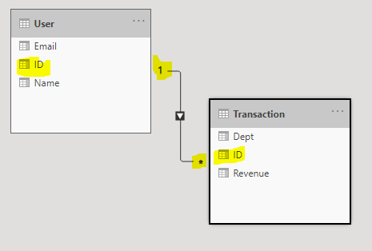

**Step3**

Create report or use existing report.

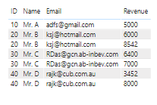

**Step4**

Create Role apply filter with expression email = userprincipalname()

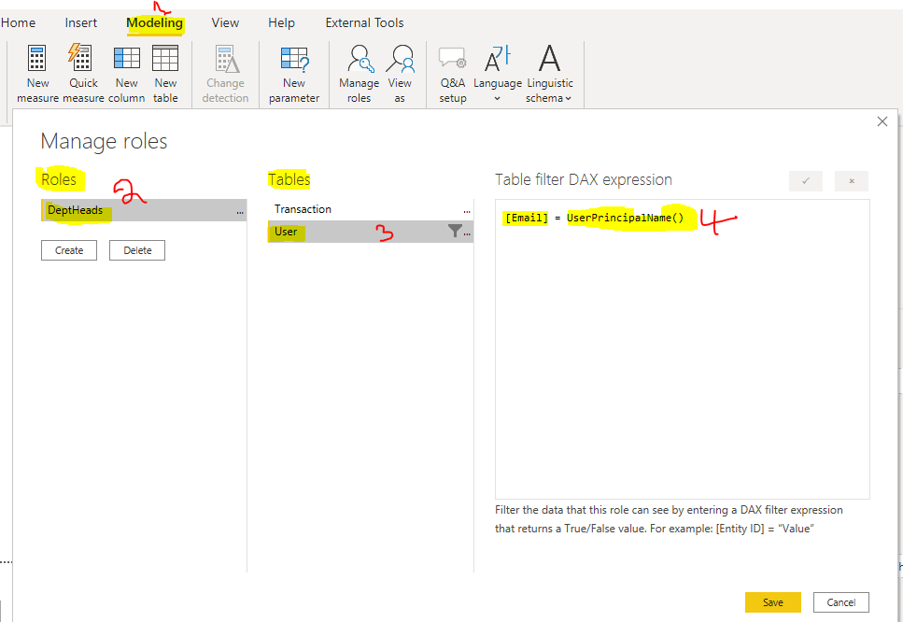

When user will access this report, this filer will filter data accordingly to user email ID.

**Step5**

Publish report service

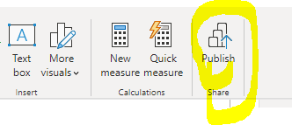

**Step6**

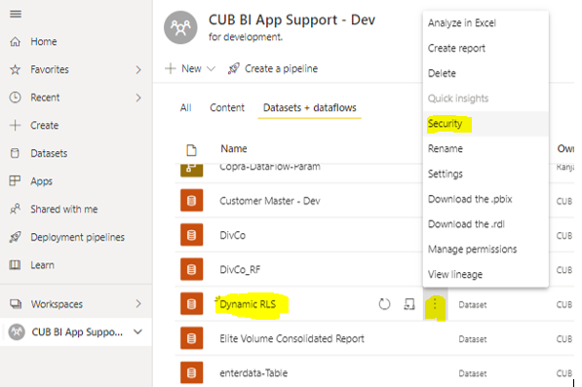

**Step7**

**Testing newly created Role**

Add user email or group id into

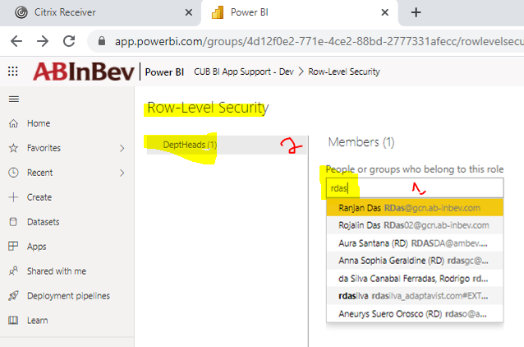

**Login as user (rdas) and view Test as role**

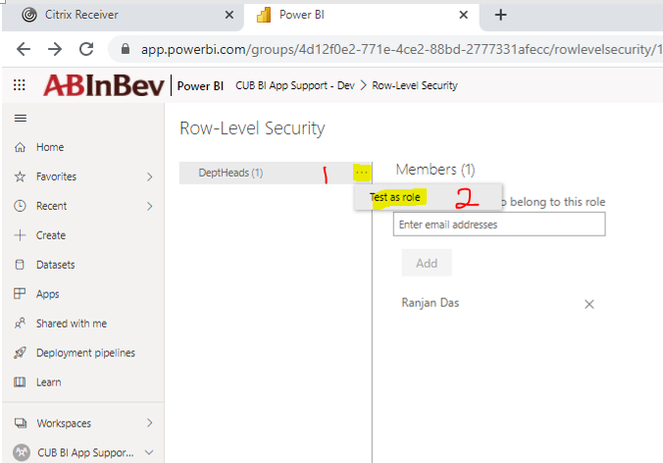

**Result**

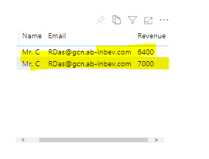

1. **Tabular Model RLS**

Below is way how to provide row level security in tabular model in **SSMS** and **Visual studio**.

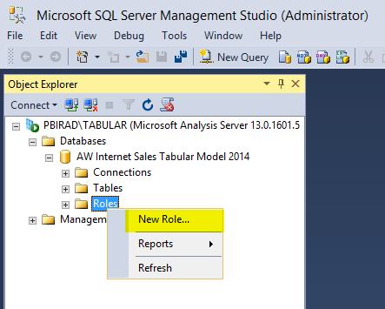

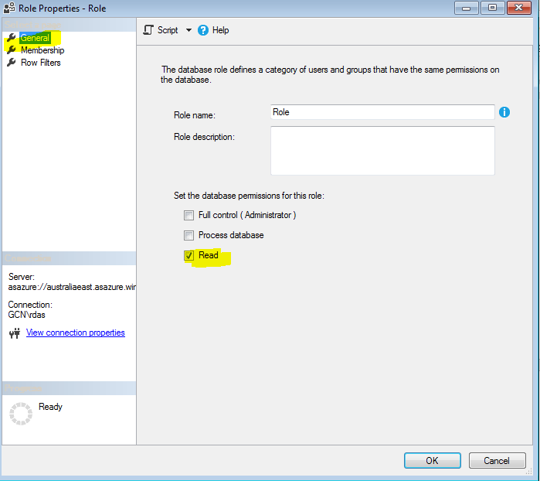

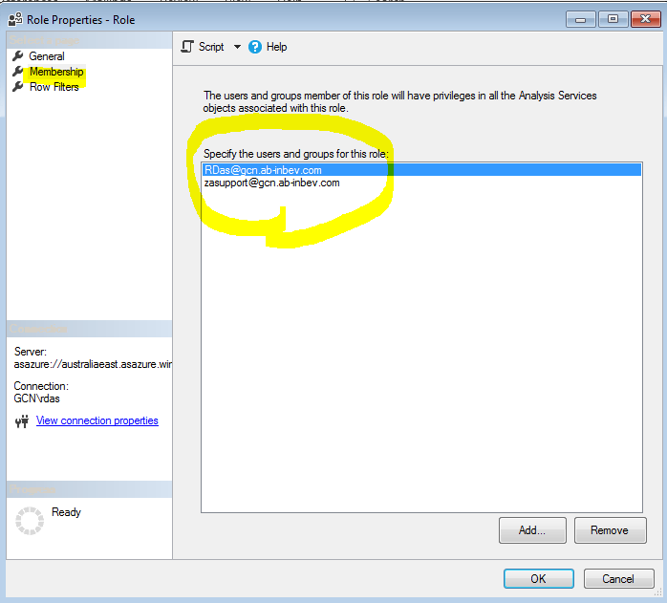

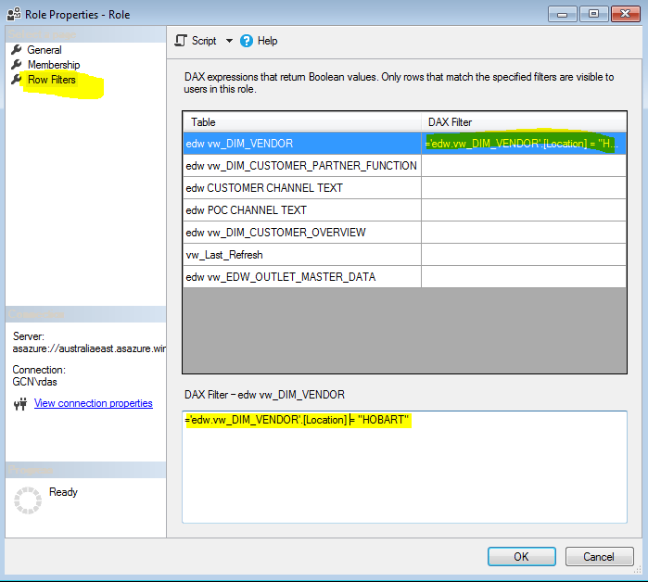

1. **SSAS Prospective.**

**Hide Table or Column by Prospective** Perspectives are **not as a security mechanism**, but as a tool for providing a better user experience.

Create Prospective to select required tables, columns

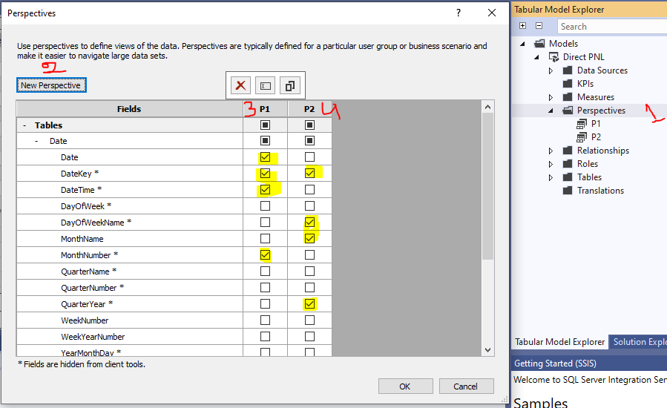

Testing of Prospective from drop down.

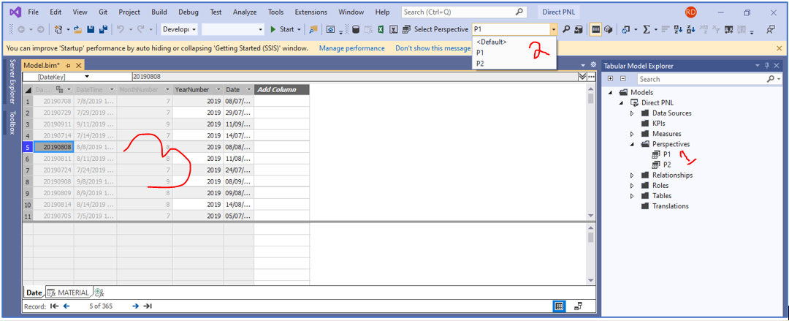

1. **SSAS (Object Level Security) Hide Table or Column by Role.**

Create Role then > select the object which need to exclude

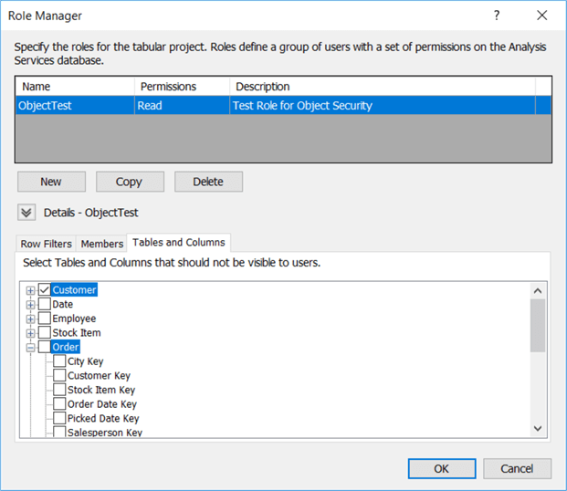

1. **Composite Model**

A report can seamlessly include data connections from more than one Direct Query or import data connection combination:

* Direct Query <> Direct Query.
* Direct Query <> Import.
* DWH <> Transactional data.

**Limitations of composite model:**

* Currently, **incremental refresh** support to (SQL, Oracle, and Teradata) data sources only.
* **SAP HANA, SAP BW, SSAS, AAS, PBI datasets,** **Cubes** (Live Connect) - can't be used with composite models.
* Multi-dimensional sources by Direct Query can't connect to another Direct Query source.
* Multi-dimensional sources can't combine with import data.

Each table in a composite model has a storage mode that indicates whether the table is based on Direct Query or import. The storage mode can be viewed and modified in the **Property** pane. To display the storage mode, right-click a table in the **Fields** list, and then select **Properties**. The following image shows the storage mode for the **Sales Targets** table.

|  |  |  |
| --- | --- | --- |
| Tooltip displaying the storage mode |  |  |

1. **Power BI Free License**
   1. You can connect and import data from over 70 cloud-based and on-premises sources
   2. The same rich visualizations and filters from Power BI Pro
   3. Auto-detect that finds and creates data relationships between tables and formats
   4. Export your reports to CSV, Microsoft Excel, Microsoft PowerPoint and PDF
   5. Python support
   6. Save, upload and publish your reports to the Web and the full Power BI service
   7. Storage limit of 10 GB per user
2. **Embedded license**
3. **Embedding for your customers** lets you embed dashboards and reports for users who don't have a Power BI account. This type of embedding is also known as *Power BI Embedded*.
4. *Power BI Embedded* is a **Microsoft Azure** service that lets independent software vendors (ISVs) and developers quickly embed visuals, reports, and dashboards into an application. This embedding is done through a capacity-based, hourly metered model.
5. Embedding allows you to extend the Power BI service. This type of embedding requires application's user’s sign into the Power BI service to view the content. Once someone signs in, they only have access to dashboards and reports that they own or that someone shared with them in the Power BI service.
6. Embedding customers embed dashboards and reports for users who don't have a Power BI account. This type of embedding is known as Power BI Embedded.
7. Embed dashboards and reports to users who don't have a Power BI account. Embedding content, this gives access to the latest Power BI features.
8. Organization embedding examples include internal applications such as SharePoint Online, Microsoft Teams (Admin rights), and Microsoft Dynamics & web apps.
9. With Power BI Embedded, customers don't need to know anything about Power BI.
10. Integrate a report into an application using the Power BI .NET SDK with the Power BI JavaScript API.

## **Pricing details**

The total cost of Power BI Embedded depends on the node type chosen and the number of nodes deployed. Node types differ based on number of V-cores and RAM as outlined in the table below:

|  |  |  |  |  |
| --- | --- | --- | --- | --- |
| **NODE TYPE** | **VIRTUAL CORES** | **MEMORY** | **FRONTEND / BACKEND CORES** | **PRICE** |
| A1 | 1 | 3 GB RAM | 0.5 / 0.5 | $1.0081/hour |
| A2 | 2 | 5 GB RAM | 1-Jan | $2.0081/hour |
| A3 | 4 | 10 GB RAM | 2-Feb | $4.0242/hour |
| A4 | 8 | 25 GB RAM | 4-Apr | $8.0565/hour |
| A5 | 16 | 50 GB RAM | 8-Aug | $16.121/hour |
| A6 | 32 | 100 GB RAM | 16 / 16 | $32.2506/hour |

1. **How to create a Summary Table by using SUMMARIZE Function in Power BI DAX.**

How to use the SUMMARIZE Function to Summarize data Group By specific Columns in Power BI DAX

The **SUMMARIZE** Function in Power BI DAX is used to create a Summary Table from the Fact Table, and data will be Grouped by the specific columns from the related Dimension Tables or from the same Fact Table.

SalesSummary =

SUMMARIZE(FactSales, DimRegion[Region_Name], FactSales[MonthN],

"SumSales", SUMX(FactSales,FactSales[TotalSales]),

"SumUnits",  SUM(FactSales[Units_Sold]))

1. **How to solve many to many relationship**

* The many-to-many relationship causes tons of issues, and that is why it is called a weak relationship too. Most of the time, it can be resolved with creating a **shared dimension** and creating one-to-many relationships from the shared dimension to the fact tables. AVOID this type of relationship in your model.
* Solved by
  + **Bridge Table**: between 2 tables we are putting FACT table, which is nothing but bridge table, after that we can use **DAX Crossfilter(), for** Bi-Directional relationship
  + **Bi-Direction** relationship will help to solve this problem.
  + **Shared dimension**
  + **Fact less Fact Table** Using this Bridge Table, you can then relate the two dimension tables together via the Bridge Table, whereby the "trail" from Channel to Sales is One-to-Many / Many-to-One:-

**OLD Many to Many Relationship and how it solved.**

<https://www.youtube.com/watch?v=onR_sLhbZ4w&pbjreload=101>

Roll No 1 doing course C1, C2

Roll No 2 doing course C2, C2

C-id C1 Done by Roll No 1 and Roll No 2

C-id C2 Done by Roll No 1 and Roll No 2

No Reduction of tables

Composite key is Roll No and C-id

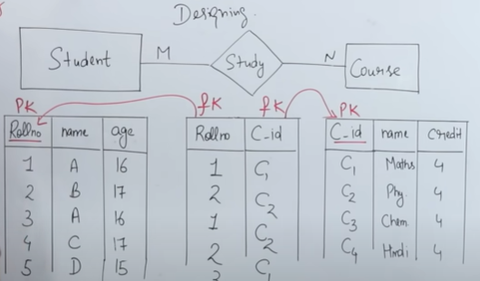

**Power BI Many to Many relationship**

Below is problem of when wants to analyze how many products purchased by customer then we can see only total of product is repeating, it’s because of Many to Many relationships.

**One product having Many customers** and **One Customer having many products**.

**Problem statements.**

Problem is if we want to get **count of products** for customers then problem

Problem is if we want to get **count of customers** for products then problem

This problem is because of Many to Many relationships.

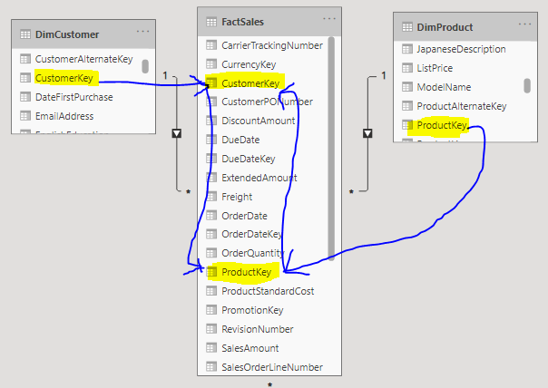

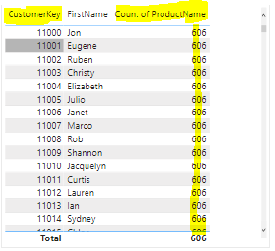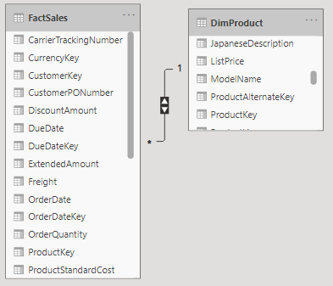**Solutions 1: Bidirectional CROSSFITER relationship**

**Solutions 2:**

Using DAX solve this problem because Bi-Directional relationship will down performance.

**Count of Product in Product Dim =**

CALCULATE (COUNT (Product [Product cat Key]), **CROSSFILTER** (‘Fact Sales’ [Product Key], Product [Product Key], Both))

**Count of Product sub cat in Product Dim=**

CALCULATE (COUNT (Product [Product cat key]), **CROSSFILTER** (‘Fact Sales’ [Product Key], Product [Product Key], Both))

**Count of City in Customer Dim=**

CALCULATE (COUNT (Customer [city]), **CROSSFILTER** (‘Fact Sales’ [Customer Key], Customer [Customer Key], Both))

**Solutions 3:**

Bridge table between two table

Many to many relationships between **Inventory and Supplier**. It is many-to many because

A given product can have many Suppliers and A given Supplier can supply many products.

Many-to-many relationships must be resolved, so add a new bridge table called **Item-ordered** to the model.

You now have 2 one-to-many relationships.

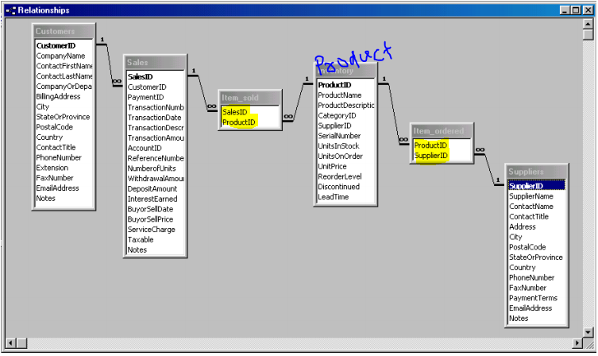

|  |  |
| --- | --- |
| **Product** | **Supplier** |
| P1 | S1 |
| P1 | S2 |
| P1 | S3 |
| P2 | S1 |
| P2 | S2 |
| P3 | S1 |

|  |  |
| --- | --- |
| P1 Product maintained by many supplier (S1, S2, S3)  P2 Product maintained by many supplier (S1, S2)  P3 Product maintained by many supplier (S1) | S1 Supplier maintained many products (P1, P2, P3)  S2 Supplier maintained many products (P1, P2)  S3 Supplier maintained many products (P1) |

1. 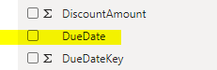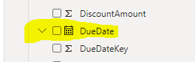**Auto Date hierarchy can hide or show by Time Intelligence Auto date/time check and un-check**

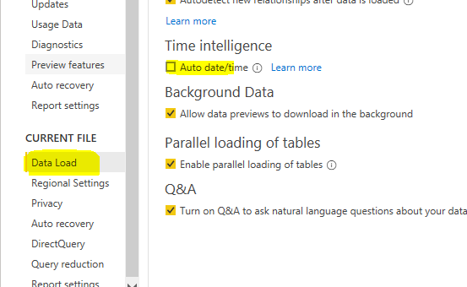

1. **Power BI Dataset refreshed by passing parameters in Power bi service**

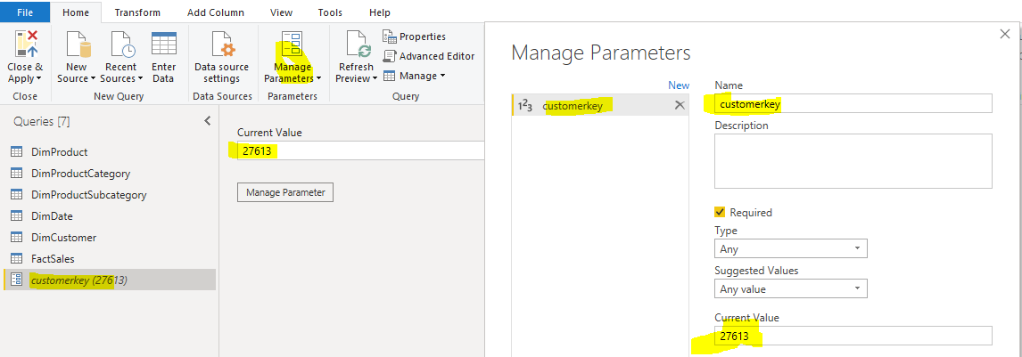Create Parameters in power query

Apply filter with help of newly created parameter.

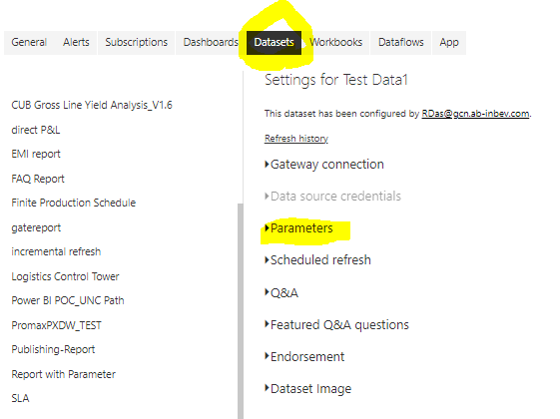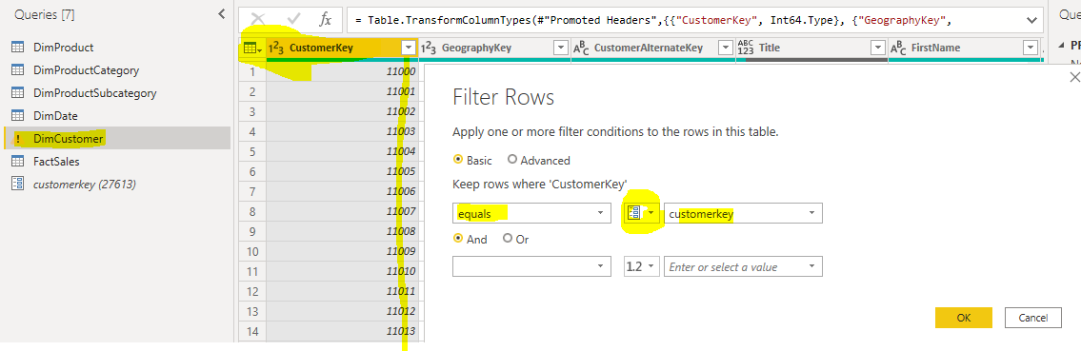To go power bi service then report data set then click on parameters filter parameters as you want.

1. **Tabular model refresh by passing by parameters.**

Write parameter SQL statement in table / query of tabular model when model/table will execute it will ask parameter to enter but in this case @[Order date] is parameter. Then only model will get refresh accordingly entered values **@ [Order date]**

**SELECT * from Sales where [Order Date] = @ [Order date];**

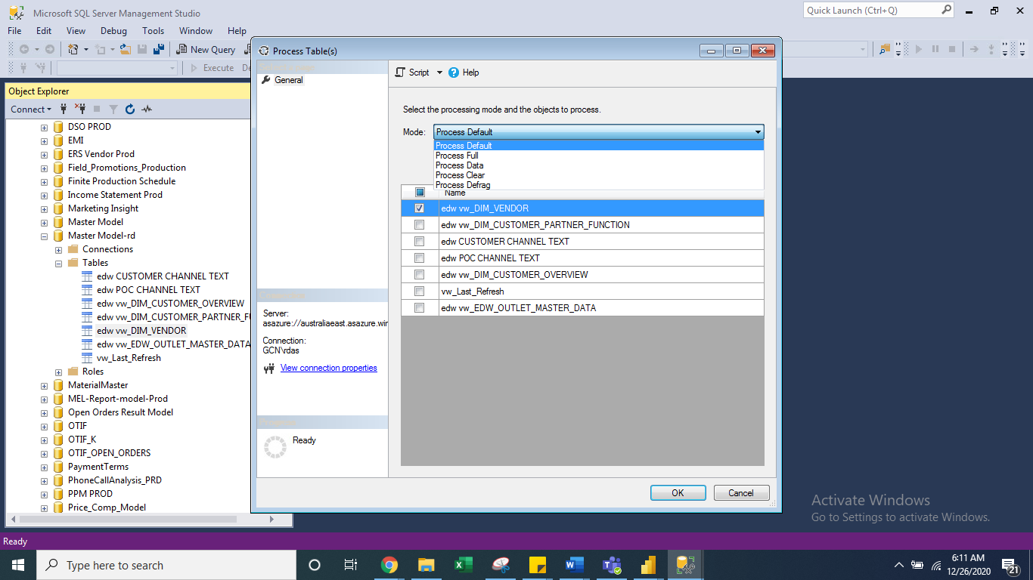

1. 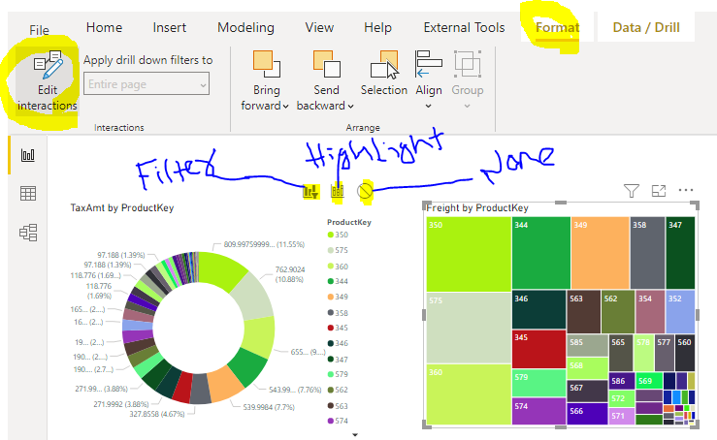**Edit interaction**
2. **In both x and y axis used measure which visual you can used?**

>>Line chart, >>Area chart, >>Line & stacked column, >>Scatter plot, >>whisker chart

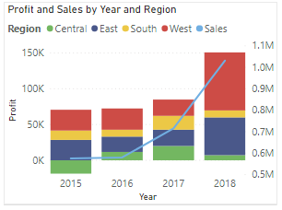

* Line and Clustered column

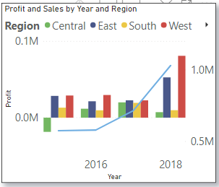

1. **Generate function?**

Returns a table with the Cartesian product between 2 tables **GENERATE(<table1>, <table2>)**

Create 2 tables then create another table with GENERATE FUNCTION.

1. **How to implement same security as applied tabular model into power bi reports or dashboard?**

* 1st collect list of users from Tabular model “Role” example if they have RLS to “Finance”.
* 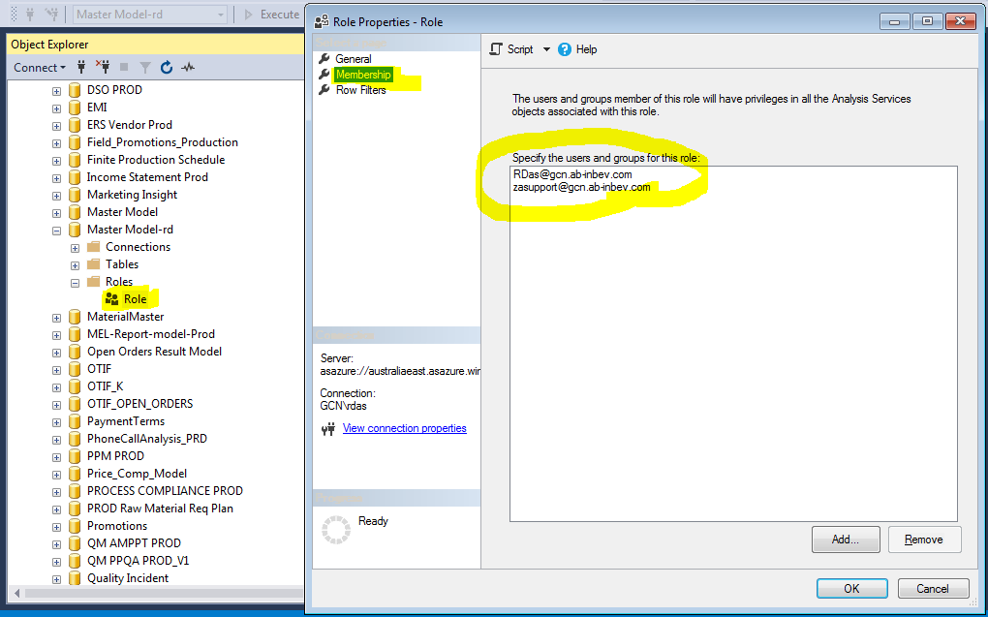Then go to power bi desktop create Role “Finance” with DAX filter expression dept = “Finance”.
* Go to Power BI service and Open Dataset RLS add users which you have collect into Role “Finance”

1. **Content pack**

Content Packs in [Power BI](https://intellipaat.com/blog/tutorial/power-bi-tutorial/) are used to share various Power BI objects like datasets, reports, and dashboards within the business organization. You can share the necessary data with a single employee or with a number of departments in the organization. It provides a central location wherein the organization can create and maintain their report in a standardized format and share it. **Dashboards, Reports, Excel Workbooks, Datasets.**

**Types of content pack:**

* + 1. **Organizational content pack**: Organizational Content Pack is a way to share your Power BI content with others easily. an organizational content pack can be shared with your entire organization, or specific group of people.
    2. **Service content pack** (Google Analytics, Git hub, Microsoft, SAP Dynamics, Facebook, salesforce etc.)

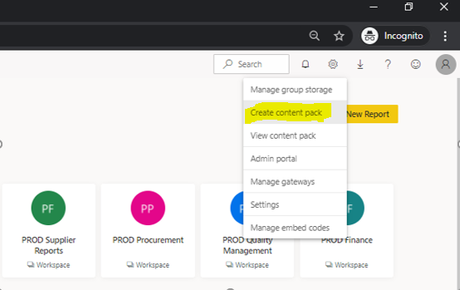**Create Content pack**

After Publish, your content pack will be ready to use.

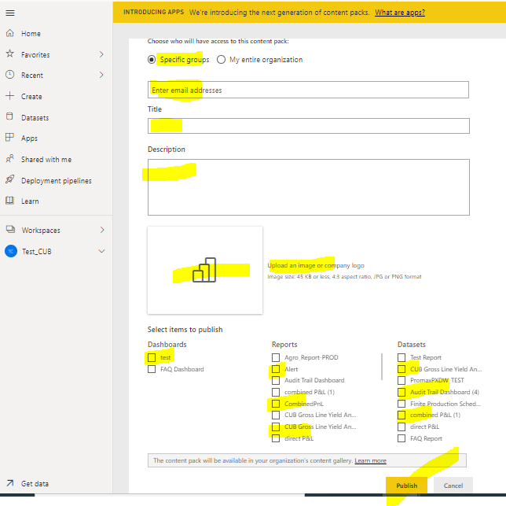

**How to Consume content pack**

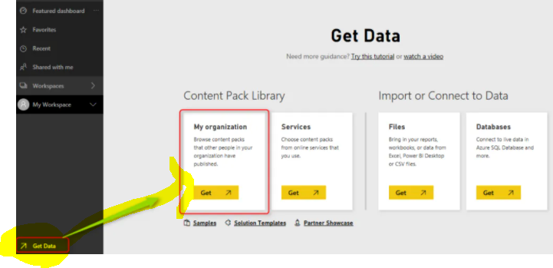Now if someone from your organization (or the group of people that this content pack is published for them) logs into Power BI, and go through Get Data section;

Users will see content packs shared with them they can select the one that they want to install. then click on **Get It Now**.

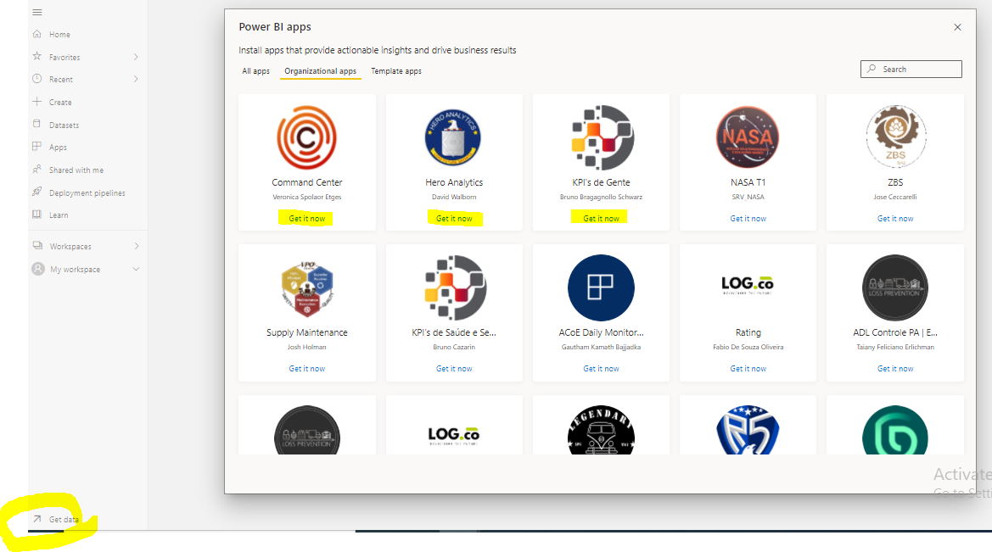

User will be able to view dashboards, reports, and data sets with full interactive reporting features of Power BI;

Content Packs are easy way of sharing content, but their benefits isn’t just this easiness. It is more because of other great features. In brief explanation, features are;

1. **How to handles nulls in power BI**

**Using DAX:**

Using ISBLANK () function or It can be replaced values with 0 in Power query editor.

**Using Power Query:**

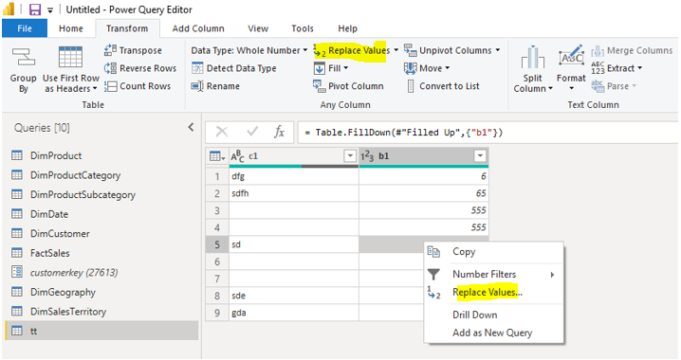To replace or fill the null

**Now you can select replace or fill**

* If you select fill, then the values in the field are either copied from up to down or vice-versa. (Preferred when the data of that column not highly important).
* 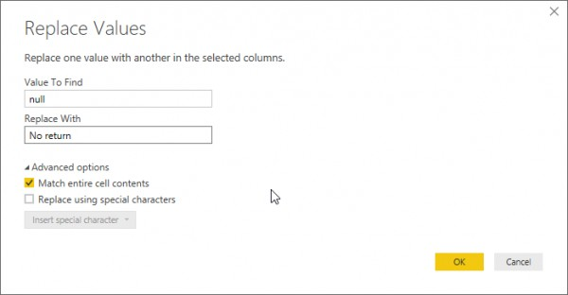If you select replace then the following dialog box opens.

1. **Workspace**

**Upgraded workspace:**

When creating workspace automatically (Default) creating an "upgraded workspace" and Specifying O365 group is optional.

At time of creation of "Upgraded workspace" allowed to Specify “O365 group” file storage location. Also allowed mention “O 365 group” post "Upgraded workspace" creation.

**Classic workspace:**

When you create a classic workspace, you're automatically creating an underlying, associated O365 group.



1. **Different Excel BI add-in**

* Power Query: It helps in finding, editing and loading external data.
* Power Pivot: It’s mainly used for data modeling and analysis.
* Power View: It is used to design visual and interactively reports.
* Power Map: It helps to display insights on 3D Map.

1. **Drill through functionality and how to configure it**

**Target report prepare** - Add drill-through field here as target report lets say “Year” column.

Same year column we need pass from child report, When click year column from child report it will prompt drill though.

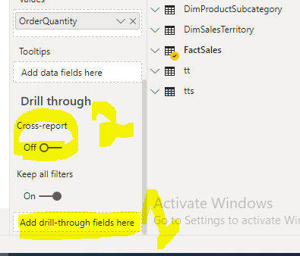 **Cross-report**: Allow this report as a target page for other pages.

1. Drill Through button

|  |  |
| --- | --- |
| Source report | Target detailed report |
|  |  |

NOTE: Select one data point from source visual then click on Drill bottom it will navigate to target report.

1. **How implement top N (Citi/Person)**

Solution 1: Rank of Product by amount >> Apply in to filter

= RANKX (ALL (Sales [Product Key]), [amount],, DESC)

Then apply top N on top of this column

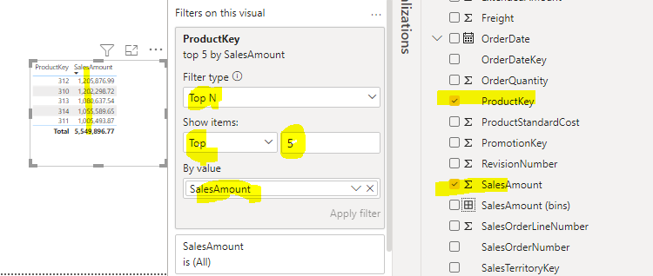Solution 2:

1. **Types of processing in AAS model / DB**

| **Mode** | **Description** |
| --- | --- |
| Process Default | Detects the process state of database objects & performs processing necessary to deliver unprocessed or partially processed objects to a fully processed state. Data for empty tables and partitions is loaded; hierarchies, calculated columns, and relationships are built or rebuilt (recalculated). |
| Process Full | Processes a database and all the objects that it contains. When Process Full is run for an object that has already been processed, Analysis Services drops all data in the object, and then processes the object. This kind of processing is required when a structural change has been made to an object. This option requires the most resources. |
| Process Clear | Removes all data from database objects. |
| Process Recalc | Updates all of the calculated columns, indexes, relationships and hierarchies for a model.  Runs a Process Data on the table or partition, followed by a Process Recalc. |

1. **What is AAS partition and how to do partitions**

Partitioning data is a standard SQL Server administration practice. Partitions enable independent administration of different slices of data. When a SQL Server Analysis Services (SSAS) tabular data model is developed and processed, data is read from the source system and loaded into the tabular data model configured in In-Memory processing mode. Every time the model is processed, the entire data set may not require re-processing. Only certain slices of data containing changes may require re-processing which can be achieved by partitioning data into logical slices. In this tip we would look at how to partition tables in Tabular SSAS.

PNLT2018: SELECT * FROM [edw].[VW_DIRECT_PNL] WHERE DATE_KEY='2018'

PNLT2019: SELECT * FROM [edw].[VW_DIRECT_PNL] WHERE DATE_KEY='2019'

PNLT2020: SELECT * FROM [edw].[VW_DIRECT_PNL] WHERE DATE_KEY='2020'

1. **Forecasting and analysis**

* **Forecasting** using exponential smoothing to automatically detect seasonality in the data to provide **forecast** results from a series of data.
* **Exponential smoothing**: Is a time series forecasting method.



* **How?** Using chat as visual to represent time diminution like year, month along with Sale/Quantity
  + Define forecast length: 6 or 12 Need to define, how many months/years we need to forecast.
  + Ignore Last month’s (which will not come under forecast)
  + Seasonality: Which is in case of months need to provide 12 but incase of Days need to define 365
  + Forecasting period will show 3 lines, **upper bound, lower bound, forecast line**

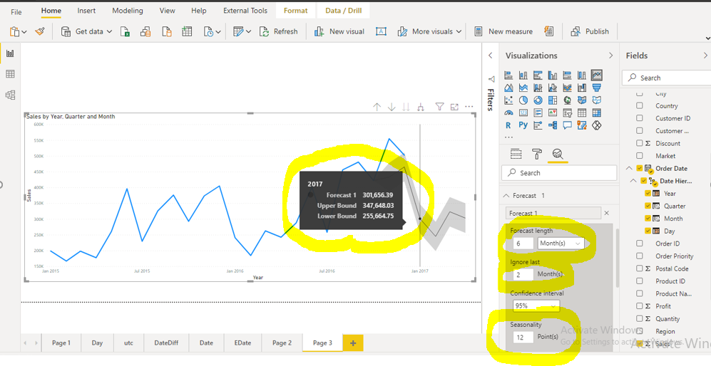

1. **Sync Slicer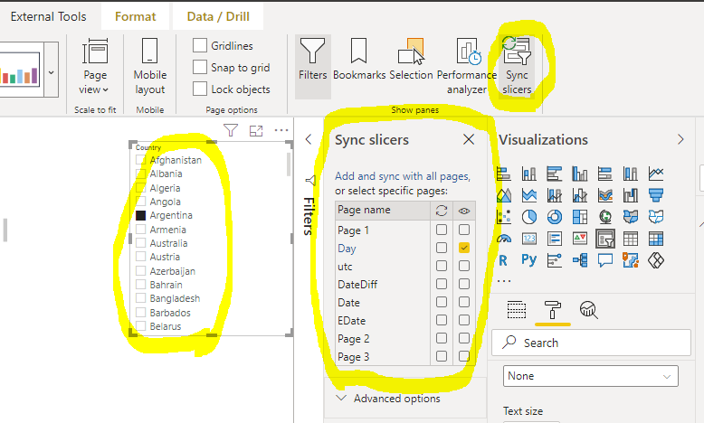 : Sync** **slicers** use on other pages of report on the **Power BI** Desktop View menu, select **Sync slicers**. Same slicer value we need to apply other pages. Particular slicer which page you wants to apply that can define here.
2. **Power BI components**

|  |  |
| --- | --- |
| 1. Power BI Desktop, 2. Power view, 3. Power pivot, 4. Power Query, 5. Power Apps, 6. Power Maps, 7. Power BI service 8. Report Server | 1. Excel plugin BI 2. Power Q&A 3. Gateway 4. Dashboard 5. Reports 6. Visuals 7. Tiles 8. Relationship |

1. **Building Blocks in Power BI**

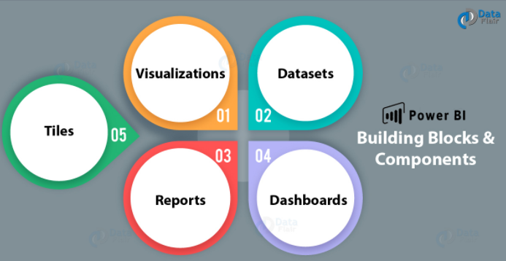

1. **Type of Merge join & Cardinality**

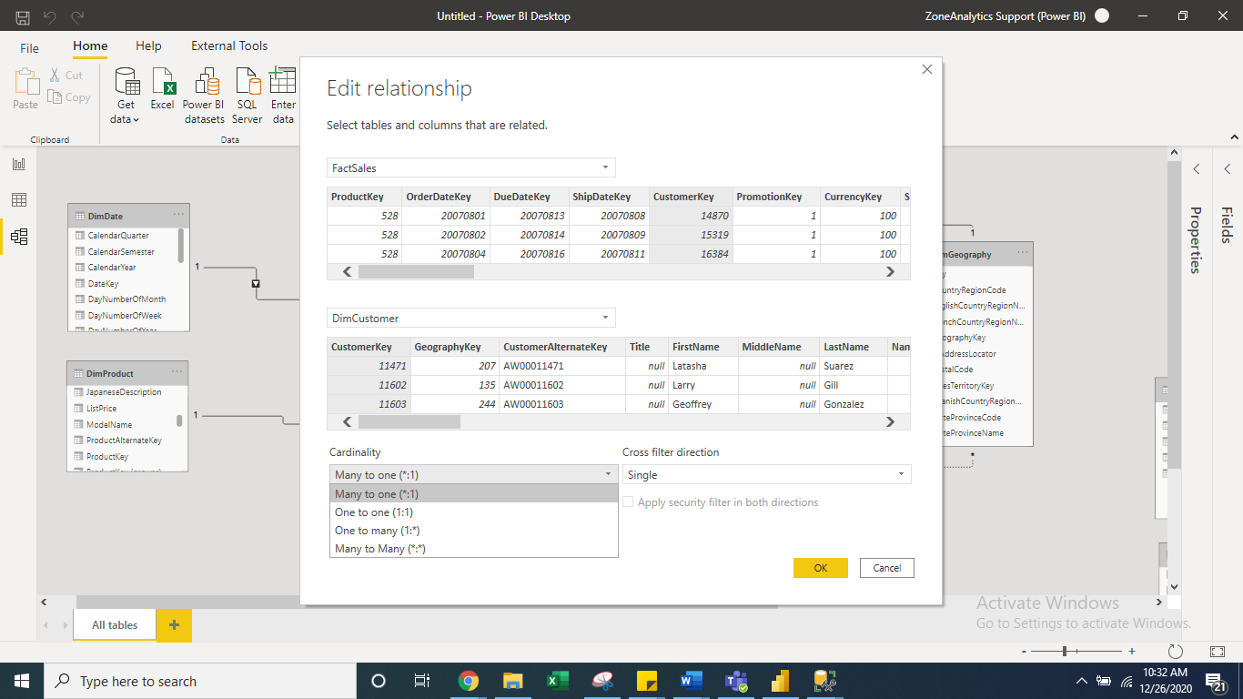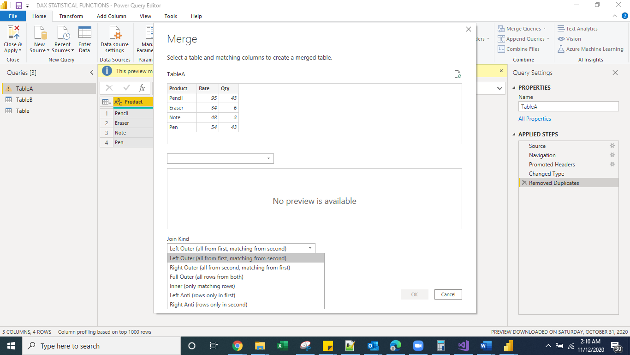

1. **Power BI report shares in web**

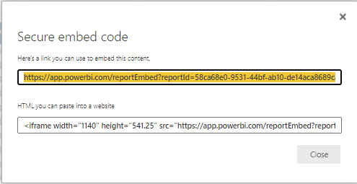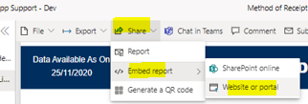

1. **Without relation tables in power bi Model**
   1. Sorting tables
   2. Parameter tables
   3. Ad-hoc visual table
   4. Summarized table & Calculated table
   5. Tables with Calculated columns & calculated measures
   6. Static values like guideline, rules, policies, flags, symbols etc.
   7. Placeholder for metrics in the user interface.
   8. Rows and columns hidden but all metrics are visible in reports.
2. 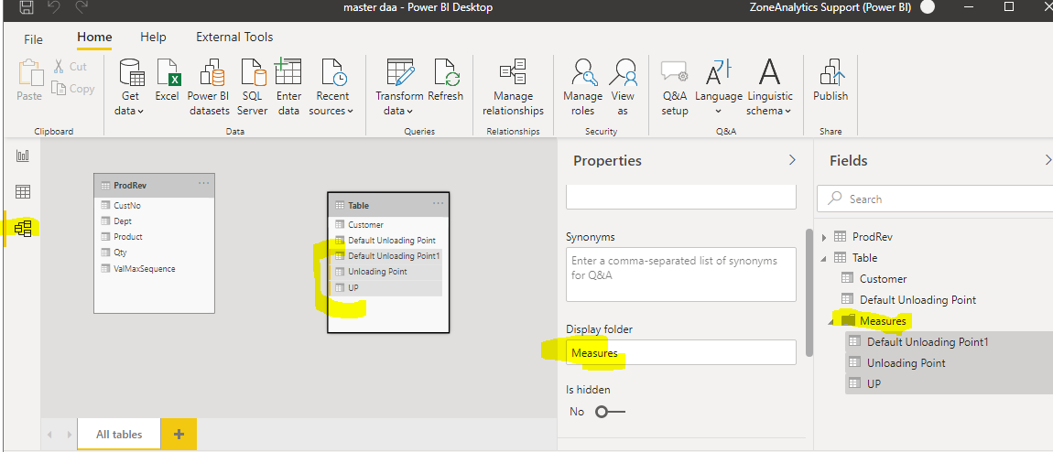**Create folder in power bi desktop**
3. **Time Intelligence functions:** 
   1. Paralleled period:

Previous Year Sales = CALCULATE (SUM (Sales [Sales]), **PARALLELPERIOD** (Sales [Due Date], -1, YEAR))

* 1. Same period last year:

SPLY = CALCULATE(SUM(Sales[Freight]), **SAMEPERIODLASTYEAR**(Sales[Due Date]))

* 1. Previous day

= CALCULATE(SUM(InternetSales_USD[SalesAmount_USD]), **PREVIOUSDAY**('DateTime'[DateKey]))

* 1. Previous month

= CALCULATE(SUM(InternetSales_USD[SalesAmount_USD]), **PREVIOUSMONTH**('DateTime'[DateKey]))

* 1. Previous year

= CALCULATE(SUM(InternetSales_USD[SalesAmount_USD]), **PREVIOUSYEAR**('DateTime'[DateKey]))

1. **Proper Case (** **ord)**

Convert to lower case, capital, each word to capital like below, lenth

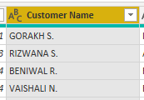

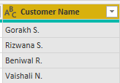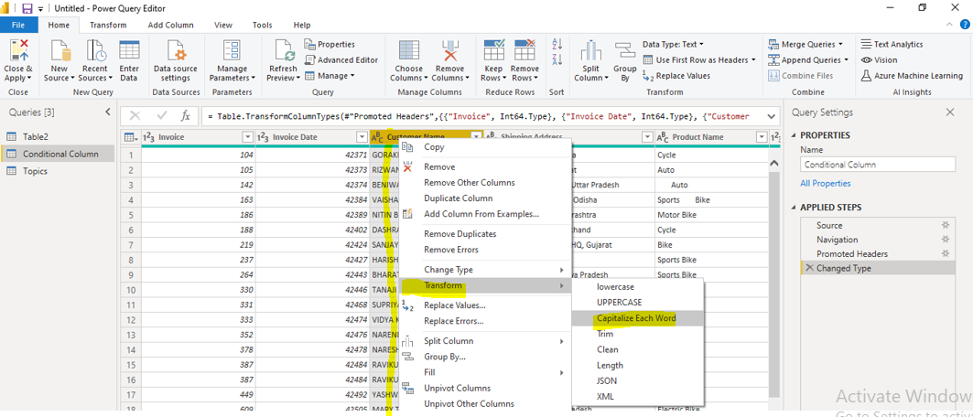

1. **Horizontal slicer same like chicklet slicer**

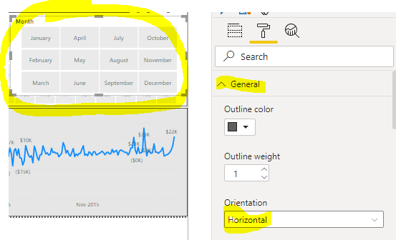

1. **Append: Dynamically add records when you add files into folder.**

**Step-1: Select folder path**

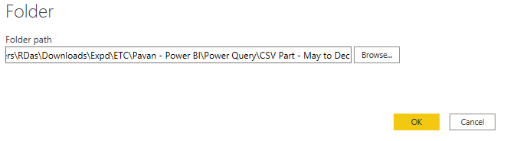

**Step-2: click on Transform**

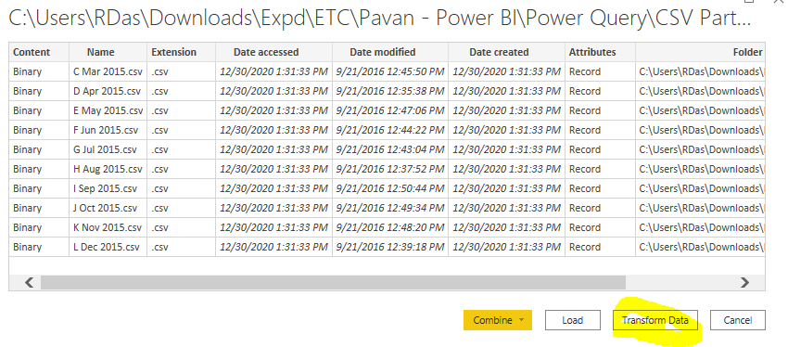

**Step-3:** Select **Content, Name, Extension** and then **Remove Other Columns**

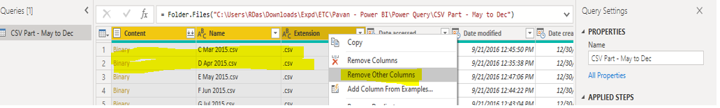

**Step-4: Write custom column with below code**

|  |  |
| --- | --- |
|  |  |

**Step-5: Expand custom columns**

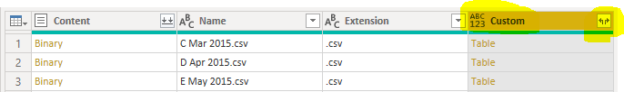

**Step-6: Finally, you will see data**

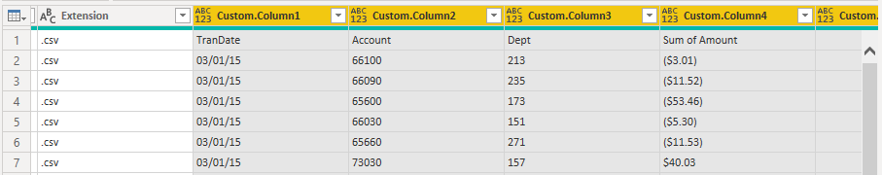

1. 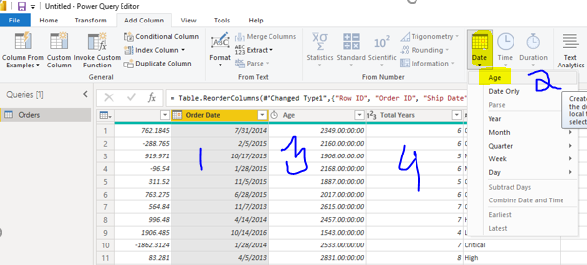**How to calculate Age in Power BI**
2. **Difference between ALL, ALL EXCEPT**

**ALL**

* All function is used when you want to fetch data from the entire table or columns without filter restriction.
* Remove all the external filter contexts applied on the visual.
* Returns all the rows in a table, or all the values in a column, ignoring any filters that might have been applied. This function is useful for clearing filters and creating calculations on all the rows in a table.
* Example when we need to calculate percentage, difference from total. Actual divided by total.

**ALL EXCEPT**

* Remove all the external filter contexts applied on the visual except the filters that have been applied columns.
* Removes all context filters in the table but only keep/ retain/ hold that specified column.
* This will behave as same like ALL but only when specified column get into dataset then it will not remove context filter, it will accept all context filters.

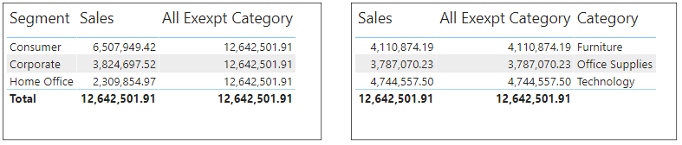

**ALL SELECTED**

* ALLSELECTED returns all the visible values in the filter context.
* 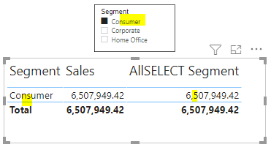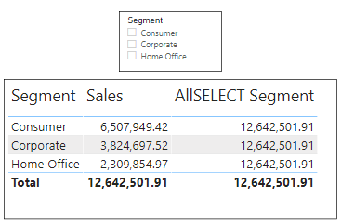Removes context filters from columns and rows in the current query, while retaining all other context filters or explicit filters. The ALLSELECTED function gets the context that represents all rows and columns in the query, while keeping explicit filters and contexts other than row and column filters.
* = ALLSELECTED (<columnName1>, <columnName2>... ) -- Single or Multiple Columns
* = ALLSELECTED (<table>) -- Table
* = ALLSELECTED ( ) -- No Input

1. **MAX, MAXA and MAXX**

|  |  |  |
| --- | --- | --- |
| **MAX** | **MAXA** | **MAXX** |
| Returns the largest numeric value in a column, or between two scalar expressions.  = MAX(Orders [Sales]) | Returns the largest value in a column. **Logical, blanks, Dates** counted.  = MAXA(Orders[Order Date])  = MAXA(Orders[Sales]) | Evaluates an expression for each row of a table and returns the largest numeric value.  = MAXX(Orders, Orders[Sales]) |

1. **CALENDER & CALENDERAUTO**

|  |  |
| --- | --- |
| **CALENDER** | **CALENDERAUTO** |
| Returns a table with a single column named “Date” that contains a contiguous set of dates. The range of dates is from the specified start date to the specified end date, inclusive of those two dates.  =CALENDAR (DATE (2005, 1, 1), DATE (2015, 12, 31))  =CALENDAR (MINX (Sales, [Date]), MAXX (Forecast, [Date])) | Returns a table with a single column named “Date” that contains a contiguous set of dates. The range of dates is calculated automatically based on data in the model.  In this example, the Min Date and Max Date in the data model are July 1, 2010 and June 30, 20  =CALENDARAUTO () will return all dates between January 1, 2010 and December 31, 2011. =CALENDARAUTO (3) will return all dates between March 1, 2010 and February 28, 2012. |

1. **YTD**

|  |  |
| --- | --- |
| **TOTALYTD** | **DATESYTD** |
| Returns a table that contains a column of the dates for the year to date, in the current context  = TOTALYTD(SUM(Orders[Sales]),Orders[Order Date]) | Evaluates the year-to-date value of the expression in the current context.  YTDC= CALCULATE(SUM(Orders[Sales]),DATESYTD(Orders[Order Date]))  YTDF= CALCULATE (SUM (Orders [Sales]), DATESYTD(Orders[Order Date].[Date],"12/03/2018")) |

1. **RELATED and RELATEDTABLE**

|  |  |
| --- | --- |
| **RELATED** | **RELATEDTABLE** |
| Returns a related value from another table or (Parent table)  = RELATED([Price])  = [Quantity] * RELATED([Price]) | Evaluates a table expression in a context modified by the given filters  =[Price] * **SUMX(RELATEDTABLE(Sales), [Quantity])** |

1. **Search, Find, Switch**

|  |  |  |
| --- | --- | --- |
| **SEARCH** | **FIND** | Switch |
| Returns the position of the character at which a specific character or text string is first found, reading left to right. Search is case-insensitive and accent sensitive.  = SEARCH("F",Orders[Customer Name],10,1) | Returns the starting position of one text string within another text string.  FIND is case-sensitive.  = FIND("F",Orders[Customer Name],1,1) | Evaluates an expression against a list of values and returns one of multiple possible result expressions.  Like Case statement.  If else statement. |

Day of Week = Switch(Week[Day],1,"Sunday",2,"Monday",3,"Tuesday",4,"Wednessday",5,"Thursday",6,"Friday",7,"Saterday")

1. **Where clause in DAX**

[New Table] = CALCULATETABLE (Sales, FILTER (Sales, Sales[b1] <50))

1. **Comments, share and subscribe**

|  |  |  |
| --- | --- | --- |
|  |  |  |

1. **Method to create dashboard in power BI service**

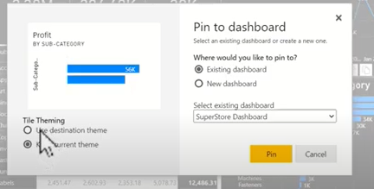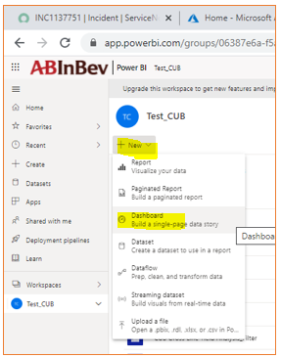

1. **Pin live page to dashboard**

If you click dashboard which you pined as visual then it will redirect to report – it’s a problem of power BI (Dashboard not interactive)

That why we do entire report to pin to dashboard so it will not redirect back to report page.

Pin visual to dashboard - ok

Pin slicer to dashboard - not allowed.

Pin report to dashboard - allow both visual and slicers.

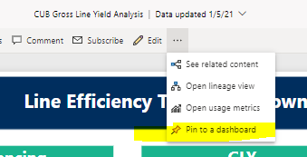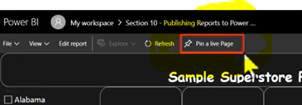

1. **Gateway: How to install and configure**

**Gateway types and uses**

**On-premises Data Gateway (Enterprise mode):**

This version of the on-premises data gateway allows connection with multiple on-premises data sources for more than one user. You can use the data in *Power BI, Azure Analysis Services, Azure Logic Apps, Microsoft Flow, PowerApps,* etc. You can establish direct connections to multiple data sources just by once installing this type of data gateway. This data gateway is recommended for complex scenarios where multiple users need to access multiple data sources.

**On-premises Data Gateway (personal mode):**

The personal mode of on-premises data gateway is used by only one user to connect to different data sources. It is recommended when only one person needs to access the data sources. To create reports and dashboards using Power BI, the user cannot share its access privilege with other users.

* Over organization able to access on-premise enterprise mode gateway.

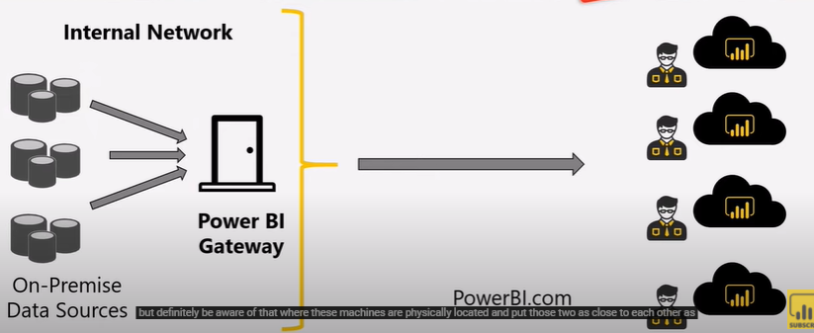

* Install and select enterprise mode

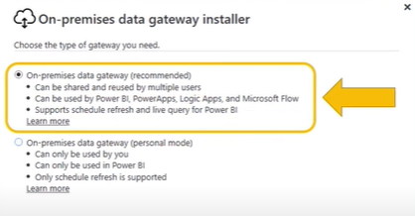

* After installation it will ask enter admin email ID which used in Power BI service.

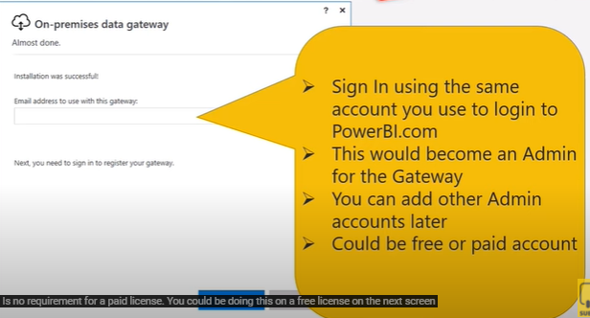

* Enter Gateway name and recovery key

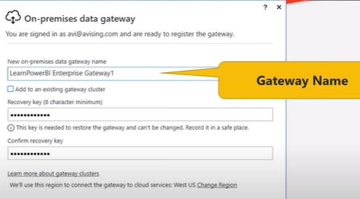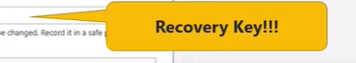

* Gateway setup / installation completed

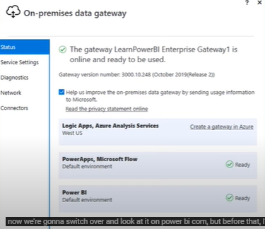

* Click on manage Gateway then Do **Gateway configuration,** Here you can do setup bothfile path and SQL server Database.

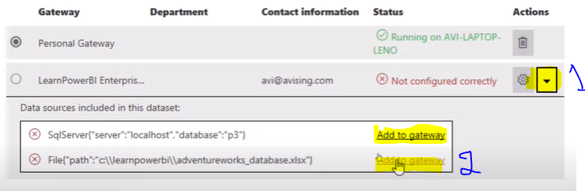

* Give Gateway name, Setup files path, Window username and Password

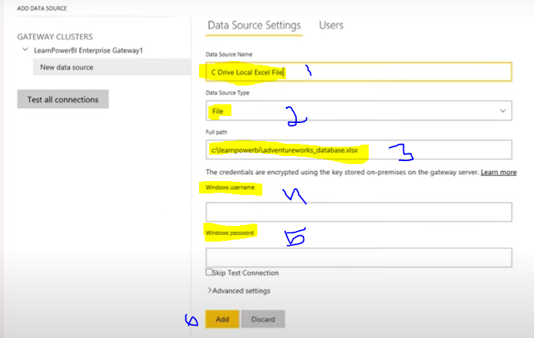

* SQL server Gateway configuration

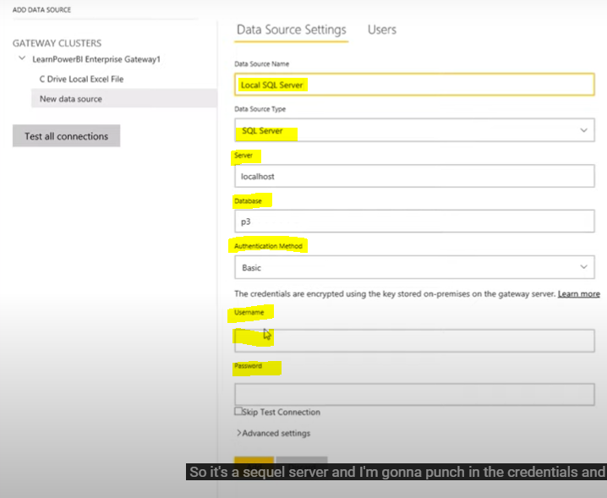

* Now configuration done successful and looking good.

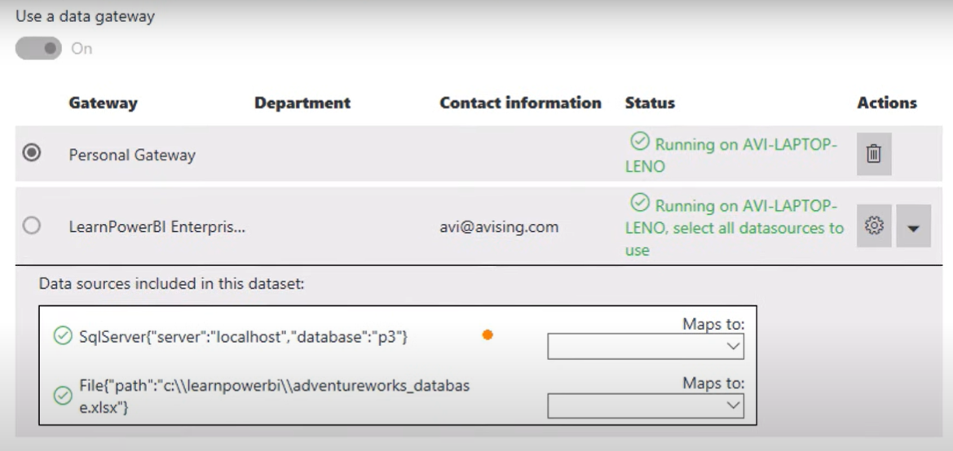

* Map to Gateway

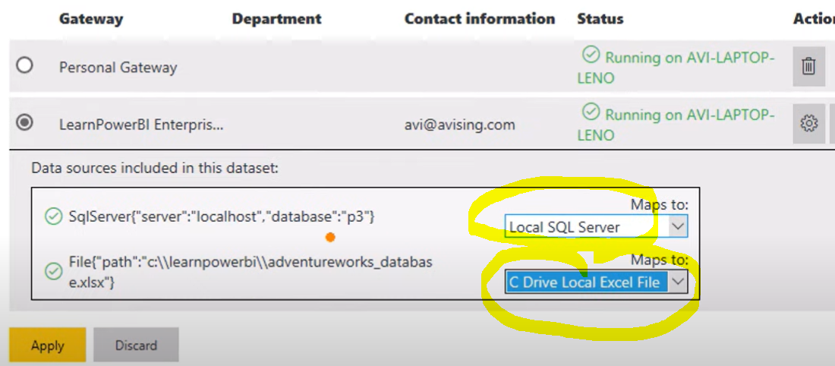

* Provide access to On-premises data gateway

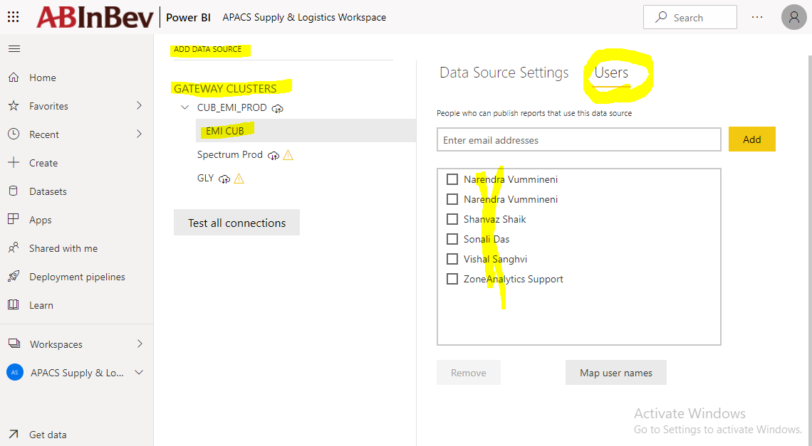

1. **Why to use DIVID () FUNCTION whereas / symbol is there**
   * The DIVIDE function was designed to automatically handle division by zero cases.
   * Performs division and returns alternate result or BLANK() on division by 0.
2. **What If Parameters**
   * Its used for Future prediction analysis. It will generate separate parameter table.
   * When wants forecast analysis on given data if like this happen then what. Future prediction analysis.
   * We can define percentage **starting and ending point with increment point** which will helps to analysis what if parameters.
   * It will created only through Power BI Desktop, using the Modeling Tab.
   * It will get automatically refresh.

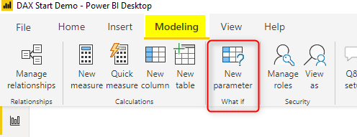



1. Query Parameters
   * Create list by taking data from table itself.

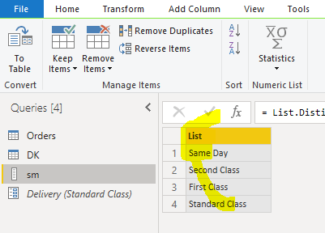

* + Create parameter

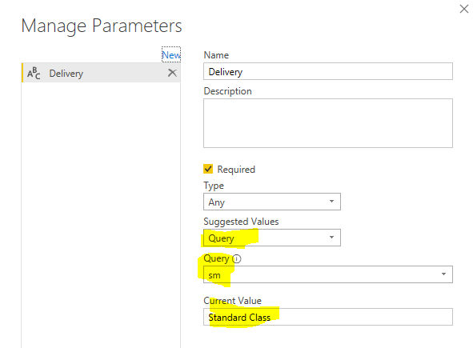

* + Apply as filter into dataset / table

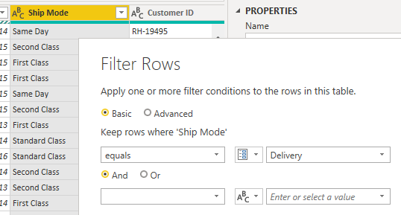

1. What is filter context, Row context, Query context in power BI

**Row Context:**

Row context: Context of calculation will go every row by row called row context. Every single row calculating.

Context of calculation will go row by row.

**= Orders[Sales] + Orders[Profit]**

When calculation will go every row by that is called row context sumx, maxx is row by row calculation. Other words iterative functions will do row by row operation.

**Filter context:**

When filter applied on DAX calculation / expression, filter function will extract row / result based on condition defined in filter / criteria that is called filter context.

Filter context is the set of values allowed in each column, based on filter constraints that were applied to the row or that are defined by filter expressions within the formula.

**Query context:**

Query context refers to the subset of data that is implicitly created for each cell in a PivotTable, depending on the row and column headers.

1. **One to One relationship**

Depending on data one to one relationship will detect.

ONE TO ONE relationship solved by:

* **Merge 2 tables:** Two table can be merge make it one table where found one to one relationship

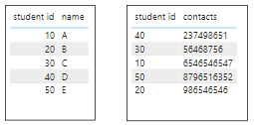

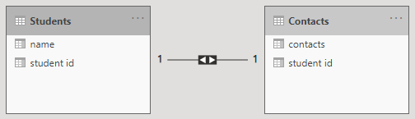

**Result of one to one relationship**

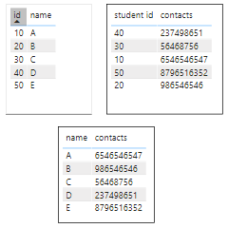

**You can merge with full outer join**

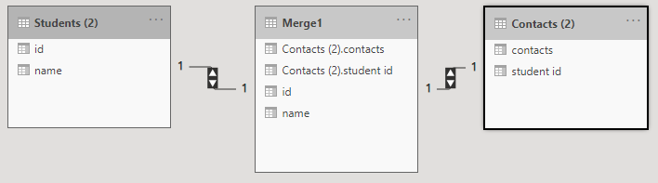

Below result is merge with full outer join. Bridge table join one to one relationship.

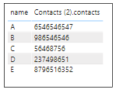

* **Create bridge table:** Create bridge table between two table to join with one to one relationship.

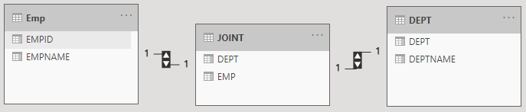

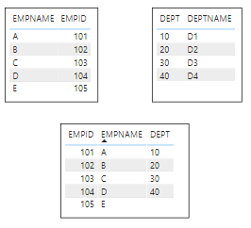

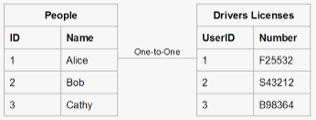

1. **Why slicer will not filter calculated table**

Calculated table is separated physical table itself. Slicer will only work when table has relationship, even its calculated / extracted table.

1. **Data Flow**

We want data that’s ready for analytics, to populate visuals, reports, and dashboards, so we can quickly turn our volumes of data into actionable insights. With self-service data prep for big data in Power BI, you can go from data to Power BI insights with just a few clicks.

Dataflows are a capability in Power BI for self-service ETL and data preparation that enable analysts and business users to define and share reusable data entities. Each dataflow is created in a Power BI workspace and can contain one or more entities. Each entity is defined by a Power Query “M” query. When the dataflow is refreshed, the queries are executed, and the entities are populated with data.

The underlying data behind the dataflow is stored in a data lake. However, since it’s fully managed, this data lake is not directly accessible or visible to the customer.

|  |  |
| --- | --- |
|  |  |

* + **Where is the data stored in the “Data Flow”?**

Data is stored in [CDM folder](https://ssbipolar.com/2018/10/20/dataflows-in-power-bi-overview-part-4-cdm-folders/) format. Each dataflow is saved in a folder in the data lake.

The folder contains one or more files per entity. If an entity does not use incremental refresh, there will be one file for the entity’s data.

For entities that do use incremental refresh, there will be multiple files based on the refresh settings.

The folder also contains a model.json file that has all of the metadata for the dataflow.

* + **Do I need to pay for Power BI dataflows?**

No, Dataflows are available to Power BI Pro and Premium users.

* + **Power BI Premium dataflows?**

-Incremental refresh of dataflow entities

-[Already computed entities](https://ssbipolar.com/2018/10/23/dataflows-in-power-bi-overview-part-6-linked-and-computed-entities/)

-[Enhanced compute engine](https://ssbipolar.com/2019/12/11/power-bite-dataflows-enhanced-compute-engine/)

- Direct Query

* + **Do dataflows support incremental refresh?**

Yes. Incremental refresh can be configured on a per-entity basis. Incremental refresh is supported only in Power BI Premium.

* + **Can I use on-premises data sources with dataflows?**

Yes. Dataflows use the same gateways used by Power BI datasets to access on-premises data sources.

* + **How do I do *X* with dataflows? I can do it in a query in Power BI Desktop?**

If you have a query that works in Power BI Desktop, copy the query and paste it into Power Query Online. In most cases it will work.

* + **Do I still need a data warehouse if I use dataflows?**

If you needed a data warehouse before Power BI dataflows, you probably still need a data warehouse. Although dataflows serve a similar logical function as a data warehouse or data mart, modern data warehouse platforms provide capabilities that dataflows do not.

* + **Do I need dataflows if I already have a data warehouse?**

Dataflows fill a gap in data warehousing and BI tools by allowing business users and analysts to prepare and share data without needing help from IT.

With dataflows, users can build a “self service data mart” in Power BI that can be used in their solutions.

* + **Do dataflows replace Azure Data Factory?**

ADF is a hybrid data integration platform designed to support enterprise-scale ETL and data integration needs. ADF is designed for use by professional data engineers. Power BI dataflows are designed for use by **analysts and business users** – people familiar with the Power Query experience from Power BI Desktop and Excel – to load data into ADLSg2.

* + **Limitations of Data flow?**

1. Dataflows are for batch data, not streaming data.
2. Dataflows can only be modified by their owners.
3. Dataflows are not available in *My Workspace*
4. Dataflows using gateway data sources do not support multiple credentials for the same data source
5. Using the Web Page connector requires a gateway
6. Incremental refresh does not work in shared Dataflows – Pro License
   * **Do dataflows replace Power BI datasets?**

You can use Data flow to build report but when you publish to service it will generate dataset, because report stand on dataset not data flow.

You cannot build a Power BI report directly against a dataflow – you need to build reports against datasets.

* + **How can I use the data in a dataflow?**

You use the data in a dataflow by connecting to the Power BI dataflows connector in Power BI Desktop. This will give you a list of all workspaces, dataflows, and entities that you have permission to access, and you can use them like any other data source.

* + **Can I connect to dataflows via Direct Query?**

Yes. When [using the dataflows enhanced compute engine](https://ssbipolar.com/2020/09/16/dataflows-enhanced-compute-engine-will-it-fold/), you can connect to dataflows using import or Direct Query. Otherwise, dataflows are an import-only data source.

* + **Can I use the data in dataflows in one workspace from other workspaces?**

Yes! You can import entities from any combination of workspaces and dataflows in your PBIX file and publish it to any workspace where you have the necessary permissions.

* + **Can I use the data in a dataflow from tools other than Power BI?**

Yes. You can configure your Power BI workspace to store dataflow data in an Azure Data Lake Storage gen2 resource that is part of your Azure subscription. Once this is done, refreshing the dataflow will create files in the CDM Folder in the location you specify. The files can then be consumed by other Azure services and applications.

* + **Three ways to use Power BI dataflows**

**Option 1: Fully Managed by Power BI**

In this first option, Power BI handles everything. We use the web-based Power Query Online tool for structuring the data. Power BI handles scheduling the data refresh. The underlying data behind the dataflow is stored in a data lake. However, since it’s fully managed, **this data lake is not directly accessible or visible to the customer.** As with most cloud-based implementations, the infrastructure is hidden under the covers.

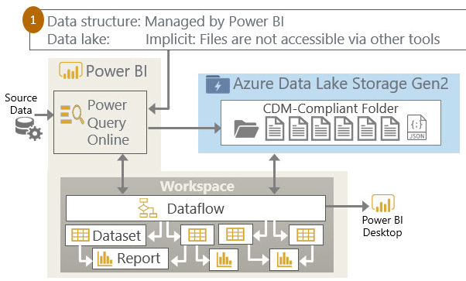

**Option 2: Managed by Power BI with an Explicit Data Lake**

the diagram looks exactly the same as option 1. The key difference is that we have associated our data lake account to Power BI. This is the “bring **your own data lake**” scenario which means **we can actually view the data behind the scenes with a tool such as Azure Storage Explorer** (dataflows data is comprised of csv files and the model. json file which contains the schema and other metadata).

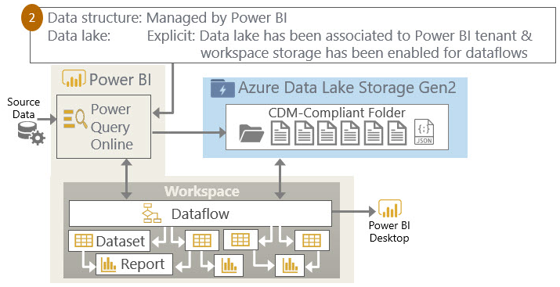

**Option 3: External Dataflows (Managed Outside of Power BI with an Explicit Data Lake)**

With the third option, we are maintaining the data with another tool such as **Azure Databricks, Azure Data Factory, HD Insight**.

Although Power BI doesn’t take responsibility for updating external dataflows, the dataflow can be consumed by PBIX files like any other dataflow.

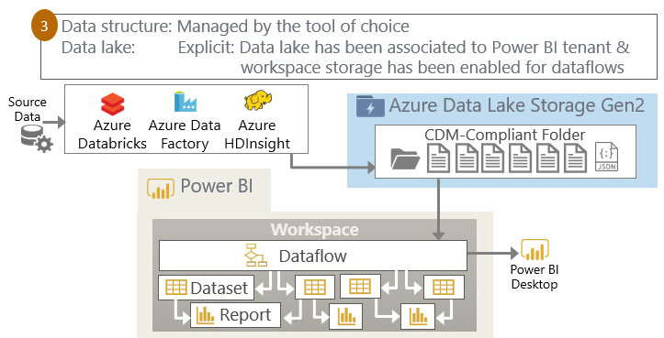

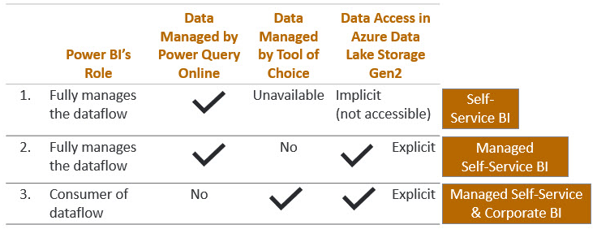

1. **CDM and CDS**

**CDS:**

CDS is a data storage system, which also comes with a lot of services around it for security, integration, and etc. **CDS is something like a database**, which is primarily used for Power Apps and some other Power Platform services.

Common data model and Common data services. CDS behind the scene is using **Azure SQL DB, Cosmos DB, Blob storage**, and etc for storing the data.

**CDM:**

CDM is not a meta data storage system, is not a database. There should be always a data storage technology behind it. CDM just provides the metadata structure for entities. For example, the Power BI dataflows stores data into Azure Data Lake Storage, but that data can get stored in the format of CDM, into the structure of CDM.

1. **CDM Folder**

Each CDM folder is a simple and self-describing structure. The folder contains one or more[2] CSV files for each entity, plus a JSON metadata file. Having the data in a simple and standard format like CSV means that it is easy for any application or service to read the data.[3] Having a JSON metadata file in the folder to describe its contents means that any consumer can read the JSON to easily understand the contents and their structure.

**The JSON metadata file contains:**

* The names and locations of all files in the folder.
* Entity metadata, including names, descriptions, attributes, data types, last modified dates, and so on.
* Lineage information for the entities – specifically, the Power Query “M” query that defines the entity
* Information about how each entity conforms (or does not conform) to Common Data Model standard entity schemas.

1. **Deployment pipelines**

The deployment pipelines tool enables BI creators to **manage the lifecycle** of organizational content, with Premium capacity. Pipelines enables creators to develop and test Power BI content before the content is consumed by users. The content types include reports, dashboards, and datasets.

**Development stages**

This stage is used to design, build, and upload new content.

**Test stages**

Share content with testers and reviewers.

Load and run tests with larger volumes of data.

Test your app to see how it will look for your end users.

**Production stages**

After testing the content, use the production stage to share the final version of your content with business users across the organization.

**Supported Content**

* Datasets
* Reports
* Dashboards

**Non-Supported Content**

* Datasets that do not originate from a PBIX
* Reports based on unsupported datasets
* Template app workspaces
* Paginated reports
* Dataflows
* PUSH datasets
* Workbooks

**Limitations of Deployment pipeline**

* The workspace must reside on a premium capacity.
* Reports and dashboards that have Power BI sensitivity labels, cannot be deployed.
* The maximum number of contents in a single deployment is 300.
* Downloading a PBIX file after deployment isn't supported.
* Downloading a dataset not supported, After deployment.
* For a list of workspace limitations, see workspace assignment limitations.
* For a list of unsupported items, see unsupported items.
* You must be an admin of the workspace.
* The workspace is not assigned to any other pipeline.
* The workspace must be a new workspace.
* You cannot assign a workspace with Power BI samples to a pipeline stage.

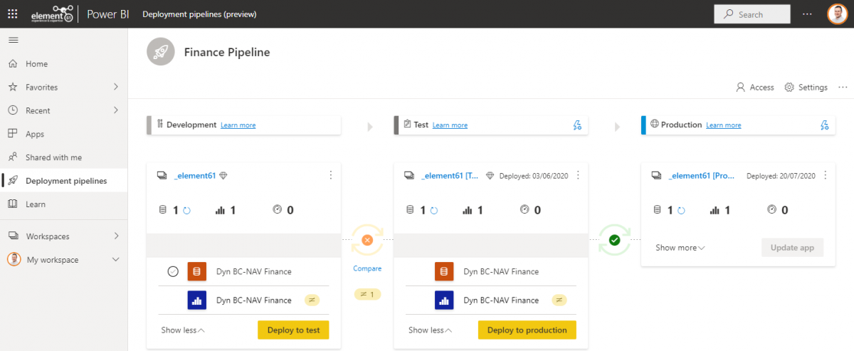

1. **Can we use SQL and Power Query together?**

Yes, we can use them together. A SQL statement can be used as a source of Power Query for making additional logical processing.  This will help in ensuring that an efficient query is passed to the source and avoids unnecessary complexities.

1. **DAX Variables?**

* A single variable can be re-used multiple times in DAX expression.
* Variable eliminates additional querying from the source database.
* Variables have only limited scope to their query or measure.
* It is not possible to define them at the model level or Variable can’t share among measures.
* Variables can make DAX expressions more useful and logical.

1. **Dataset types**

* Push dataset
* Streaming dataset
* Pub-Nub (Online)
* External - outside Azure/Microsoft
* Internal - Azure/Microsoft
* File system

1. **Push data into a Power BI dataset**

The **Power BI REST API** lets you push data into a Power BI dataset.

You create a dataset in Power BI by passing a (**JSON**) string to the Power BI service.

1. **What are the various views available in Power BI Desktop?**

* **Report View:** In the report view, a user can add additional report pages and also visualizations and publish them on the same portal using Report View.
* **Data View:** Data view helps in looking at your data after that has been loaded into the model.
* **Model View:** A user can check to control the relationships between the data sets by using a relationship view.

1. **When 1st time connect to a database in Azure SQL Database you need?**

Need to configure the firewall settings to enable remote connections before connecting it to the database in Azure SQL Database.

1. **What are the data types supported by DAX?**

* String
* Boolean
* Numeric
* Decimal
* Datetime

1. **What are the important capabilities included in the Power BI?**

* Datasets
* Tiles
* Navigation pane
* Help and feedback buttons
* Ad Hoc analysis
* Mobile device compatibility
* Trend indicators
* Data visualization tools
* Complete reporting
* Customizable dashboards
* Reports
* Get Data
* Ad Hoc reporting
* Q&A question box
* Row-level security
* OLAP (Online Analytical Processing)
* Interactive reports authoring.
* Bi-direction relation

1. **What do you know about Power BI designer (Power BI Desktop)?**

Power BI designer is a mix of Power view, Power query and Power pivot. It is a stand- alone application which allows the users of power BI to build Power BI reports. The created report is further uploaded to powerbi.com. Power BI designer does not require Microsoft Excel.

1. **Limitations of Power BI?**
2. Domain email to share.
3. Does not mix with imported live streaming source.
4. Power BI can't accept file size larger than 1 GB.
5. Dashboard Not Interactive if you pin tiles.
6. Parameters
7. Bi-Directional Relationship
8. Role playing dimension
9. DAX, M Query
10. **Explain the term responsive slicers?**

On a report page, you can easily resize a responsive slicer to various sizes and shapes, and the data contained in it should be rearranged according to it. In case if the visual becomes too small to be useful, an icon representing the visual ability to take its place, thus saving the space on the report page.

1. **Performance DAX, Power Query?**

* **Join** - DAX can apply join quickly in formula itself , Power Query can be very slow at applying a join.
* **Filters -** DAX is blazing fast at applying filters, where Power Query is slow in Appling filter.
* **Compression** - A column with better compression is smaller in memory winner is Power Query whereas DAX is lower compression might be lower.

**:** [**https://radacad.com/m-or-dax-that-is-the-question**](https://radacad.com/m-or-dax-that-is-the-question)

1. **Power Query Performance Optimization – Steps**

All multiple “Type steps” change to 1 step

All multiple “Rename steps” change to 1 step

All multiple “Reordered Columns steps” change to 1 step

**Finally, all bunch of steps can consolidate to few (4-5) steps.**

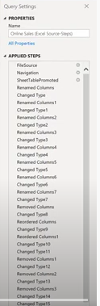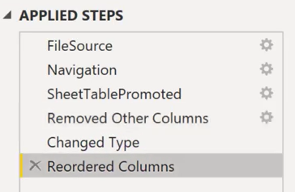

1. **Dynamic Dataset:**

When data set prompted to pass parameters to select data source connection string, swith from one database source to other database.

1. **How to do performance analysis of power BI (Performance analyzer)**

* Performance analyzer will do analysis & record each visuals and slicer in the page and detect who is taking how much time.
* Each operation will execute all visuals related to it, which will interact with Database and return result.
* Performance Analyzer is an easy and accessible way to track the performance of a Power BI report during the development process in Power BI Desktop.
* It evaluates and displays the duration required for updating or refreshing the visuals, helping the user to identify which visual or element is impacting the performance of the report.
* Captures the duration time in milliseconds for each visual on the page which helps to tune the performance of the report.
* Each visual’s log information comprises of the duration to complete the following types of tasks – DAX query, visual display, and others (waiting time for pending operations on a page).
* Allows saving the performance analyzer list generated by the tool in the JSON format using the ‘export’ option. It helps to compare operations after completing multiple required actions.

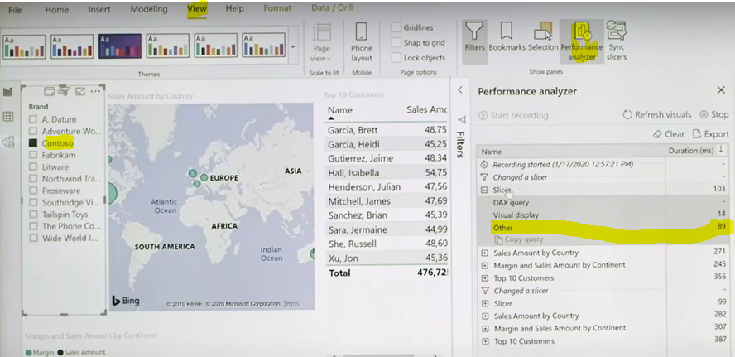

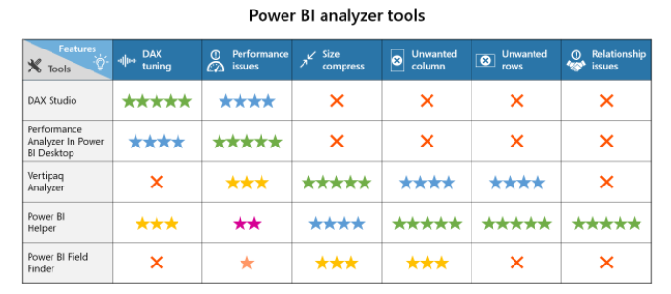

1. **DAX Studio**

It’s a tool to write, execute, and analyze DAX queries in Power BI Designer, Power Pivot for Excel, and Analysis Services Tabular. Analyzing DAX queries can be helpful to understand the performance issues and to improve the writing of DAX queries. DAX Studio includes object browser, query editing and execution, formula and measure editing, syntax highlighting and formatting, integrated tracing, and query execution breakdown. Some of the features include:

* Internally uses daxformatter.com, which allows the users to keep DAX measures or columns formatted, making the code easily readable.
* Easily swaps the delimiter style for DAX expressions.
* Integration with VertiPaq Analyzer 2.0 (preview feature).
* Connects with a variety of data sources, as shown in figure 1.
* Only calculates the time taken by the DAX query to generate results on Power BI. It does not consider the time required for loading visual and network processing.
* One of the popular features is ‘Load Perf Data’ which allows DAX studio to import the JSON file from Power BI Performance Analyzer. Once the PowerBI PerformanceData.JSON file is imported, the PBI Performance pane in DAX displays all the queries captured by the Power BI Performance Analyzer. Figure 2 displays various components in the DAX Studio

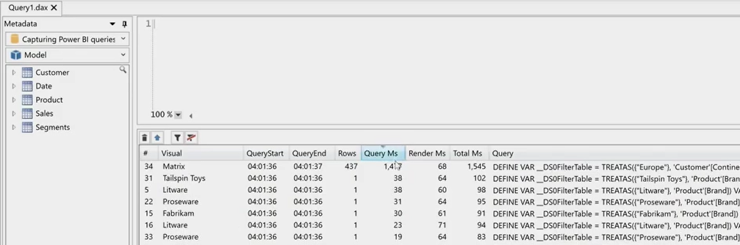

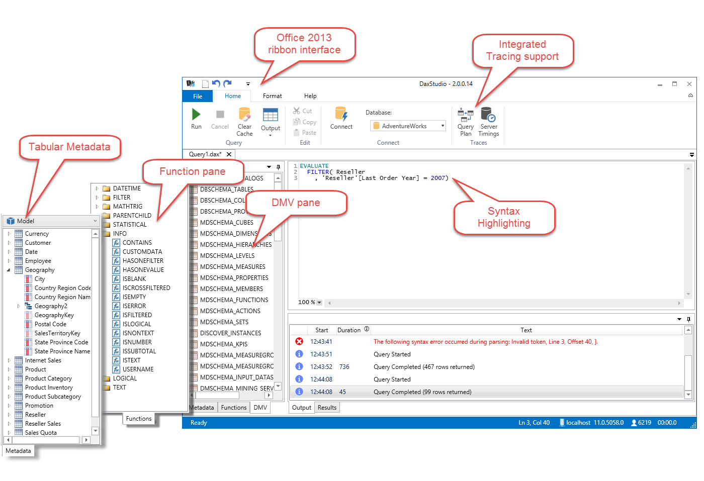

1. **Power BI helper?**

It can help you to find all the details about DAX measures and all the expressions with syntax errors.

* Hiding unused tables
* Gives directional filters,
* Inactive relationships,
* Modeling advice.
* Shows the list of tables and bookmarks, where the tables are being used.
* Provides information unused measures.
* Allows unlimited exporting data in the CSV file format.
* Provides information about : apps, gateways, data sources, and service configurations.
* Downloading a version of all Power BI reports (PBIX files) from all workspaces to a local folder
* Publishing Power BI files to multiple workspaces
* Copying content from one workspace to another!
* Find Bookmarks belong to each page
* Find pages associated with each bookmark
* Export the Model documentation about : tables, measures, measures expressions, columns, columns expressions.
* Connecting to more than one Power BI model.
* Showing the connection mode of the Power BI file.
* Showing list of tables that are NOT used in any visualization.
* Modeling advises: list of Bi-Directional relationship, inactive relationships.
* List of all tables, columns, and measures in a Power BI Model
* Is there any Report Level Filter for this field or table
* List of all report pages that this field or table used in their “Visual” fields.
* List of all report pages that this field or table used in their “Page Level Filter”
* Identify tables that are used in the Fields or Filter sections of report tab
* List of fields used in the Filter area
* List of tables or fields used to create a calculation (calculated table, column, or measure)
* List of tables or fields used to create a relationship to other tables
* Details of what fields or tables used in a specific report or visual
* Diagram view and dependency view of reports and visuals with tables and fields from the model

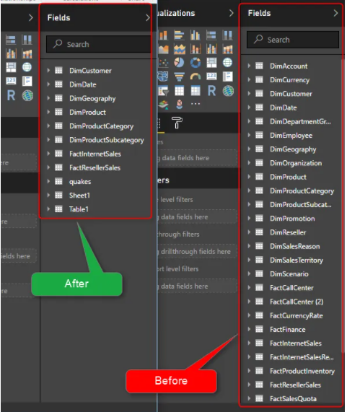

1. **Vertipaq Analyzer**

Vertipaq engine stores the data column-wise as opposed to the row-wise data storage in SQL databases. It uses internal algorithms to avoid duplicates in the columns which reduces the size of the data and the time to query.

* Provides insights into queries, columns, and the size of the relationships which enables the user to document the model.
* Analyzing the size of the table and columns is an important step in optimizing the data model for Power Pivot, Power BI, or Analysis Services Tabular.
* Shows the cardinality of columns in the table which helps to identify areas in the model that take up space.
* Provides a hierarchy list of all columns and size of the rows.
* Provides many ‘dynamic management views’ to collect information about the memory used by a data model.

1. **Customize tooltip?** We can customise tooltip as page

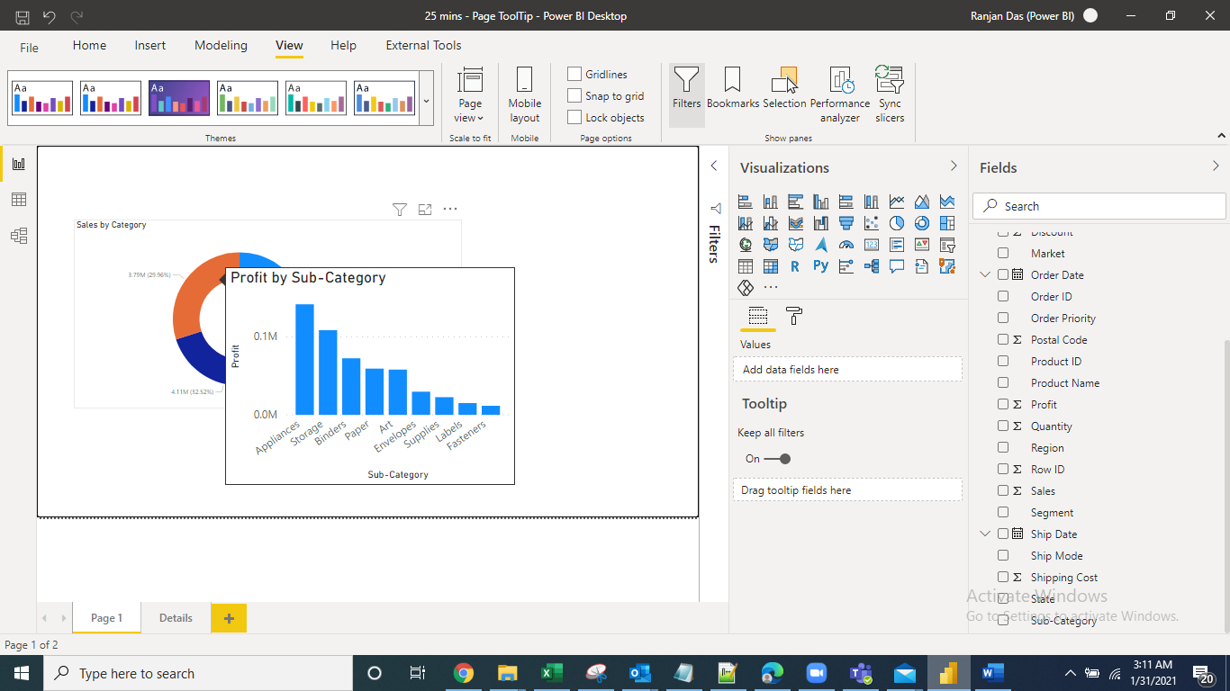

**Step 1** : In page turn on Tooltip

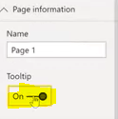

**Step2**: In page size, select tooltip

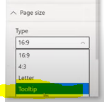

**Step3**: In page allignment, select middle

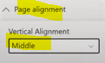

**Step4**: View > Actual Size

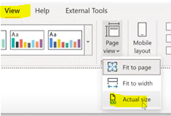

**Step5**: Shodow apply to page > page background color > Transporancy 0%

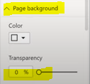

**Step6**: Goto Main report page> and then select Type= Report page, select the Page1

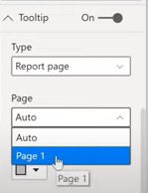

1. **Query Diagnosys**

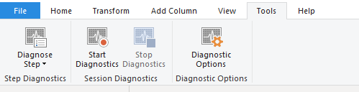

With **Query Diagnostics**, you can achieve a better understanding of what **Power Query** is doing at authoring and at refresh time in **Power BI** Desktop. ... Whenever you start **diagnostics**, **Power Query** begins tracing any evaluations that you cause. In query which operation taking more time then you can plan accordingly troubleshooting.

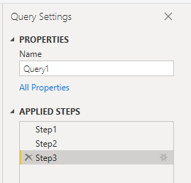

1. **Group by operation?**

Group data in power Query , removing duplicate with aggrigate sum, count, min & max

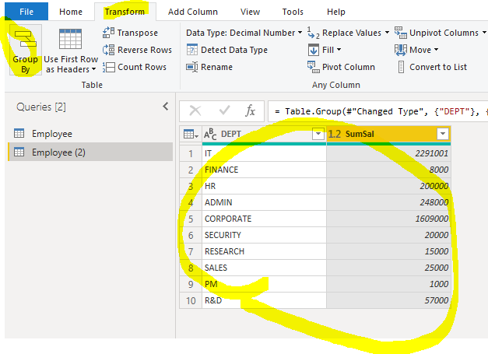

1. **Small Multiples visualization Line , Bar , Area**

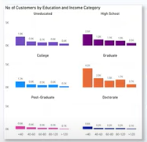

1. **Smart narrative visual in power BI**

Smart narrative visuals can be created and viewed in both Power BI Desktop and the Power BI service.

The smart narrative visualization helps you quickly summarize visuals and reports. It provides relevant innovative insights that you can customize.

Use smart narrative summaries in your reports to address key takeaways, to point out trends, and to edit the language and format for a specific audience. In PowerPoint, instead of pasting a screenshot of your report's key takeaways, you can add narratives that are updated with every refresh. Your audience can use the summaries to understand the data, get to key points faster, and explain the data to others.

|  |  |
| --- | --- |
| Screenshot showing the Visualizations pane. The Smart narrative icon is selected. |  |

1. **Fuzzy lookup in join**

|  |  |
| --- | --- |
|  |  |

1. **Compare of data Visualizations?**

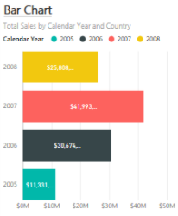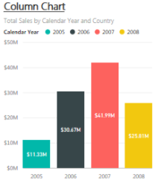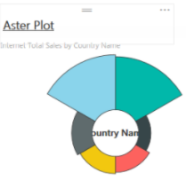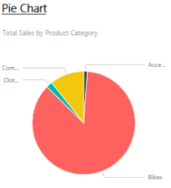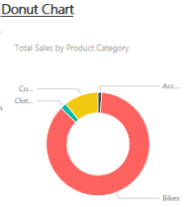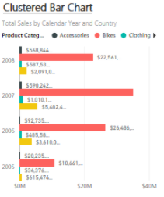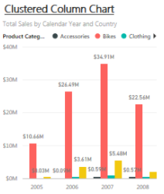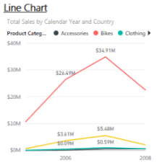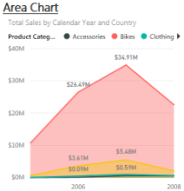 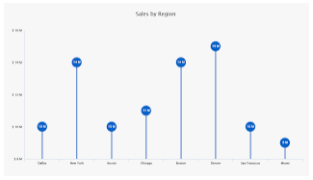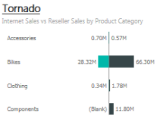

1. **Distribution of data Visualizations?** Bubble, Tree, Scatter, Tornado, Waterfall, Pulse, Line SparkLine, Whiskas

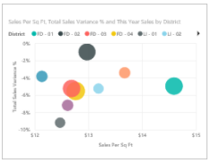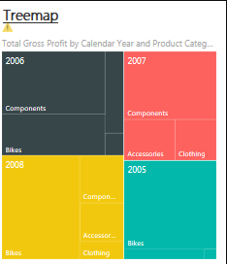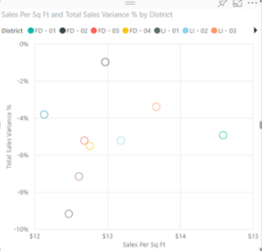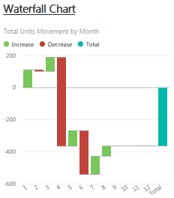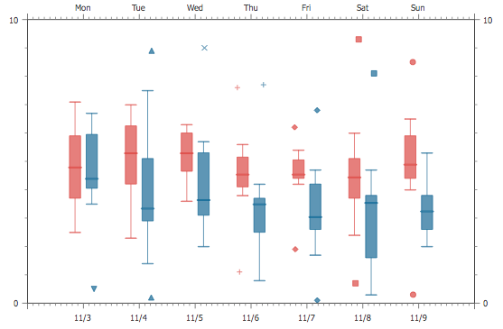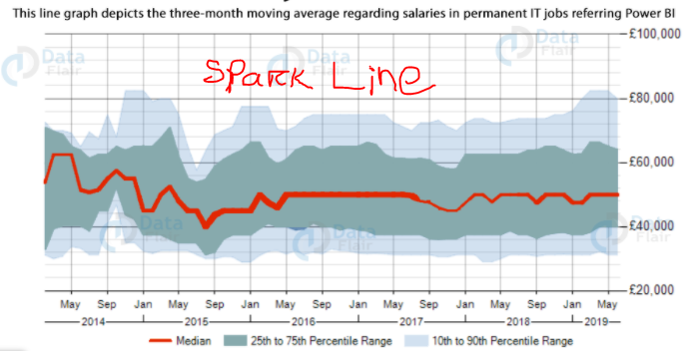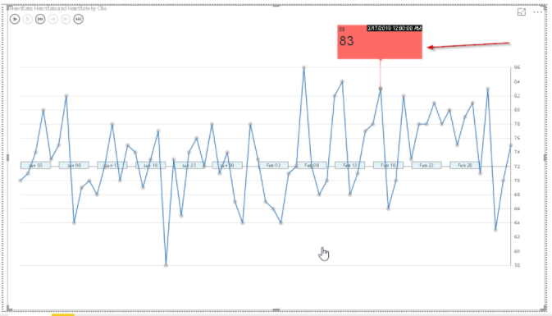 

1. **Relationship of data Visualizations?** Bobble, Tree Map, Scatter, Torndo, Waterfall, Correlation plot

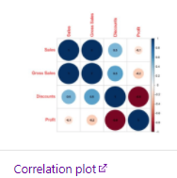

1. **Trends analyzing Visualizations?** Pulse chart, Gant chart, Waterfall, Area, Histogram & Line, Line

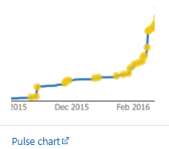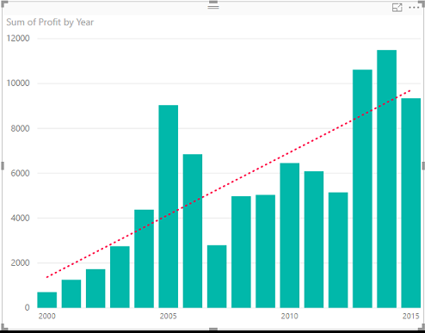

1. **Composition of data Visualizations?**

Area, Pie, Donut,TreeMap ,Funnel Chart ,Pyramid Chart,,Stacked Bar, Mekko,Stacked Column, Lillipop

1. **Anomaly Detection In Power BI**

,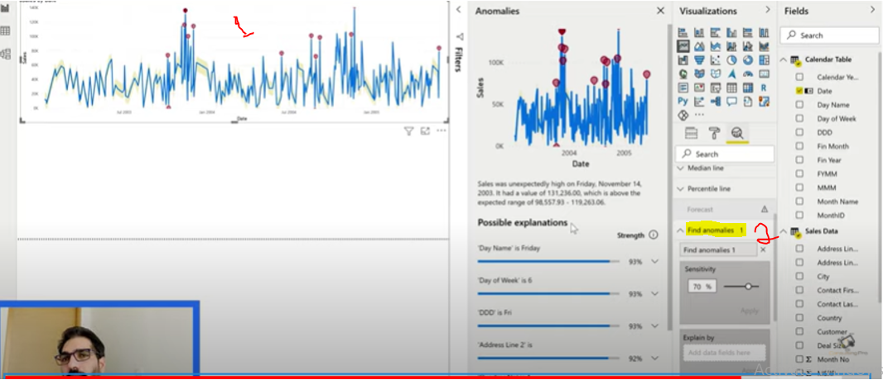

1. **Refresh only particular table not all tables in Power BI**

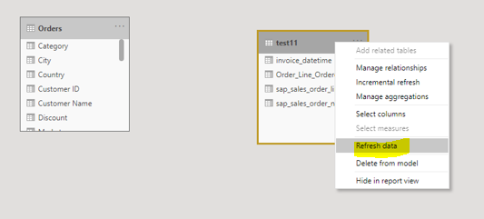

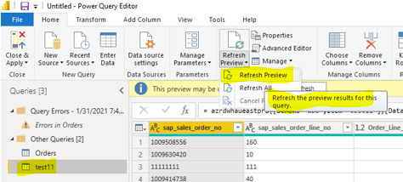

1. **Text filter in power BI**

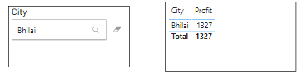

1. How to know who all user is accessing report / dashboard in power bi?

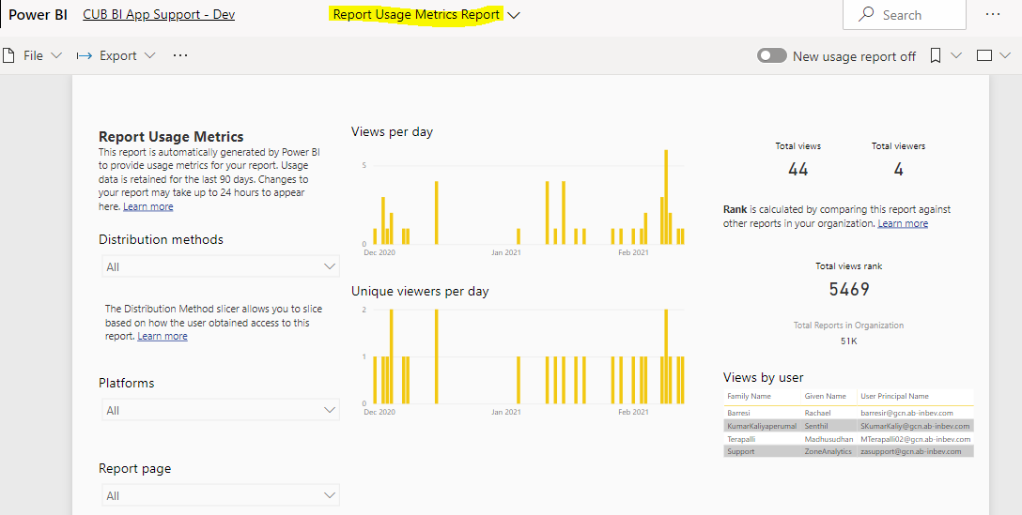

1. Power BI Audit in PowerShell:

Step1 - Open power shell as administrator

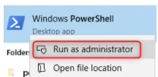

Step2 - Set-ExecutionPolicy RemoteSigned

After pressing enter, choose Y as the answer;

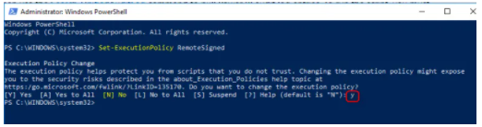

Step3 - $UserCredential = Get-Credential

if we are going to access the entire audit log across tenant, we need to have access to the admin account, so we need to ask for the credentials. the script above does that;

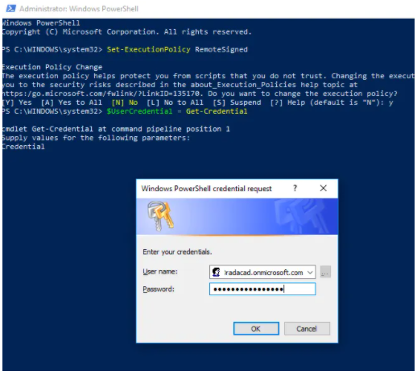

Step4 - Open power shell as administrator

After successful login, we can start with creating a session connection to office365 using the same credentials;

$Session = New-PSSession -ConfigurationName Microsoft.Exchange -ConnectionUri https://outlook.office365.com/powershell-liveid/ -Credential $UserCredential -Authentication Basic -AllowRedirection

then the script line below imports that session data;

Import-PSSession $Session

So far, we have got the output below in PowerShell

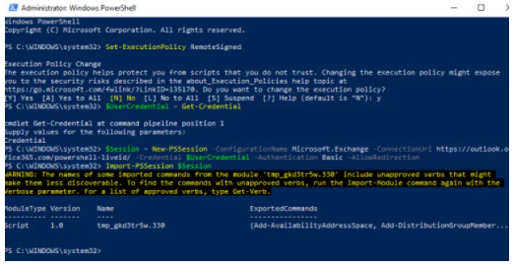

Now as the final step, we can read the audit log using Search-UnifiedAuditLog function, here is an example:

Search-UnifiedAuditLog -StartDate (Get-Date).AddDays(-90) -EndDate (Get-Date) -RecordType PowerBI -ResultSize 10

this will give you only ten rows of audit log (I have limited the result size to 10) as below;

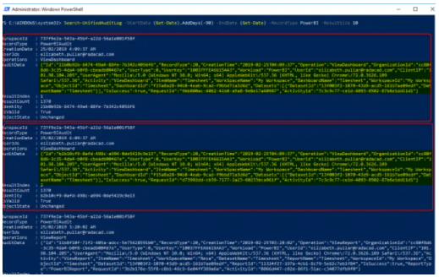

As you can see in the above screenshot, we will have a list of log activities, with a field named AuditData which includes anything about the activity; including object name and ID, the operation, the time and date of the operation, and users who did the operation and the result of the operation.

Now the next step is to format this data and export it to CSV, which is the task that the script below does.

Search-UnifiedAuditLog -StartDate (Get-Date).AddDays(-90) -EndDate (Get-Date) -RecordType PowerBI -ResultSize 5000 | ConvertTo-Csv | Out-File c:\PowerBIAuditLog.csv

This will export the output of 5000 log entries in the period of the last three months to CSV format such as below;

Few tips about the export above;

* The default time period that Office365 keeps the audit log is 90 days. you can change it if you want. That is why I got back 90 days in my date periods.
* The export only supports up to 5000 audit log transactions, if you have more than that number, then you need to split it into multiple exports, I may right about it in the future.

Now that we have the CSV file of all audit logs, let’s use that as a data source in Power BI. Open a New Power BI file, and start with getting data from CSV.

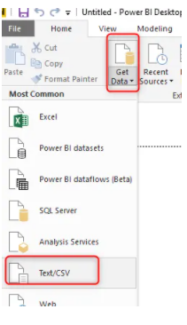

As you can see, there is some generic information, and then the main details are all in the AuditData field. AuditData field is formatted as JSON. let’s remove all other fields, and only keep the AuditData;

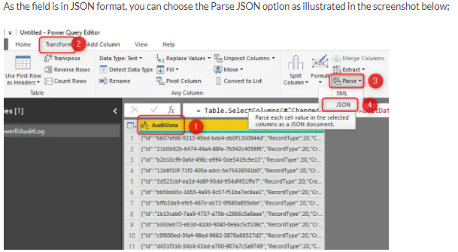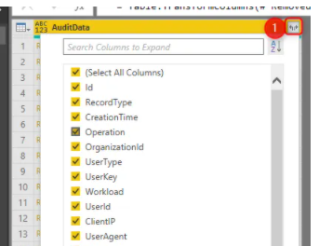

JSON data will be as a record in every cell, and now you can expand it to underlying columns;

https://radacad.com/build-your-own-power-bi-audit-log-usage-metrics-across-the-entire-tenant

<https://www.youtube.com/watch?v=fC6SK2TkoS0>

1. How to extract uses metrics dataset in workspace - How to prepare uses metrics single dataset for workspace

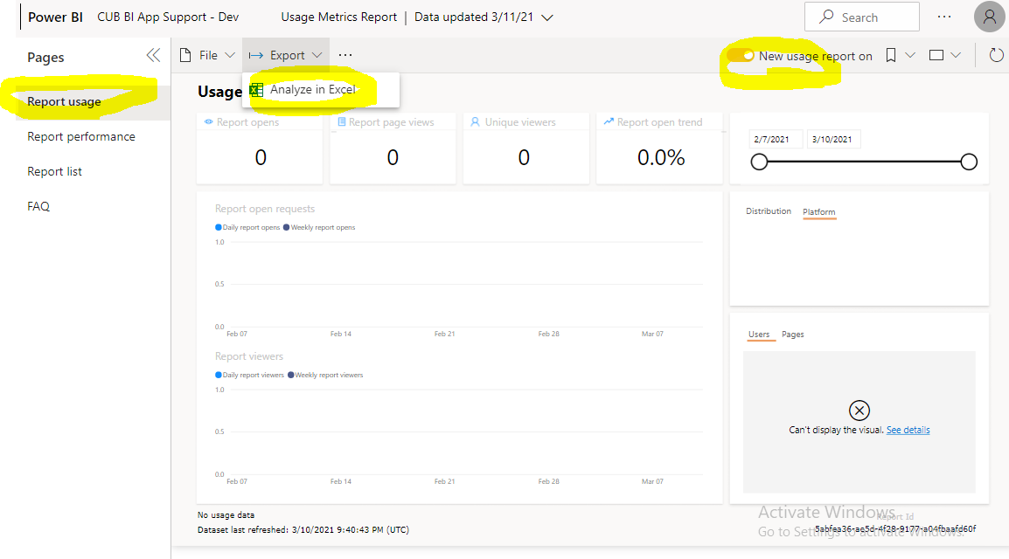

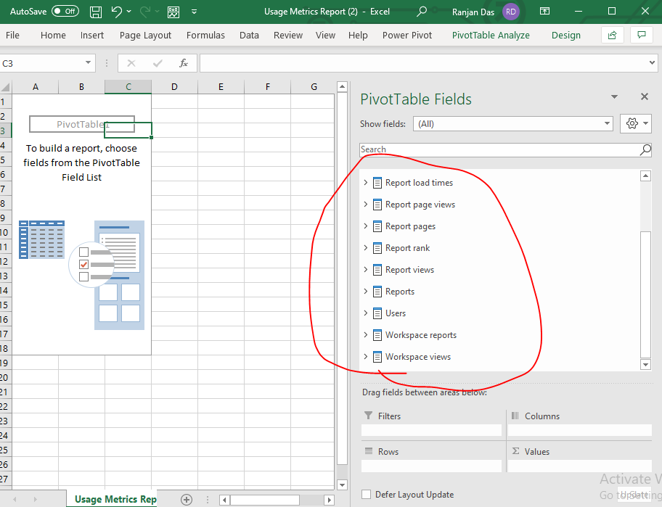

1. Workspace storage

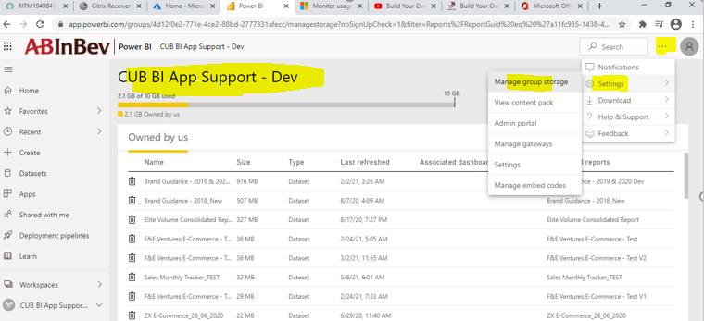

1. **Data Modelling details explanations**

**Data modeling** is the process of creating a data model for the data to be stored in a database. The data model emphasizes on what data is needed and how it should be organized. Data Model is like an architect's building plan, which helps to build conceptual models and set a relationship between data items.

***Types of Data modelling***

* **Entity-relationship (ER) data models** use formal diagrams to represent the relationships between entities in a database. Several ER modeling tools are used by data architects to create visual maps that convey database design.
* **Dimensional data models** Speeds for analytic purposes in a [data warehouse](https://www.ibm.com/cloud/learn/data-warehouse). While relational and ER models emphasize efficient storage, dimensional models increase redundancy in order to make it easier to locate information for reporting and retrieval. This modeling is typically used across [OLAP](https://www.ibm.com/cloud/learn/olap) systems.

## ***Types of data models***

Data models can generally be divided into three stages.

* **Conceptual data models.** is an organized view of database concepts and their relationships. The purpose of creating a conceptual data model is to establish **entities**, their **attributes**, and **relationships**.
* **Logical data models**. is used to define the **structure of data elements** and to set **relationships between them**. The logical data model adds further information to the conceptual data model elements. The advantage of using a Logical data model is to provide a foundation to form the base for the Physical model. **Normalization** processes to the model is applied typically till 3NF.
* **Physical data models.**Describes a database-specific implementation of the data model. It offers database abstraction and helps generate the schema. This is because of the richness of meta-data offered by a Physical Data Model. The physical data model also helps in visualizing database structure by replicating database **column keys, constraints, Primary and Foreign keys indexes, triggers**, and other RDBMS features.

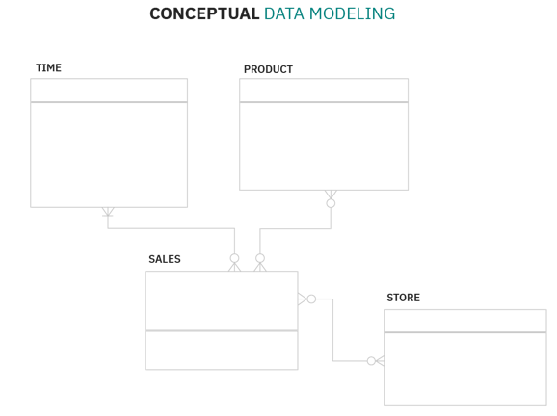 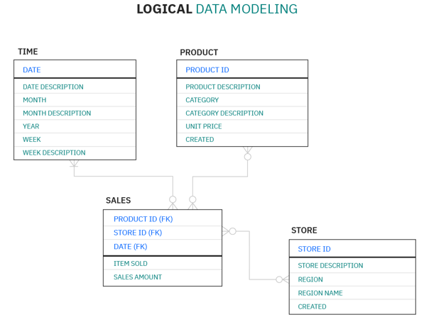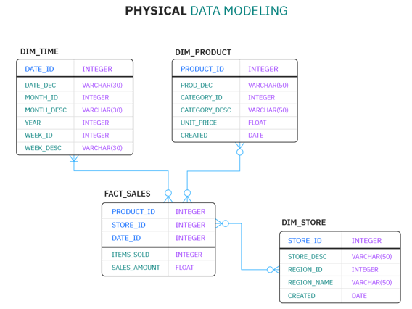

## ***Data modeling process***

### As a discipline, data modeling invites stakeholders to evaluate data processing and storage in painstaking detail. Data modeling techniques have different conventions that dictate which symbols are used to represent the data, how models are laid out, and how business requirements are conveyed. All approaches provide formalized workflows that include a sequence of tasks to be performed in an iterative manner.

* 1. **Identify the entities.**
  2. **Identify key properties of each entity.**
  3. **Identify relationships among entities.**
  4. **Map attributes to entities completely.**
  5. **Assign keys as needed & decide of normalization that balances the need to reduce redundancy performance**
  6. **Finalize and validate the data model.**

## ***Data modeling tool***

* 1. ***ERWIN***
  2. ***ER/Studio***

## **Benefits of data modeling / Why data modelling**

Data modeling makes it easier for developers, data architects, business analysts, and other stakeholders to view and understand relationships among the data in a database or data warehouse.

* Reduce errors in software and database development.
* Increase consistency in documentation and system design across the enterprise.
* Improve application and database performance.
* Ease data mapping throughout the organization.
* Improve communication between developers and business intelligence teams.
* Ease and speed the process of database design at the conceptual, logical and physical levels.

## ***Conclusion***

* + **Data modeling is the process of developing data model for the data to be stored in a Database.**
  + **Data Models ensure consistency in naming conventions, default values, semantics, security while ensuring quality of the data.**
  + **Data Model structure helps to define the relational tables, primary and foreign keys and stored procedures.**
  + **There are three types of conceptual, logical, and physical.**
  + **The main aim of conceptual model is to establish the entities, their attributes, and their relationships.**
  + **Logical data model defines the structure of the data elements and set the relationships between them.**
  + **A Physical Data Model describes the database specific implementation of the data model.**
  + **The main goal of a designing data model is to make certain that data objects offered by the functional team are represented accurately.**
  + **The biggest drawback is that even smaller change made in structure require modification in the entire application.**
  + **Reading this Data Modeling tutorial, you will learn from the basic concepts such as What is Data Model? Introduction to different types of Data Model, advantages, disadvantages, and data model example.**

1. Power BI PRO Capacity? We can’t do capacity settings in Pro. In premium license can do capacity setting like below.

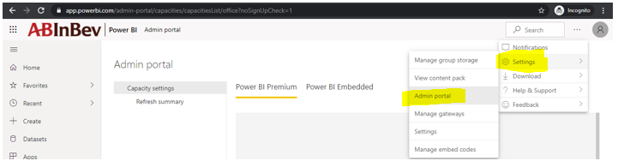

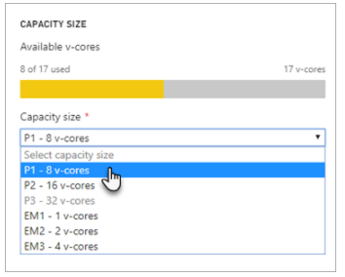

1. **Rest API Power BI?**

Which help us to pass parameters from URL and extract **workspace, dataset, user, dataflow** etc. information can be extracted by Power Shell, should have admin access.

Using Power BI REST API, you can create apps that integrate with Power BI reports, dashboards, and tiles. With Power BI REST API, it is possible to perform d tasks on Power BI objects like reports, datasets, and workspaces.

That data can be used to **GET, PUT, POST and DELETE** data types, which refers to the **reading, updating, creating and deleting** of operations concerning resources.

REST API generate JSON file which we can import into Power BI for analysis.

1. **Publish report powershell?**

**PowerShell Commands :** [**https://docs.microsoft.com/en-us/powershell/power-bi/overview?view=powerbi-ps**](https://docs.microsoft.com/en-us/powershell/power-bi/overview?view=powerbi-ps)

**Publish Report to Workspace:**

Connect-PowerBIServiceAccount

New-PowerBIReport -Path C:\Report\SamplePBIREport.pbix -Name 'Sample Report' // my workspace

New-PowerBIReport -Path C:\Report\SamplePBIREport.pbix -Name 'New Report' -WorkspaceId 4885ac3e-9ba8-4a34-80ba-2d74a89c749d

**Export Power BI File:**

Connect-PowerBIServiceAccount

Export-PowerBIReport -Id e1b2f91c-0fb6-46e6-be31-6b71b0cca9c5 -OutFile C:\Report\SampleMyWS.pbix

Export-PowerBIReport -Id c77c9126-0864-4e5d-bf02-86f8ed8be649 -OutFile C:\Report\SampleBlogWS.pbix -WorkspaceId 4885ac3e-9ba8-4a34-80ba-2d74a89c749d

**Add Users to PBI Workspace:**

Add-PowerBIWorkspaceUser -Scope Organization -Id ef2d7e7b-9f0b-4926-9861-e4d3738f84ce -UserEmailAddress AdeleV@dshah27.onmicrosoft.com -AccessRight Admin

**Remove User From WorkSpace:**

Remove-PowerBIWorkspaceUser -Scope Organization -Id ef2d7e7b-9f0b-4926-9861-e4d3738f84ce -UserEmailAddress AdeleV@dshah27.onmicrosoft.com

**Create New Workspace:**

New-PowerBIWorkspace -Name "New Workspace"

Set-PowerBIWorkspace -Scope Organization -Id "ab1d0719-5935-4745-8ef0-90519d18bfef" -Name "Power BI WS with PS" -Description "Test WS for PS"

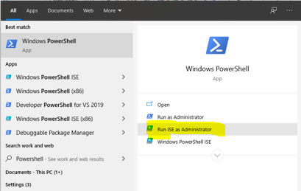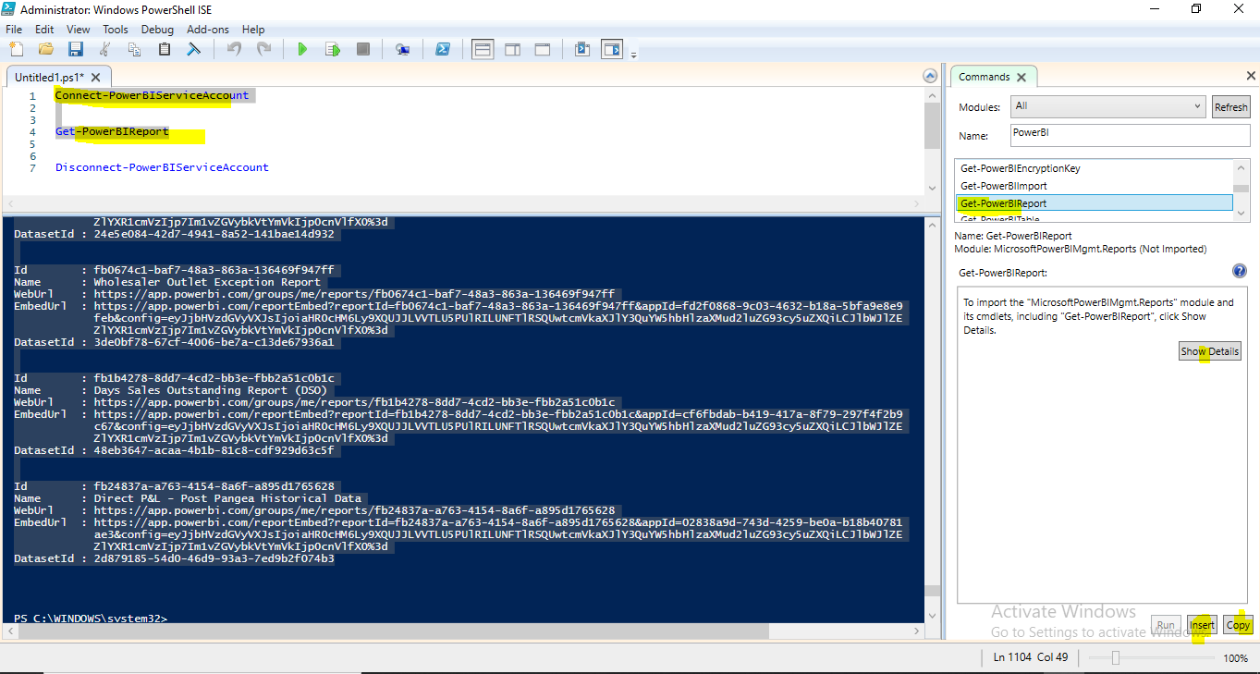

1. Types of Administrator?

* **Power BI Global Admin (Super)**
* **O 365 Global Administrator (Super)**
* **Power BI Service Administrator (Super)**
* Power BI Administrators
* Power BI Admin Alerting
* Power BI Gateway Admin
* Power BI Capacity Admin

1. Azure AD security to apply in Power BI report?
2. **Drill through to other page without filter?**

Create drill through button and in Action select page which you wants to navigate.

1. **Refresh report in service with huge data which I don’t want to refresh in desktop?**

Option1 - 1st develop report pointing to Development environment once report published to service then change connection to production in power BI service then start refreshing.

Option2 - Direct Query mode Write SQL query to restrict Data, once development done in power BI desktop then publish into service and change the query filter just before publishing report to service.

Option3 - Using Parameter

Option4 - Spit the CSV file into multiple then develop report with 1 file then Power Query will pick-up all then files automatically from folder location / gateway location.

1. **Feature/Promote Power BI Reports, Dashboards and Apps on Power BI Home?**

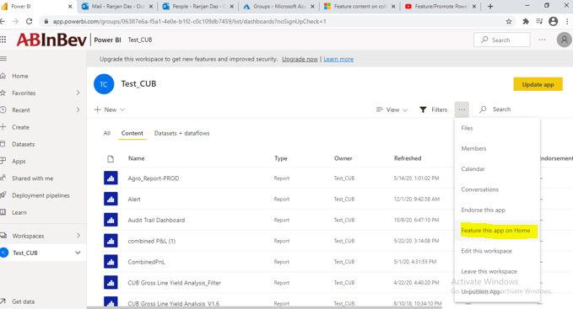

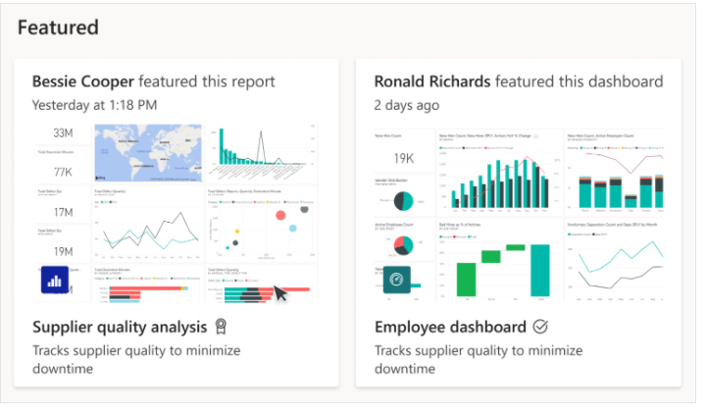

1. **Endorse your content?**

Endorsement is a way to make it easier for users to find the high-quality content they need. Endorsed content is clearly labeled, both in Power BI and in other places where users look for Power BI content (such as Excel).

**Promotion**: Promotion is a way to highlight content you think is valuable and worthwhile for others to use. It encourages the collaborative use and spread of content within an organization.

**Certification**: Certification means that the content meets the organization's quality standards and can be regarded as reliable, authoritative, and ready for use across the organization.

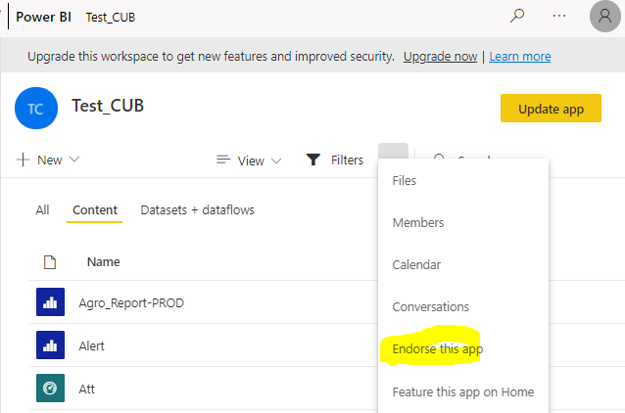

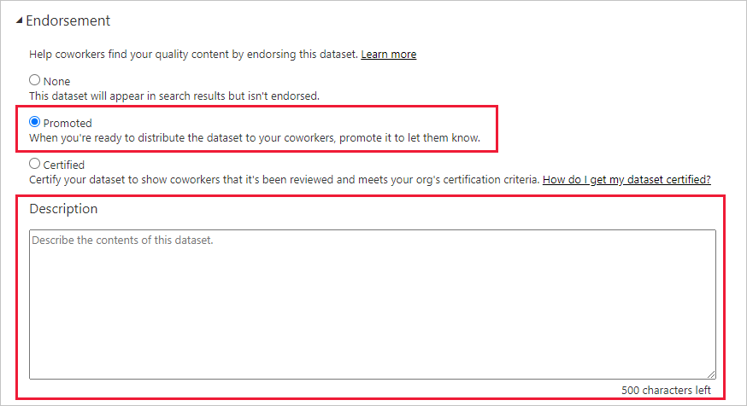

1. 1000 Users user shared service and premium capacity, Calculate License.

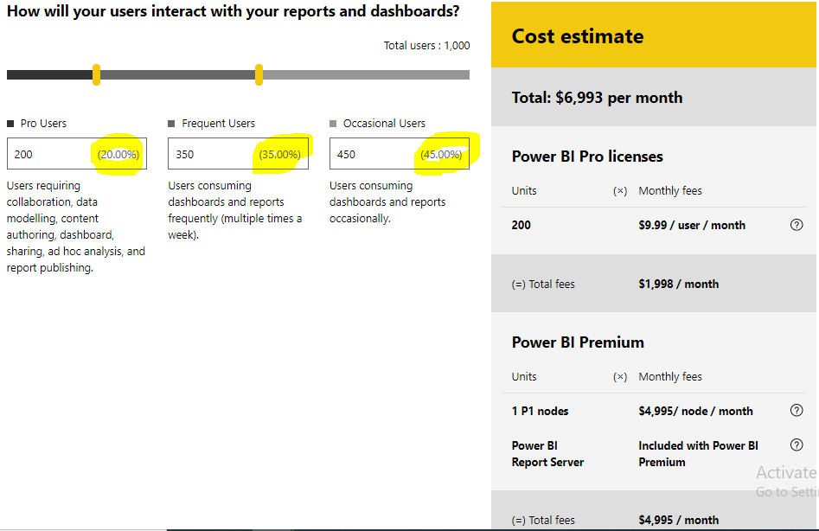

1. How to convert to Premium workspace?

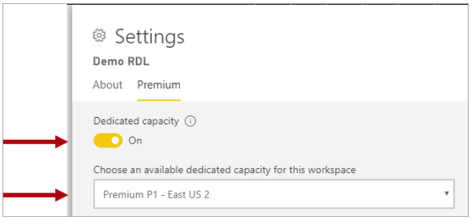 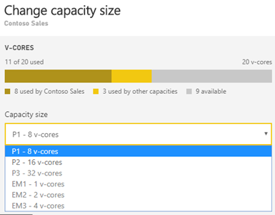

1. **What are pre-requisite to connect to any other data database other than native connection?**

Install Driver/connector with server , database, IP address, ID , Password.

1. **GETDATE() & SYSDATE()**

SELECT **GETDATE**() for SQL server, SELECT **SYSDATE**() for Oracle and My SQL

# **Monitor and Manage Power BI Premium Capacity**

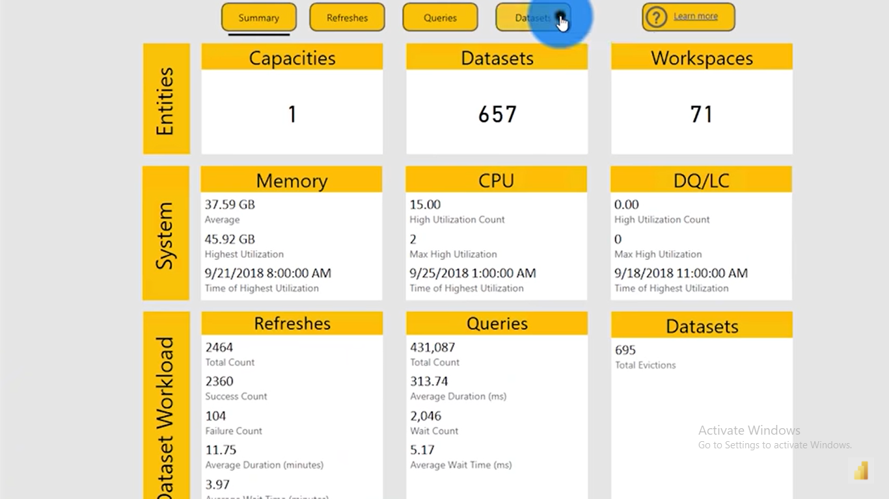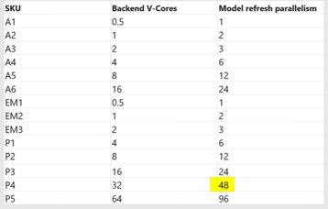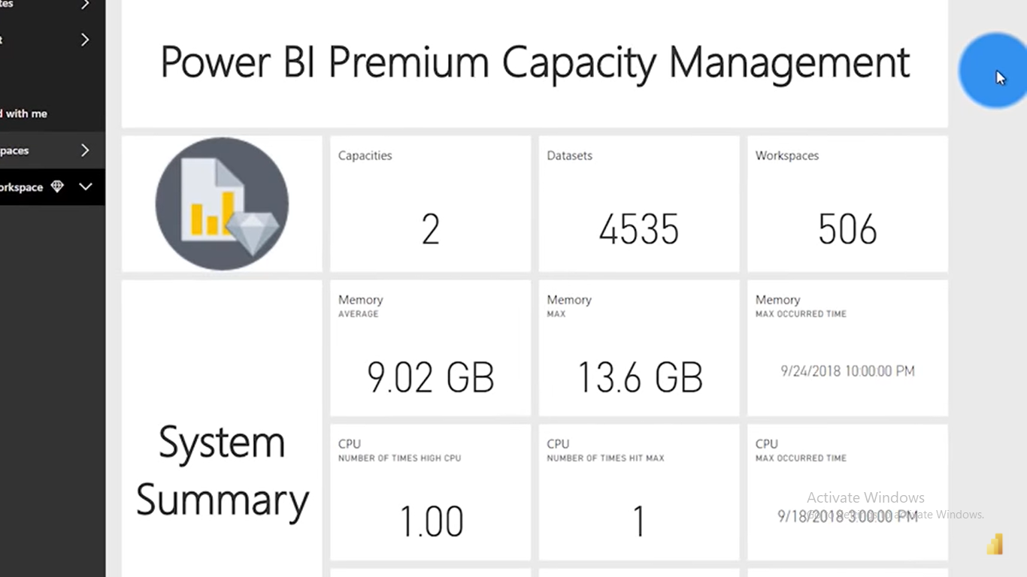

**SKU** is short for 'Stock-keeping-Unit'.

1. **3 tables has 3 measures need to create slicer combining 3 columns.**

Append 3 tables and columns to one column

1. **Line chart y axis year and x axis measures?**

Yes, Line chat X and Y axis can be assigned measure and legend can be assigned category

1. **Year over year?**

DIVID([CY Sales]-[PY Sales],[CY Sales],BLANK())

1. **Column profiling and table profiling and Columns distribution?**

|  |  |
| --- | --- |
| **Column profiling and table profiling?** | **Columns distribution?** |
|  |  |

1. **Columns Quality?**

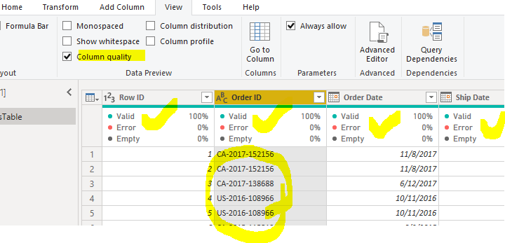

1. **Live connection RLS in Dataset?**
2. **Tabular model audit history?**
3. **How Office 365 group publish / unpublish into power bi**
4. **PRODUCTX function**
5. **Path DAX**
6. **Co-Related function**
7. **Multiple visual show/hide based on user selection**
8. **Time Intelligence functions:**
9. **Power Bi server administration with experience in backups, recovery, and restoration**
10. **Power BI User and License management**
11. **How to give report export access?**
12. Paginated report
13. **How to handle AAS Error**
14. **Region wise CY & LY amount with hierarchy year, Quarter, month, day**
15. **Export all tabs in Excel?**

**No tabs output will be exported in Excel.**

1. **RLS with Subscription**
2. **What tangent setting to do which will not degrades performance of developer and viewer/consumer?**
3. **Pac index, Stuff**
4. **String aggregate, spit**
5. **Rows maximum sal**
6. **Distinct record with without distinct**
7. **Trasaction isolation level: Read uncommitted, Read committed, Repeatable read, Serializable**
8. **Item, Price, Date - Latest price of each item**
9. **aaaabbbcccccddd**

**a 5**

**b 3**

**c 5**

**d 3**

1. **Present viewing report**
2. **SQL rolling total**
3. **Tabular exel footer not exporting**
4. **Matrix not exporting as is**
5. How you distribute / Share work within your team?
6. **How to check Quality/ Best Practices / Reporting standard?**
7. **SDLC – Water Fall & Agile (Scrum, and Kanban).**
8. **Dataset and Dataflow**
9. **Option without publish report how to distribute to 1000 customers.**
10. **How to convert Pro workspace to Premium.**
11. **Add new col in power bi dataset on tabular model.**
12. **Multiple Dimension chart?**
    * 3D Multiple Bar Chart
    * Area Charts
    * Stag Bar
    * Stag Column
    * Stag cluster Bar
    * Stag Bar Line
    * Matrix Chart
    * Tables
13. **Multiple Measures charts?**
    * Multi Line
    * Scatter
    * Stag Bar
    * Stag Column
    * Bubble Charts
14. **What is Temp table and CTE table in stored procedure?**
    * **Store Procedure Temp table?**

You can create and use **temporary tables** in a **stored procedure**, but the **temporary table** exists only for the duration of the **stored procedure** that creates it. When the **procedure** completes, Adaptive Server automatically drops the **temporary table**.

* + CTE common table expression.

Temporary named result set that you can reference within a SELECT, INSERT, UPDATE, or DELETE statement. The CTE can also be used in a View and function. if we create the **CTE** in a **Stored Procedure**, we can't use it in another **Stored Procedure**.

A **CTE** declared inside a **stored** procedure is therefore **stored** on disk. Function, procedure, view definitions etc are **stored** in the database where they are created. This definition is **stored** on disk. A **CTE** declared inside a **stored** procedure is therefore **stored** on disk.

1. **Temp table and CTE will not available after execution?**

Temp table will not available after execution.

1. **On-prem and azure data set RLS?**

**Using USERNAME () can setup security on prem database. You can add AD user or AD group into power bi dataset.**

1. **Direct query to Gateway?**

**Yes, Using Direct Query mode can retrieve data from On Prem database.**

1. **Personalize View.**

**https://www.youtube.com/watch?v=6vi-DQNC9PI**

1. **object level security.**
2. **Last Bar should show total of previous BAR**
3. Calculation group AAS?

**Calculation groups** are shown in reporting clients as a table with a single column. The column isn't like a typical column or dimension, instead it represents one or more reusable calculations, or calculation items that can be applied to any measure already added to the Values filter for a visualization.

1. LOOKUPVALUE FUNCTION

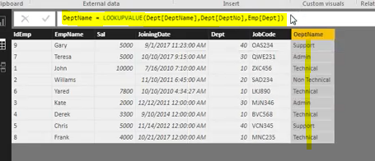

Writing DAX column in EMP table as new column called Dept Name which need to pull from Dept Table.

1ST parameter: Result column what you want to show.

2nd parameter: Based on which column we are pulling data from DEPT table (its matched column).

3rd parameter: which column passing values from EMP table to DEPT table.

1. SSMs can be used to access workspace URL to access Dataset, Dashboard, reports, data flow inside workspace.

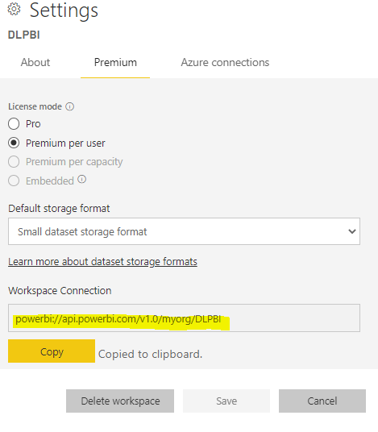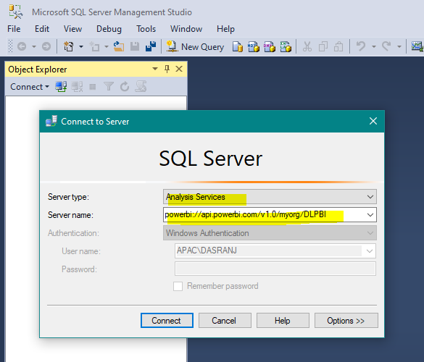

1. **Share point , Power automate, Power BI streaming dataset**

Once order created on share point then **power automate** will pick up order then push to Power BI streaming dataset.

* Streaming dataset: Create streaming dataset in power bi service.
* Power bi desktop: create power bi report using streaming dataset.
* Power automate: create automated flow to push data into power bi dataset
* Share point: create order/records in share point

[**https://www.youtube.com/watch?v=jmJJHFGwWFc**](https://www.youtube.com/watch?v=jmJJHFGwWFc) **:**

# Power BI Power Automate Quick Tip: Append Push Datasets in Real-time Based on a SQL Server Table

[**https://www.youtube.com/watch?v=qqGYj1Ktxbg**](https://www.youtube.com/watch?v=qqGYj1Ktxbg)

1. **Creating real time dashboards in Power BI with push datasets**

[**https://www.youtube.com/watch?v=vpD_PKtcTj8**](https://www.youtube.com/watch?v=vpD_PKtcTj8)

[**https://www.youtube.com/watch?v=OEQgIzPhiKo**](https://www.youtube.com/watch?v=OEQgIzPhiKo)

1. **Embed report to share point online?**

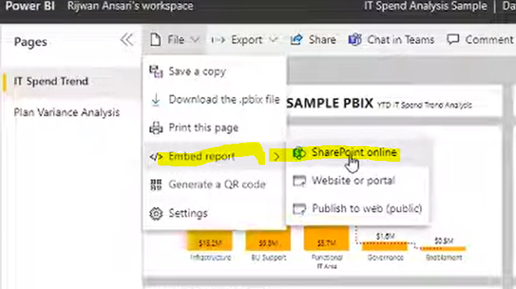

[**https://www.youtube.com/watch?v=lXVm7wtvea4**](https://www.youtube.com/watch?v=lXVm7wtvea4)

1. **Query Diagnostics**

**Step 1** Go to **Power Query** > Tools Menu. We have following 2 Group Options here.

* Step Diagnostics
* Session Diagnostics

[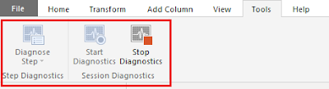](https://1.bp.blogspot.com/-vgoaBDB9vms/Xh7Dw7VBYsI/AAAAAAAAAJY/W3F6RsOnBh87zAd59fI-xnhGQojRZXPJwCEwYBhgL/s1600/Screenshot_3.png)

**Step Diagnostics:**

Here, we can measure the performance of an individual step. Suppose, if our Power Query has 15 steps and we only wish to measure the performance of step #12, at that time this one is best suitable option.

**Session Diagnostics:**

With this option, we can measure the performance of the entire report covering all the steps of Power Query.

Here, we will perform both the actions and try to analyze the data.

**Step 2:**

Let’s first perform “**Session Diagnostics**”.

Click on “**Start Diagnostics**”.

[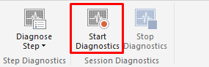](https://1.bp.blogspot.com/-fhyYLWIuRpM/Xh7GHnGWMSI/AAAAAAAAAJ8/stJN65X6emAxNxjWDNuENKNJuBV3rHv7wCLcBGAsYHQ/s1600/Screenshot_10.png)

Now, Click on **Refresh All data**.

[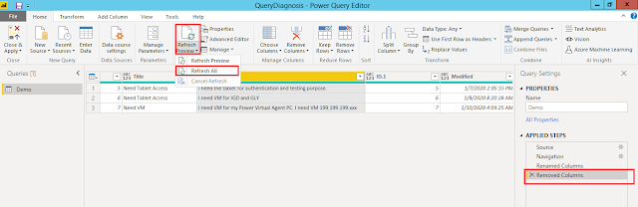](https://1.bp.blogspot.com/-Xh7qUbGPpDs/Xh7Dv6JYKFI/AAAAAAAAAJk/cqaPjDmgaYMZre005vmbB5X4jq78-vptgCEwYBhgL/s1600/Screenshot%2B%252812%2529.png)

Once data is refreshed, click on “**Stop Diagnostics**”.

[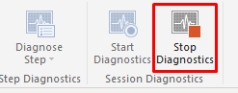](https://1.bp.blogspot.com/-JpCGSv8OzGY/Xh7GdLvyqZI/AAAAAAAAAKE/B2tl1xGpp8Emq5TR_PsPtTW3xyc0SWeKgCEwYBhgL/s1600/Screenshot_11.png)

**Step 3:**

When we stop diagnostics, this will add two new tables as a part of Query Diagnostics.

One represents **Overall diagnostics** and the other represents **Detailed diagnostics**. Let’s click on detailed diagnostics.

[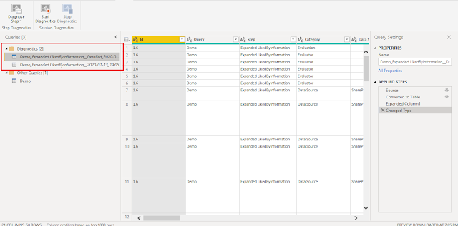](https://1.bp.blogspot.com/-7GbLRhWNUIE/Xh7DynQ4WYI/AAAAAAAAAJk/CDca0mrO2EQw15a2wneVLKM1z1jAqN9zgCEwYBhgL/s1600/Screenshot_7.png)

Here, we can see all the steps listed with the time taken for each execution.

[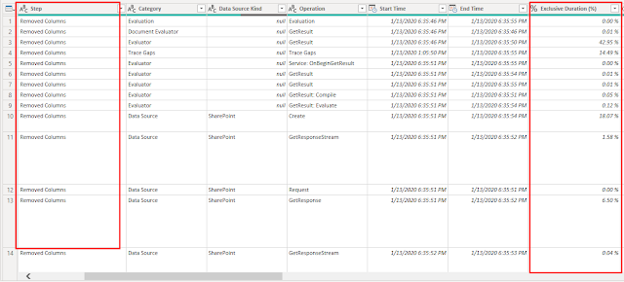](https://1.bp.blogspot.com/-NIeCKTj1NGk/Xh7DxmHTiOI/AAAAAAAAAJc/XmH2CnU5lUsYzn-ARPeE3aDKeegzkyRKgCEwYBhgL/s1600/Screenshot_5.png)

From the result, we can easily find out which step is taking the more time.

[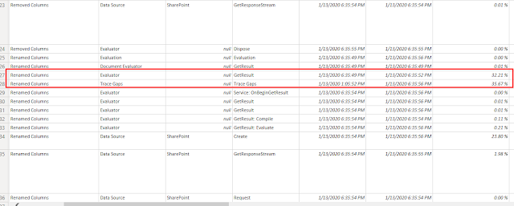](https://1.bp.blogspot.com/-z1K4FiWi32Y/Xh7DyPE89kI/AAAAAAAAAJg/douLspZSSXAeJuQAQ_Wy0-nfxHWoTLSFgCEwYBhgL/s1600/Screenshot_6.png)

1. **Project architecture**

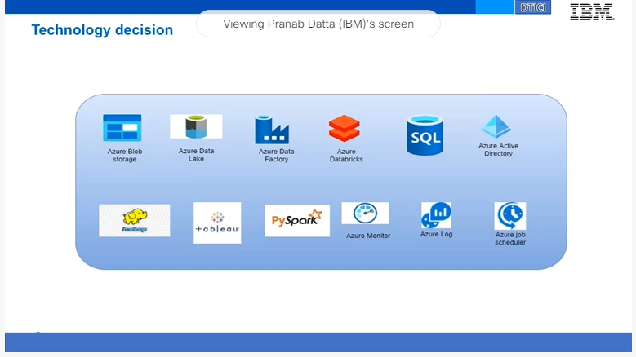

1. **RLS visual level or dataset level?**
2. **Report builder**